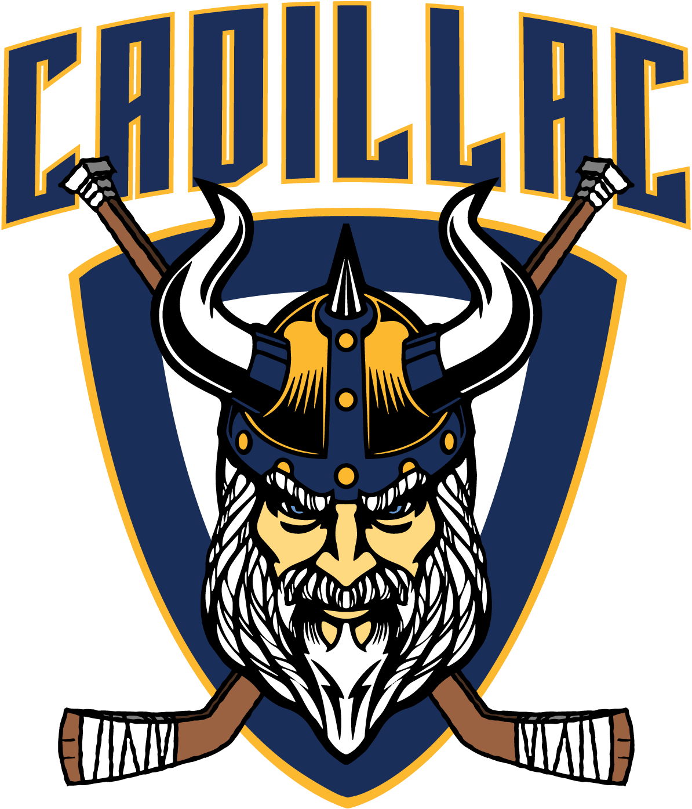

Cadillac Area Hockey Association
Board Minutes
January 15, 2026

Call to Order: 6:06
Present - SB, WL, AJW, CP, CR, KB,
Absent - HD, AT

Additions/Deletions to Agenda: Heather, HNIC funds: CR AJW
Motion to Approve:
2nd:
- Checking Clinic - SB - trying to teach it in a day in a clinic is ineffective, time and progression, starts with the younger ages, spend more time teaching it started in the younger ages with body position etc. Offer something that would help those.
- Team Books for Districts (CP) (Next Tuesday or Wednesday) - 6:30 binder checks.
- Elections for Board positions (CP) - Advertise for candidates - April 1st new takeover
  - President
  - Tournament Director
  - Treasurer
  - Scheduler
  - Equipment
- HNIC Funds: from previous years can be used for a big ticket item. No. Those funds are allocated towards player development, needs to benefit everyone. EX - Skills night. Hard board shooter tooters, Cody coaching clinics. If people have suggestions please bring to board. Going to put in newsletter.

Public, Members and Coaches Comments:
Duke: Appreciate all that CAHA. Tournament structure

Approve March Minutes:
Motion to Approve: AJW
2nd: KB

Financial Report:
Checking: WL
Savings: AJW

Board Comments:

SB: Combine PW and bantam charge double the fee. Was not clear when. Squirt tournament. Work group together to look at the format of the organization.
KB:
WL:
AJW:
CP:
CR:

Adjourn: 6:56
Motion to Approve: CP
2nd: WL

