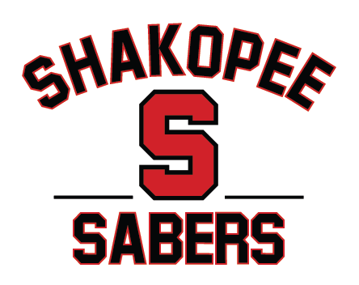

Shakopee Youth Hockey Association
Board of Directors Meeting Minutes
April 8, 2026 @ Turtles 6PM.

Members present: Justin Kimpling, Dan Meyers, Jared Osentowski, Chris Johnson, Alicia Waits, Jenn Holzer, Erik Peterson, Becky Benson, Vanessa Breimhorst, Curt Zins, Scott Reed, and Dan Woodall.

Meeting called to order at 6:01p by President Johnson. Quorum is met and no conflicts.

- Private Board discussion: McCarvel Scholarship discussion. Hilary and Dan McCarvel are here to discuss scholarship candidates. Put placeholder for a letter to be distributed next season from Dan and Hilary to garner additional applicants. Following a vote, applicant 3 was voted as the scholarship winner. Jenn will receive the name and, following proof of enrollment, the scholarship check will be distributed.
- 2026-2027 Season Board Positions: Chris Johnson is here in an advisory role and assisting with transition. President: Dan Meyers , Vice President: Jared Osentowski , Treasurer: Jenn Holzer, Secretary: Erik Peterson.
- Player Evaluation Updates: Shep Harder- Pushing hard for SPL evals to be completed by coaches. Need to review SPL use of St. Cloud State coach for next season.
- Gambling Update-Scott Reed. Estimate for April 2026 of $57,400.00 and the actual of January 2026 of $48,952.55. Estimate for May 2026 of $57,400.00 and actual of February 2026 of $47,105.08.
  - Donations for January of $20,000 to SYHA and $353.90 to MSU Baseball.
  - Donations for February 2026 of $25,000 to SYHA, $264.99 to MSU Baseball, $722.00 to Shakopee Crime Prevention (Bingo), and $878.00 to St. John’s Church (Bingo). Motion to accept Estimate, Actual, Donations by Meyers, second by Jenn. All three motions passed unanimously.
  - Scott County Fair contract will need to be renegotiated following the conclusion of this year's fair.
- Position updates: Kristine McGuire is returning. Vanessa and Alicia will continue as Mite liaisons. Curt and Kristine will continue on Safesport and Coaching committee. Tryout coordinators will be Jenn and Dan W. Dan W. will retain travel tournament coordinator. Estimates of levels are needed from HDC as well as level coordinators. Home team tournaments will be Alicia. Mite team away jamboree will be on and off ice coordinators, will be Cece Beckman and Amanda Ungas. The travel manager coordinator still needs to be decided. Concessions will be Jesse Thomas and Ally Hemphill (pending) but need to replace Wendy Raymaker and Jenny Lorenz. Sponsorship role(s) still to be decided; potentially a 3 person crew to include one board member Jared Osentowski. Jenny Kaufhold is staying on as DIBS coordinator. Webmaster role needs to be decided between 2 candidates. Social Media coordinator needs to be determined. Need to find a SKATE committee leader as there have been no applicants. Ice coordinator is still contracted for another year. Becky will stay on as McCarvel scholarship coordinator. Pizza fundraiser position is still open but Justin and Erik will work with Jenn. Golf tournament is all covered, only needing a board member to check in. Try Hockey for Free will be Vanessa again. Rhythm on the rails coordinator is still needed, 2 people in the booth (for dibs) responsible for setting up and taking down Justin will take on. Scott County Fair coordinator will be Jared. Little Wild will be maintained by Vanessa. Sabers snipers club will be maintained by Alicia.
- Will continue to use JOG jerseys next season through General Sports with potentially an upfront deposit for Jerseys/Swag followed by the rest of season fee.

Meeting adjourned at 9:07pm. Next meeting is May TBD.

