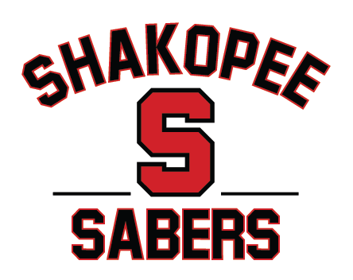

Shakopee Youth Hockey Association
Board of Directors Meeting Minutes (closed to the public)
May 19, 2026 @ Shakopee Library 6PM.

Members present: Justin Kimpling, Dan Meyers, Jared Osentowski, Alicia Waits, Vanessa Breimhorst, Curt Zins, Scott Reed, Dan Woodall, and Shep Harder.

Meeting called to order at 6:09 pm by President Meyers. Quorum is met and there are no conflicts.

- Dan Woodall brought sample red and white jerseys and sample sweatshirt to feel. Discussion on pairing jersey and sweatshirt with breezer covers in a joint order. Another possibility of creating a sweatsuit (pant and sweatshirt warmups) for players to look unified when going to tournaments and games.
- Shep Harder came to SYHA to “coach the coaches” but no one was willing to show up. Pivoted and brought in Dr. Wagner and it still did not work. Pivoted again and every Monday Shep would come on Mondays to skate with teams, some teams were never touched. Director lead hockey practices with his practice plan. Each coach is then expected to warm up utilizing some of these for part of the practices. It is expected to utilize this curriculum block for two to three weeks and then coaches would continue to run this.
  - Plan to utilize this in younger teams first (8 practices for squirts, 6 for peewee, 4 for bantam). The goal would be to do 8 practices for all teams but this probably isn’t possible. First 4-6 weeks teams are trying to figure out what each coach wants and players need to figure it out. By creating director-lead practices we are creating a foundation for all players and coaches to follow and it keeps practices consistent regardless of team level or coaches.
  - Co-op conversations: Shep would lead these practices on the boys side. He needs to discuss this with Co-op and Gracie to be able to lead it on the girls side. Member-at-large would be from Shakopee this year.
  - Team declarations: Spoke with Bloomington Jefferson and met with some of their HDC members to discuss rainbowing peewee and bantam AA players. Ultimately, it did not work out. Met with EP and it did not work out. Difficult to create peewee/bantam AA teams currently.
    - Need to schedule a bantam parent meeting before the June 3rd meeting (tentatively scheduled for June 1st or 2nd). Dan to send out email to all potential bantam families.
  - Must create a firm policy that players wear Shakopee Hockey gear only . . . no Breakaway, summer AAA, etc.
  - EoY Player Evaluations: Coach evaluations (35% response rate). Most head coaches have replied. Coaches need to fill out at the start of the season, perhaps middle of the season and the end of the season. Focuses on skating, skill, sense and compete. It gives parents a ROI on their child’s progress and may help parents see the outcome of specialty camps (i.e. shooting, etc.). Evaluations should only take 10 minutes to fill out for a team.
  - HDC: Being revamped. Moon, Lumberg, Rife, Hislop, Radmacher, Gracie, Kimpling, Breimhorst, and potentially 4 others as well. Varsity coaches will be non-voting members. Will set level coordinators, etc.
  - Devenir: Spoke with Ryan Es who would like a 3 year contract with Devenir. Ryan would like to have set days in which he could work with teams so the schedule is more predictable. Told the rate would remain the same. Awaiting new contract from Ryan.
  - Training Haus: feedback from coaches that we need to have a plan to better integrate TH. Perhaps loop it into pre-season skates where half the kids are on the ice and the other half are in TH.
  - Dr. Wagner is developing a curriculum for parents and kids.
- We need to have jerseys ordered by July 22nd to meet our September deadline. Kristine McGuire had sent an outline of payments and early bird registration. Registration can open June 1st. Three colors of practice jerseys (red, white, black).
  - Need to talk to Jen about what registration cost should be, etc.
- Rink dividers have been ordered. Shooting room update TBD; we need more info to plan out what we can do in there.
- Jr Gold tournament is full. SPL tournament was changed to 10/12U B1 only; dropped A division.
- “Saber Scouts” idea . . . try hockey on your feet before you try on skates.
- SKATE coordinator: we need someone. Need to send out one more email blast.

Meeting adjourned at 9:03 pm. The next meeting is 6pm on June 3 at Shakopee Bowl.

