Becker-Big Lake Youth Hockey Association BBLYHA
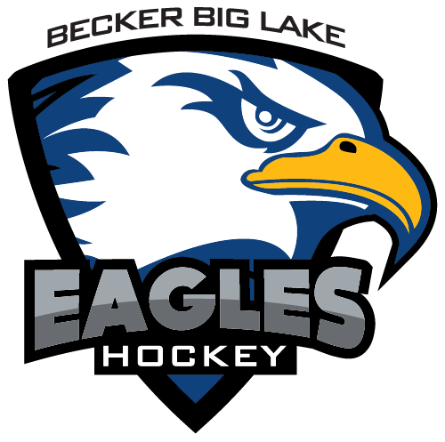

2025-2026 Season Fees & Information
Welcome, Eagles Skaters!
BBLYHA is excited for a fantastic season! Please review the information below regarding registration, fees, and important dates.

Important Information
- Electronic Payments Only: All fees and dues must be paid electronically through Crossbar.
- Crossbar Fees: Transaction fees apply to all online payments (typically 1.99% + $0.99 for credit cards).
- Deposits Required: Fundraising and volunteer deposits are collected via Crossbar during registration.
- Completion Required: All payments and deposits must be completed before on-ice participation.
- Outstanding Balances: Prior season balances must be paid in full before registration is accepted.
- Consequences of Non-Payment: Failure to pay fees may restrict skating or result in removal from the team roster. Special arrangements can be made with the BBLYHA Board.
  - The team coach, manager, and family will be notified of any suspension. Players suspended due to behavior or policy violations are still responsible for payments.

Player Registration Fees
Level | Description | Fee | Late Fee (Starting)
6U | D Mites | $250.00 | $50.00 (day following registration closing date)
8U | A, B, C Mites | $300.00 | $50.00 (day following registration closing date)
Squirt |  | $300.00 | $50.00 (08/16/2025)
Peewee |  | $300.00 | $50.00 (08/16/2025)
Bantam |  | $300.00 | $50.00 (08/16/2025)
- Due at the time of registration. No exceptions. Processing fees apply.
- Register for the level corresponding to the skater's birthdate. The Hockey Director may move players if necessary.
- No checks accepted.

Volunteer Deposit
- Amount: $400.00 per family (due at registration)
- Requirement: 10 hours per family
- Refund: Your card will not be charged if the requirement is completed.
- Charge Date: March 31, 2026, if the requirement is not met via the card used at registration time on Crossbar.
- Contact: Denise Hazelton at Hazelton.denise@yahoo.com

Fundraising Deposit
- Amount: $400.00 per family (due at registration)
- Requirement: $850 in product sales per family
- Refund: Your card will not be charged if the requirement is completed.
- Charge Date: March 31, 2026, if the requirement is not met via the card used at registration time on Crossbar.
- Contact: Mirella Dalla Venezia at mdvenezia@gmail.com

Ice Fee Payments
- Payments are made electronically via Crossbar (processing fees apply).
- Payments can be made in full or according to the schedule below.
- Due on the 1st of the month.
- Email reminders and receipts will be sent.
- Skaters with payments more than 30 days late will not be eligible to skate.
- Contact: Sarah Tollefson, BBLYHA Treasurer, at treasurerbblyha@gmail.com

Ice Fees Payment Schedule: RETURNING Skaters
Level | Oct. 1 | Nov. 1 | Dec. 1 | Jan. 1 | Feb. 1 | Total
6U (Mite D) | - | $75.00 | $75.00 | $75.00 | $75.00 | $300.00
8U (Mite A/B/C) | - | $143.75 | $143.75 | $143.75 | $143.75 | $575.00
Squirt | $281.25 | $281.25 | $281.25 | $281.25 | - | $1,125.00
Peewee | $325.00 | $325.00 | $325.00 | $325.00 | - | $1,300.00
Bantam | $375.00 | $375.00 | $375.00 | $375.00 | - | $1,500.00

Ice Fees Payment Schedule: NEW Skaters
Level | Oct. 1 | Nov. 1 | Dec. 1 | Jan. 1 | Total
6U (Mite D) | - | - | - | - | Waived
8U (Mite A/B/C) | - | - | - | - | Waived
Squirt | $140.63 | $140.63 | $140.63 | $140.63 | $562.50
Peewee | $162.50 | $162.50 | $162.50 | $162.50 | $650.00
Bantam | $375.00 | $375.00 | $375.00 | $375.00 | $1,500.00

Jerseys
Level | Jersey Fee
Mite D | $50.00 (per season)
Mite A-C | $100.00 (per season)
Squirt | $100.00 (per season)
Peewee | $100.00 (per season)
Bantam | $100.00 (per season)
Starting last season, BBLYHA implemented a new $100 annual fee to cover the cost of jerseys and 1) pair of socks for your player every 2 seasons. This fee ensures that your child receives a brand-new jersey every two years, along with a pair of socks. This will reduce the burden of the larger, one-time fee you may have experienced historically.
Benefits:
- New, high-quality, and durable jersey every two years.
- Creates unity and pride among players.
- The fee is spread over two years versus a larger one-time fee.

Girls Co-op Hockey
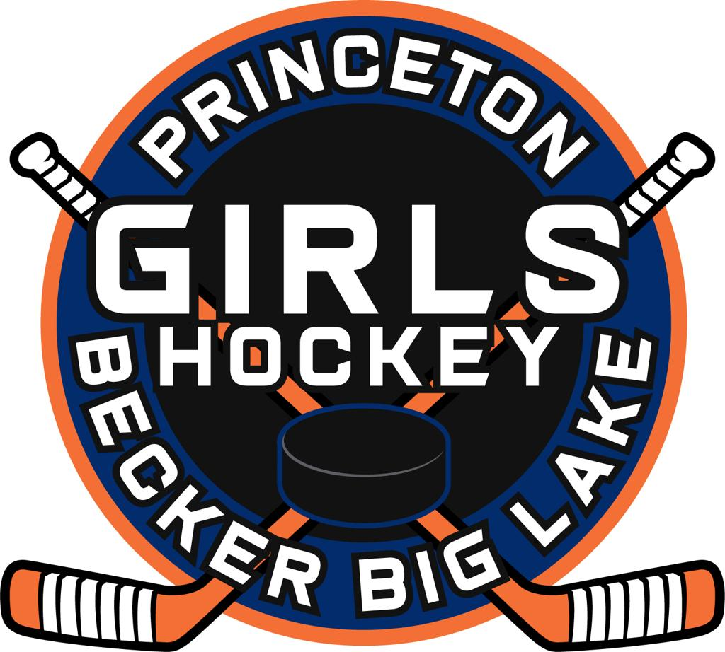

- Registration/Season Fees: First, register through BBLYHA’s Crossbar website and pay the $10.00 association dues. Then register through the Princeton Youth Hockey Association website: https://www.princetonyouthhockey.com, where you will pay your registration and season fees.

- Fundraising:
  - If you only have a girl playing with the co-op, fundraising will be completed through Princeton.
  - If you have a player in BBLYHA and a player in the co-op, fundraising will be completed through Becker-Big Lake. You will also need to sell ten $20 raffle tickets for Princeton.
- Volunteer Hours:
  - If you only have a girl playing with the co-op, volunteer hours will be completed through Princeton.
  - If you have a player in BBLYHA and a player in the co-op, volunteer hours will be completed through Becker-Big Lake.
Contacts:
- Cameron Carson
  - PYHA Girls Director
  - Phone: 612-418-9145
- Kristen Madoll
  - BBLYHA Girls Coordinator
  - Phone: 320-248-9513

Discounts
- Goalies: Squirt level and above, who own ALL of their goalie equipment, will receive 50% off their respective Ice Fees for the current season only.
- Multi-Player Discount:
  - 1st Player: No Discount
  - 2nd Player: No Discount
  - 3rd Player: 25% Discount off Ice Fee
  - 4th + Players: 50% Discount off Ice Fee

Coaching Requirements
BBLYHA will reimburse coaches for the following requirements:
- USA Hockey Number
- Background Check
- Age Module
- CEP Course
Contact Registrar Emily Korbel at emilykorbel@yahoo.com to get started.
Receipts for reimbursement of coaching expenses must be emailed to the Treasurer at treasurer@bblyha.com within thirty (30) days of completing the courses. A check will be mailed to your address on file or hand-delivered during the season.

BBLYHA In-Person Registration Dates
Please plan to attend one of the in-person registration nights to size your player for jersey & socks and pick up fundraising information for the 2025-2026 season.

- Wednesday, August 6th, 7:00 p.m. - 8:00 p.m. at Lupulin Brewery - Big Lake
- Sunday, August 10th, 5:00 p.m. - 6:00 p.m. at Moose Sherritt Ice Arena - Monticello

Mandatory Parent Meeting Date (Squirts, Peewee, Bantam):
- September 10th, 2025 @ Princeton Ice Arena Plyo Room

