INSTRUCTIONS ON HOW TO SIGN UP FOR A VOLUNTEER SESSION
- Hover over “RESOURCES” and click “VOLUNTEER INFO”.
- Click on .

- There will be a list of sessions to choose from… Example:
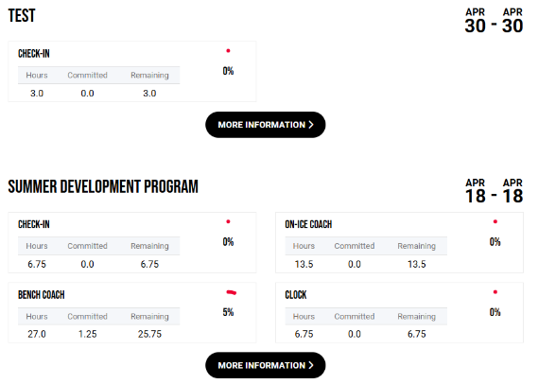.

- Click on “MORE INFORMATION”.

- Click on the green plus sign: 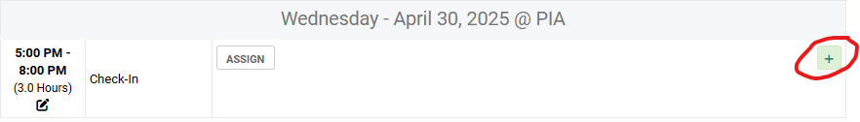.

- Click the name who will be doing the volunteering: 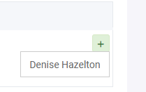.

- You are all signed up! To delete your volunteer sign up, click the red minus sign: 

