The GameSheet Scoring app replaces the traditional paper scoresheet, but follows a very similar workflow. Just like the paper scoresheet, the iPad will move from dressing room to dressing room as each team's coach reviews their lineup and signs, then it will be taken into the scorekeepers booth where it will be used to score the game. At the end of the game the iPad will be given to the referees for their post game report and sign off. Finally the game will be uploaded to the league.
Load the Game
- Open the GameSheet app on your iPad by tapping its icon on the home screen.

- If the app is requesting a "League iPad Access Key", enter ipad-md10sfdarb and tap "Sign-In".
- Tap "+ New Game" and then "Load from Schedule" .
- Locate your game and tap the "Load Game" button. This will download the game to the iPad and bring you back to the Games page. If you do not find your game in the schedule, tap "Back to active games" and create a new game from scratch.
- Touch the game to begin.

Confirm Lineups
Team rosters are downloaded when the game is loaded, so coaches should only need to make updates specific to the game's lineup.
- Tap either "Visitor Roster" or "Home Roster" on the left side to load the team's roster.
- Pass the iPad to the coach/manager and instruct them set their lineup.
  - Players can be set to Starting, Playing, Sitting Out, Injured, or Suspended by tapping on their status.
  - Editing of players and coaches can be done by tapping the content you'd like to edit and following the prompts.
  - When the lineup is correct, the coaches must sign before returning the iPad.
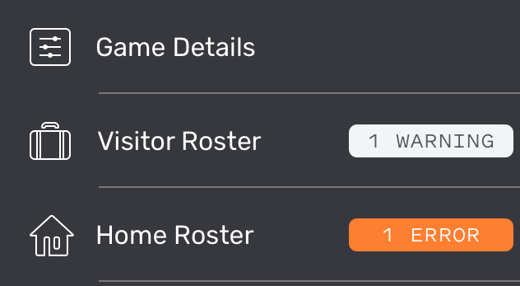
- Verify that there are no errors displayed beside the Home and Visitor Roster page titles. If the orange Error button is displayed, tap on it to review the errors.
- Repeat these steps for both the Home and the Visitor teams.

Score the Game
The pre-game setup is now complete and the iPad should be given to the Scorekeeper.
- Tap "Game Details" on the left side.
- Fill in any missing details and confirm the period lengths are correct.
- Enter the "Start Time", e.g. 7:01PM, when the puck is dropped.
- Tap "Scoring" on the left side to enter the game scoring page.
- Record the game's events.

Post a Game
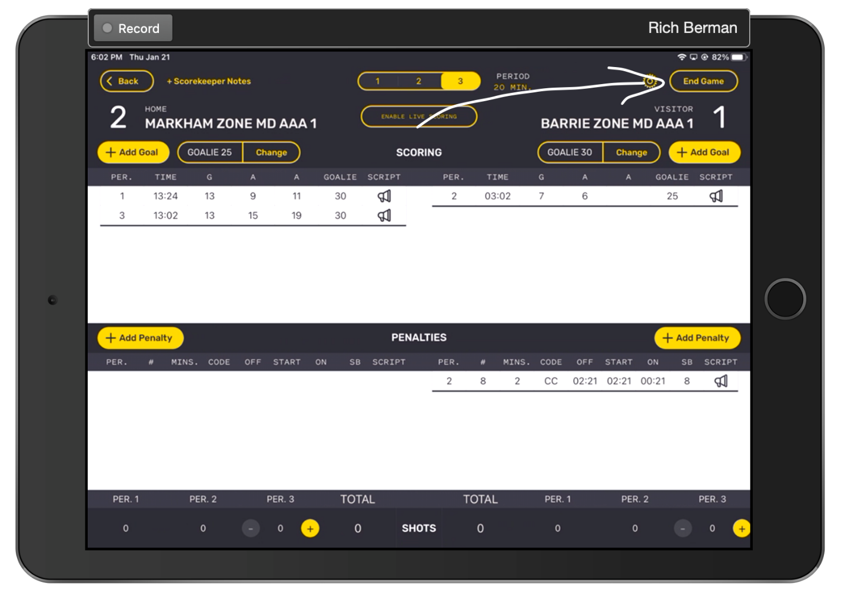
- When the game is over, verify there are no errors on the Scoring page (shown in the top right) and tap " End Game" in the top right corner. This will load the Officials / Post Game page.

- Verify that there are no errors displayed in the top right corner of the Post Game / Officials page. If the orange Error icon is displayed, tap the icon and then tap on the error to make the necessary adjustments. Warnings should be reviewed, but do not need to be addressed to upload the game.

- Give the iPad to the referees to complete the Officials / Post Game page and sign .
- Referees are expected to:
  - Add themselves to the game by tapping "+ Add Referee".
  - Review the penalties and confirm the codes and lengths have been correctly recorded. If any penalties are incorrectly recorded, the referee may edit them directly by tapping the "Edit" button above the penalties table.
  - Add notes to major and misconduct penalties (if instructed to do so by the league).
  - Sign.
  - Lock the game by tapping "Lock Game" button.
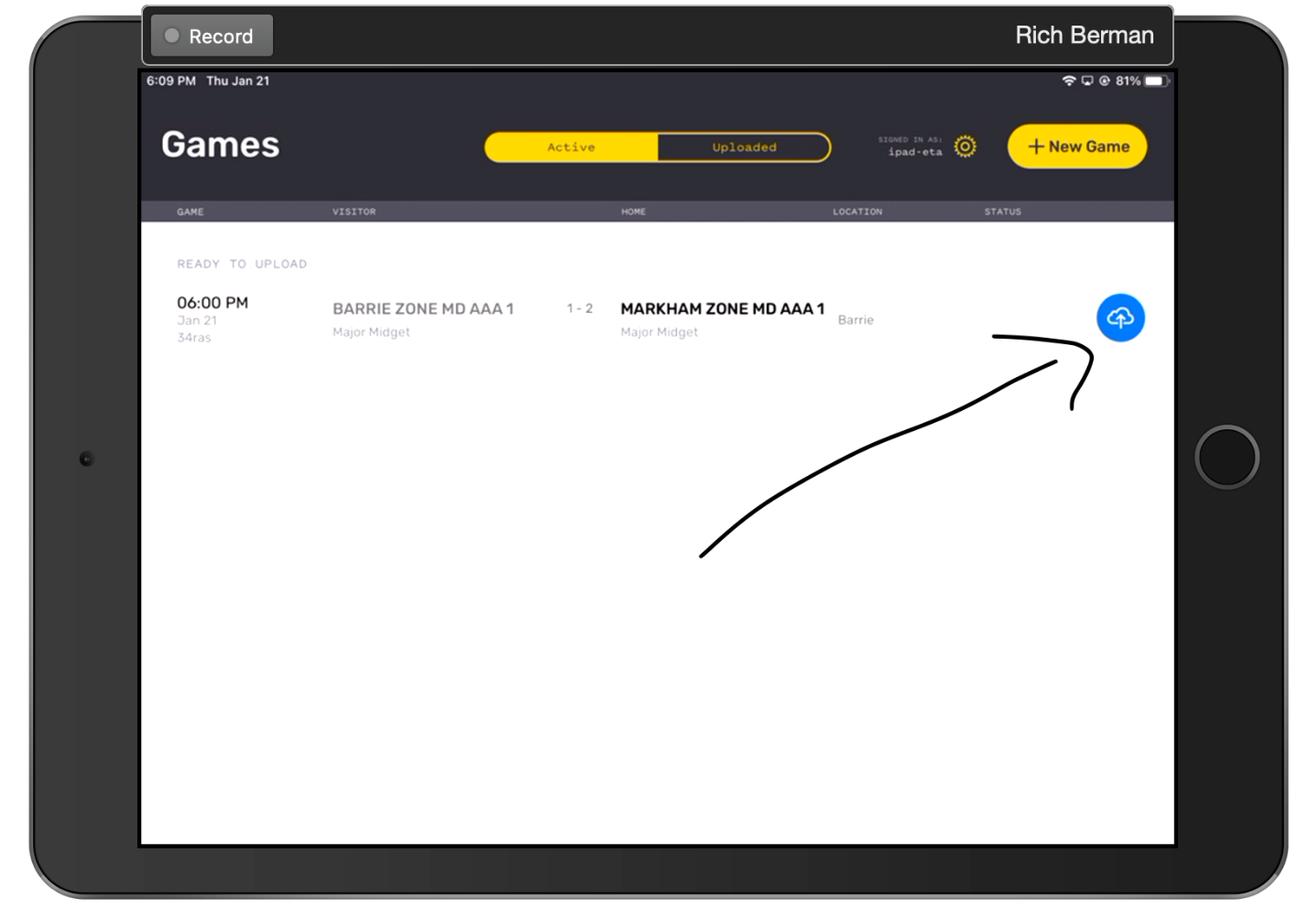
- After the referee has locked the game the app will return to the Games page and a blue icon will appear to the right of the game. Tap the blue icon to upload the game. Once uploaded the game will disappear from the Active games list, the league will have a copy of the game, the website will be updated and the managers and coaches of both teams will have been sent a copy of the scoresheet via email.

