We are looking forward to seeing you on Saturday, November 28, 2026, for the Berkshire Rattlers Thanksgiving Classic Mite Jamboree!!!
Directions & Parking Information:
Address: 245 North Undermountain Road Sheffield, MA 01257 Berkshire School Jackman L. Stewart Athletic Center

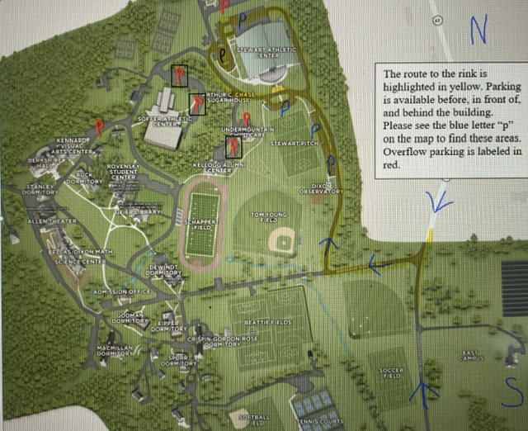
*Parking – Saturday will be very busy, and parking will require patience. If you are coming to support your team or volunteer, please park in the overflow areas. (Marked by a red P with a box around it) Thank you for helping to make today a success!

Helpful Information:
- Check in for coaches/teams will take place on the lower level at the front of the rink in the lobby area.
- There will be an on-site concession stand providing breakfast and lunch options.
- There is not an ATM in the rink, but the concession stand will accept credit cards and Venmo.
- Jamboree merchandise will hopefully be available for purchase.
- Skate sharpening is available for $5 on the rink level of the facility.
- There will be great raffle baskets! $10 per sheet of raffle tickets.
- Locker room accommodations will be labeled by team.
- You may use the front of the building to stop and unload passengers but do not leave vehicles unattended.
- Please remember that we are guests at this facility. Please respect all rink rules and regulations.

All games will be played under USA HOCKEY rules applying to the age bracket on the ice. The role of referees will be filled by one on ice coach/assistant coach from each team. Please note that the tournament committee will not tolerate abuse of officials and the referees on the ice will have the discretion to call bench penalties for any abuse of officials by fans, parents, or team officials. Abuse penalties called at the end of a game will carry over to the start of your next tournament game. All team officials, players, parents, and fans must follow the “ZERO TOLERANCE” rule listed in the current USA Hockey Rule Book.
We are very lucky to call the beautiful Jackman Stewart Rink at Berkshire School our home ice. We would like to remind everyone that we are guests in this new facility and hope you will all help us maintain this great relationship by following the guidelines below. Parents and coaches please review these rules with your skaters and help to enforce them with all team members.
1.Basic Rules:
• No stick handling anywhere in the building
• No soccer balls, lacrosse sticks, and balls
• No running around the building (you can use the track around the west rink)
• No food or drinks in the bench area (water only)
• No one is allowed on the ice until the Zamboni doors are closed
• The fitness center is for the Berkshire School community only
• You may not use the Rapid Shot or any fitness equipment on the upper deck (East rink)
• The function room and press box are off limits
• Tobacco products and vaping equipment are not allowed in the building or on the grounds
• No dogs/pets in the building
• The elevator is not a toy and should only be used by those who need it
• All children not on the ice must be supervised by an adult
2.Please do not park cars in front of the building. Stopping to unload is fine but vehicles must be moved ASAP to keep the fire lane clear of traffic. No vehicle should be left unattended on the road in front of the building. There are parking lots in front, along the entrance drive, and directly behind the building.
3. When locker rooms are provided, please use them. Using the entrance area to change limits the seating and walking room for the next teams entering/exiting the building.
Thank you for helping us to provide a fun and friendly atmosphere for our kids!

