Berkshire Rattlers Thanksgiving Mite Jamboree 2026 Registration
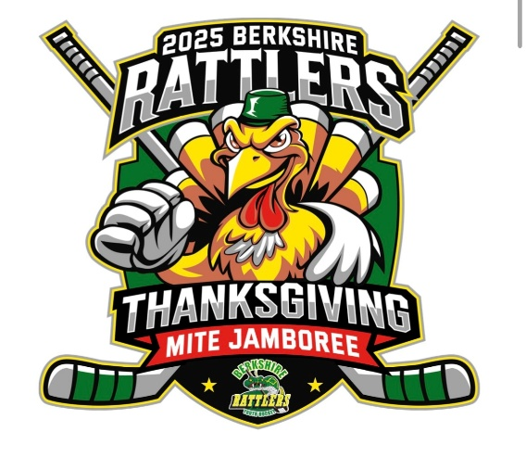
Team Name___________________________________________________________________
Organization___________________________________________________________________ Contact_______________________________________________________________________
E-Mail__________________________________________________________________________ Address________________________________________________________________________ City____________________________________ State_____________ Zip_______________________ Phone_________________________________
Number of players: B _________________ (Level B Tournament)
Number of players: C _________________ (Level C Tournament)
Please mail the following items to the address below
- registration-
- check (payable to Berkshire Youth Hockey)
- team roster
- team logo
Berkshire Rattlers Mite Jamboree
c/o Courtney Tomich
15 Squire Lane
Sheffield, MA 01257

Questions? Please contact Courtney Tomich rattersmitejamboree@gmail.com
*Registration is not complete until you receive a confirmation email.
Team Coach(es)___________________________________________________________________

