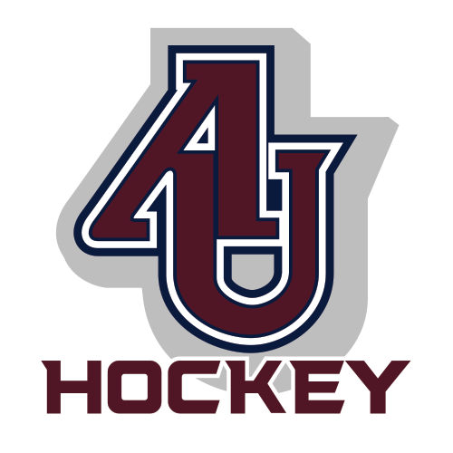

Request for Sponsorship
Appleton United Boys Hockey

Appleton United Hockey is a cooperative of Appleton North, East and West High.

Sponsorships are essential to the continuing success of the boys hockey program. Your financial support provides the additional funds to allow increased skater participation and ensures the availability of safe equipment, ice time and transportation. Please consider sponsoring the program at any of our 3 levels and you will see below what you receive in return for your sponsorship.

Sponsorships available for $250/$500/$750

Power Play Sponsorship - $250
Name/Logo in small size on the game program & website, plus 1 season passes to all home games

Slap Shot Sponsorship - $500
Name/Logo in medium size on the game program & website, plus 2 season passes to all home games

Hat Trick Sponsorship - $750
Name/Logo in medium size in game program, website and social media, Name announced at all home games, plus 2 season passes to all home games.

We appreciate your consideration and support, and would love to welcome you as part of the Appleton United team. All sponsorships must be in by November 1st in order to get them included on the game day program.

Thank you,
The Appleton Hockey Booster Club

AHBC is 501c(3) with the mission to support the operations of the Appleton High School Boys Hockey program.

Sponsor Company Name:
Contact Person:
Address:

Phone:
Email:

Mail completed form with payment to:
Appleton Hockey Booster Club
PO Box 2771
APPLETON, WI 54911-9998

Email your logo by Nov 1 to: appleton.hockey@gmail.com

