Away Game Template
Subject: Upcoming Away Game - Shakopee XXXXX vs. XXXXXX

Hello “Name”
I’m the lacrosse team manager for Shakopee Girls 12U-B and I wanted to touch base to confirm the details for our upcoming game. Here are the details as provided by our association; please let me know if you have anything different on your end.
Date: xxxxx
Time: xxxxx
Location: xxxxx

Also, can you let me know if there is any information that you could share that would be helpful for our teams to know before arrival (map of your fields, road closures/construction, etc).
Looking forward to a fun night, thanks!
Your Name

Home Game Template
Subject: Upcoming Home Game - Shakopee XXXXX vs. XXXXXX
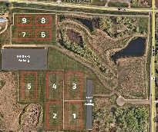
Hello “Name”
I’m the lacrosse team manager for Shakopee Girls 12U-B and I wanted to touch base to confirm the details for our upcoming game. Here are the details as provided by our association; please inform me if you have anything different on your end.
Date: xxxxx
Time: xxxxx
Location: xxxxx

Note: The roads (intersection of CH78 and CH79) around the Shakopee fields are currently under construction, so please allow for some extra time when planning your arrival. I’ve also attached a map of the Shakopee Saber Fields.
Looking forward to a fun night, thanks!
Your Name

