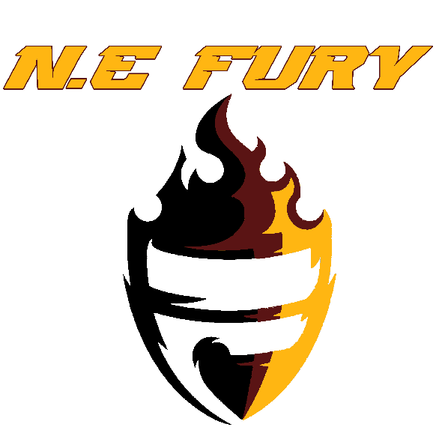

SPONSORSHIP PACKAGES
GOLD SPONSORSHIP - $1000
-WEEKLY SOCIAL MEDIA RECOGNITION
- LOGO PLACEMENT ON TEAM TENT WALL
- 2 N.E FURY HOODIES
- -TEAM ISSUED PLAQUE
- -LOGO PLACEMENT ON 2 UNIFORMS
- LOGO PLACEMENT ON TEAM WEBSITE

SILVER SPONSORSHIP - $700
- SOCIAL MEDIA RECOGNITION
- LOGO PLACEMENT ON TEAM TENT
- 1 N.E FURY HOODIE
- 1 N.E FURY TSHIRT
- LOGO PLACEMENT ON 1 UNIFORM
- BUSINESS LOGO ON TEAM WEBSITE
BRONZE SPONSORSHIP - $250
- SOCIAL MEDIA RECOGNITION
- 2 N.E FURY TSHIRTS
- BUSINESS LOGO ON TEAM WEBSITE
- LOGO ON TEAM TENT

PLEASE MAKE CHECKS PAYABLE TO:
ANDRE LEE (DRECO SPORTS

