Northeast Storm High School Hockey Team
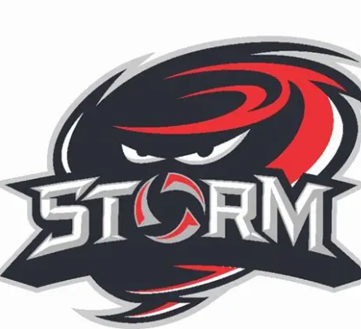
Player Code of Conduct
Purpose: To promote a safe, respectful, and inclusive environment for all players, coaches, officials, and spectators. This Code of Conduct aligns with USA Hockey’s SafeSport guidelines and reflects our commitment to preventing bullying, harassment, and abuse in youth sports.
1. Respect and Inclusion
- Treat all individuals—teammates, coaches, officials, opponents, and spectators—with dignity and respect.
- Discrimination, harassment, or bullying of any kind (verbal, physical, emotional, or cyber) will not be tolerated.
- Be inclusive and supportive of teammates regardless of race, gender, sexual orientation, religion, ability, or background.
2. Zero Tolerance for Bullying and Harassment
- Refrain from any behavior that intimidates, humiliates, excludes, or harms others.
- Locker room talk must remain respectful
- Any player who witnesses or experiences bullying or harassment must report it immediately to a coach, team official, or SafeSport representative.
- Retaliation against anyone who reports misconduct is strictly prohibited.
- Violations of this policy may result in the following disciplinary actions:
  - Offense 1: 3-game suspension and formal apology to teammates
  - Offense 2: Multi-game suspension and 20 hours of community service
  - Offense 3: Disciplinary review by the Storm Organization Board and possible removal from the team without monetary reimbursement
3. Commitment to the Team
- Arrive on time and prepared for all practices, games, and team meetings.
- Communicate absences or conflicts with coaches in advance.
- Support and encourage teammates—celebrate their successes and help them through challenges.
4. Sportsmanship
- Play fair and follow the rules of the game.
- Accept referee decisions without argument or disrespect.
- Win with humility and lose with dignity.
5. Safety and Responsibility
- Wear all required protective equipment properly at all times.
- Report any injuries or unsafe conditions to coaches, parents, or athletic trainers immediately.
- Always maintain clean locker room. Once done in the locker room all trash should be put in the trash can, no graffiti, misuse or destruction of property. This could result in player consequences dependent on the severity of destruction from game suspension to team removal.
6. Academics and Conduct
- Maintain academic eligibility and prioritize school responsibilities.
- Follow school rules and represent the team positively in the community.
- Avoid substance use, including tobacco, alcohol, and drugs.
7. Digital Behavior
- Use social media responsibly—no posting of inappropriate, offensive, or harmful content.
- Do not share private team matters or images without consent.
- Cyberbullying is strictly prohibited and will be treated as a serious violation.
Consequences for Violations
Violations of this Code of Conduct—especially those involving bullying or harassment—may result in disciplinary action including warnings, suspension, removal from the team, and referral to school administration or SafeSport authorities

Acknowledgment
I have read and understand the Northeast Storm High School Hockey Team Player Code of Conduct. I agree to follow these expectations and understand the consequences of violating them.

Player Name (Print): ______________________________________
Player Signature: __________________________________________ Date: ___________________
Parent/Guardian Name (Print): ______________________________
Parent/Guardian Signature: _________________________________
Date: ___________________

