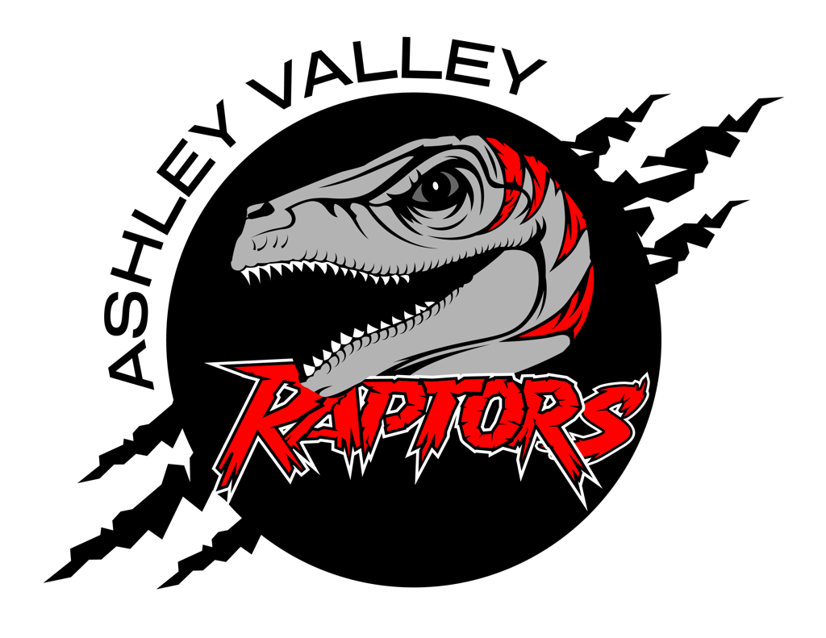
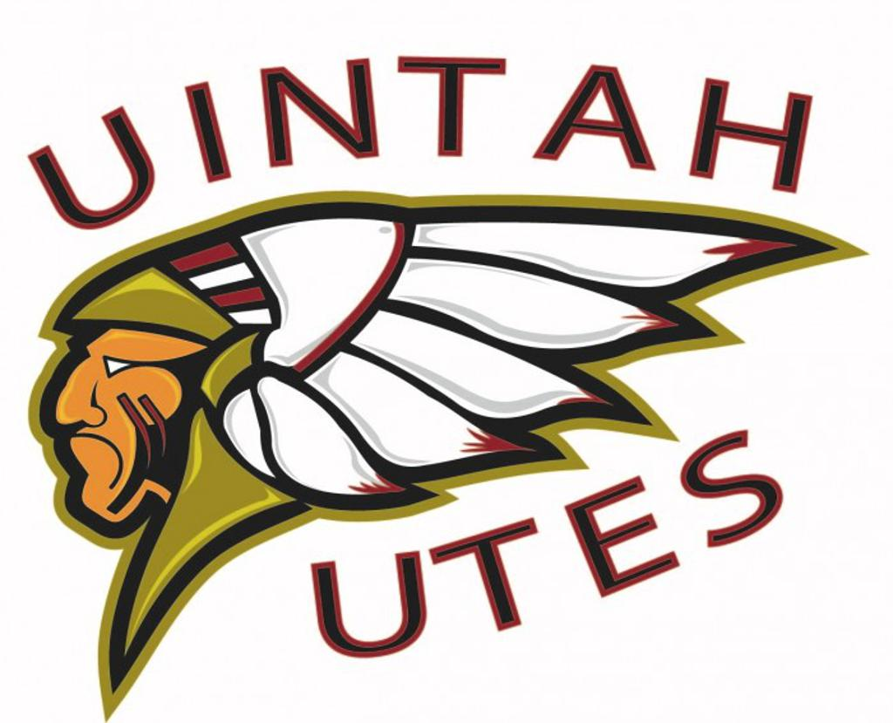
A.V.A.H.A.
ASHLEY VALLEY AMATEUR HOCKEY ASSOCIATION

Date: January 8, 2024
Time: 5:15 pm
Place: LedgeStone Hotel
Attendees: Missy Huber, Walt Wootton, Michelle Stearns, Stormie Treviz, Terrin Howcroft, Crista Gordon, Cherei Miller
______________________________________________________________________________
NEXT MEETING: February 12, 2024

MITE COACHES
- They are having a hard time with Mite coaches for every Friday.
- Would student coaches be sufficient?
- Coaches are locked because its January, so no recruiting.
  - Bob, Cajun, Dom & Deb are the only available coaches.

UTAH AMATEUR HOCKY
- Membership Agreement - April 1, 2024 if applicable.
- Applications: HS didn’t quite fit.
  - What do they need application wise?
    - List of teams.
- Membership Applications: January 15, 2024
  - February 1, 2024.
- Current Member Agreement:
  - Why do we need this? P&Ps currently say we need a membership agreement.
  - Utah doesn’t have one.
  - Move to membership committee.
    - Will discuss with individual associations discrepancies.
    - Individual associations will be able to give feedback.
    - Deadline: February 16, 2024
- AVAHA Board will go over the membership agreement individually and bring back feedback to the February board meeting, so that AVAHA can combine their thoughts and get that feedback to UAHA.
- AVAHA needs to have 1 or 2 board members attending UAHA meetings so we can be up to date on what is going on in the state.

MITE MADNESS
- Not a fundraising tournament.
- No Raffles.
- Yes Concessions.

LEAGUE DECLARATION
- 1 travel A team in each age bracket.
- 2 travel B teams in each age bracket.
- Missy will be in charge of filling the application with the state of Utah.

MITE COACHES
- We need a solution.
- How can we prevent the problem of not having enough coaches or having coaches not show up in the future?
- Incentives?
  - 95% attendance Coaches
  - 85% attendance Assistant Coaches
- Practice one day a week?
- Get rid of the split season?
- Coach commitment contract?
- Coaches have to be overseen better.
- More checks and balances?
- Someone to be over communication and regularly checking in on the coaches?

