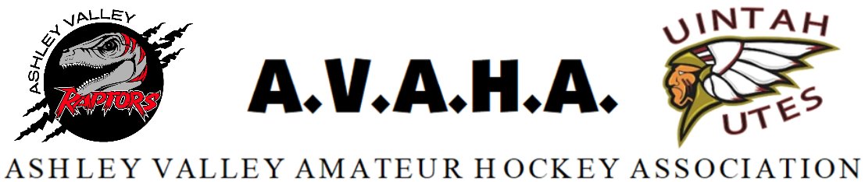

Meeting Minutes
Date: May 13, 2024

Time: 5:30pm

Place: Cipriano Residence

The following are current officers for AVAHA Board of directors:
(*Names crossed out were not present)
President: Walt Wooton | Vice President:Kyle Fuller | Secretary:Morgan Richardson
Treasurer:Danielle Cipriano | Registrar:Cherei Miller | Safe Sport:Shannon Uasilaa
Fundraising:Ari Smuin
Additional attendees: Missy Huber,Devin Smuin, Nichole Fuller

Greeting and introduction……………………………………………………………………………..President/VP
The new board members (Morgan Richardson, Ari Smuin, Kyle Fuller, and Shannon Uasilaa) were inducted in.

Discussion about the Oilers doing a golf tournament under AVAHA’s 501c3. The county only wanted to use organizations for tournaments that are a 501c3. Spoke with Cheryl Meier from the Uintah Rec District about the situation and they said that would be fine. In return for this Danielle mentioned that Alaina would allow us to use their liquor license for the cornhole tournament AVAHA does in August. AVAHA would not be putting on the tournament, AVAHA will only be cutting the check back to the Oilers.
Danielle motioned that AVAHA allow the golf tournament for the Oilers if they allow us to use their liquor license.
- MOTION was seconded and passed without dissent.

Missy also wanted to clarify the changes that are happening from UAHA. We will have in essence the same team structure with different names, moving from D1/D2 to Travel A,B,C. With the changes the out of state rules change. AVAHA will be looking at more tournaments for some teams for the travel A. These may include stay to plays. It was mentioned to do a buy out option if possible, and also informing the tournament directors that we have sibling groups. Some teams are already registered for Las Vegas next season. This tournament had reasonable prices on the hotel options so we will be requiring parents to stay at the designated hotel. The Vegas tournament will include one team from 14, 12, 10u groups.
If we put a team in the A division they will be more tournament heavy and less games. This would require close to $500 more per player. The Travel A team will require a try-out. Making these decisions will require more information. We are continuing to gather more information about the structure and will meet again at a later time. Missy says tryouts might be necessary in the next few weeks for a Travel A, AVAHA will look into the rules and will be gaining more information.

The policies and procedures for the 2024-25 season were proposed. One change was added to the play up policies, the managers will be notified and the coaches will sign off.
Walt motioned to adopt the policies and procedures 2024-25 with the one change.
- MOTION was seconded and passed without dissent.

Board duties were discussed, Walt will stay over the Equipment Manager as well as the contact for Western Park, Kyle and Walt will oversee the coaches, Morgan will be overseeing the Managers. Cherei will be in both chats. Morgan will be checking in on the UAHA board meeting zoom meetings. If she can’t cover it she will find another board member. Ari, Morgan, and Kyle all have access to the social media accounts.

Treasury Report- Danielle tried to get the Quickbooks updated but they had a malfunction and wanted to charge us to fix it. She decided to cancel the Quickbooks and stick with the Wave platform for expenses. She will have a budget breakdown for the next meeting, with the note that the financials look good and we should have plenty of money to not raise registration for next year.

The split season was discussed and will be thought out more with moving u6-u8 and house vs. travel for the upcoming season.

Kyle mentioned the Learn to Skate NHL programs. Utah NHL owns the territory so Kyle will contact them one more time but will probably use the Don Korth and see if we can get a small season for the younger kids.

The league will be buying more equipment for rentals. This year the equipment used will all be dry cleaned. Neck guards will be required and the league will buy some to sell but not for rent. Danielle will handle these tasks.

The coaching director position will not be continued next year. Instead AVAHA will look into a subscription to Power Tech for all head coaches, possibly others. Wise Tech is another one we will consider in hopes to know which company best fits by the first of the season. Kyle and Corrie will try the apps out.

Coaching clinics were discussed. AVAHA will look into what this will look like next season. Possibly looking to pay for a league wide clinic. Danielle will look into this.

The box subscription had 7 seats, mostly not being used. It was changed to just 3 seats to save money. We can either share logins or just have 3 members in it. As of now Danielle, Morgan, and Cherei. Kyle asked if there is a difference between Google Drive vs. Box. We believe it to be more secure and more storage. Box was set up to compile all of AVAHA’s documents for future board members to have all documentation, receipts, articles of incorporation ect..

Meeting was adjourned.

