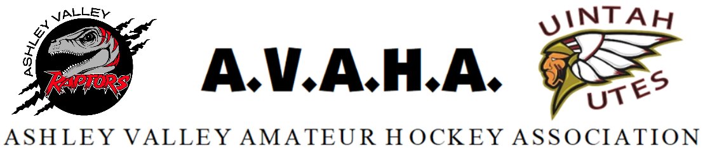

Meeting Agenda
Date: 8/6/2024

Time: 6:00pm *** Closed door session 5:30-6:00***

Place: Uintah County Library
The following are current officers for AVAHA’s Board of directors:

President: Walt Wooton | Vice President: Kyle Fuller | Secretary: Morgan Richardson
Treasurer: Danielle Cipriano | Registrar: Cherei Miller | Safe Sport: Shannon Uasilaa
Fundraising: Ari Smuin
Greeting and introduction………………………………………………………………………………………………..President

Last Meeting follow up:
June Minutes approval
Coaches meeting recap
New Business:
Membership agreement………………………………………………………………………………………………. Walt
Play-up policy update to include Tryout clarification……………………………………………Morgan
Tryouts/ice……………………………………………………………………..…………………………..Cherei/Morgan
Fundraising ideas…………………………………………………………………………………..…………Ari/Danielle
Spending without approval…………………………………………………………………………………….Daneille
Coaching gifts………………………………………………………………………………………………………….Danielle
Pictures……………………………………………………………………………………………………………………….Cherei

Section Reports:
Coaches
Managers
Safesport
Treasury
Fundraising-Cornhole, Sponsors
Western Park

Open floor:
Help keep the promise to hold the meeting to ONE HOUR!
Please be prepared, stay informed, and stay on topic.
If you have a problem, propose a solution.

