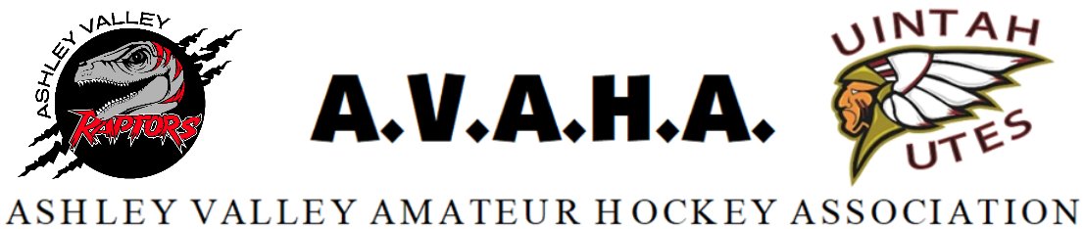

Meeting Minutes
Date: 10/22/2024

Time: 6:30pm

Place: Google Meet

The following are current officers for AVAHA Board of directors:
(*Names crossed out were not present)
President: Walt Wooton | Vice President:Kyle Fuller | Secretary:Morgan Richardson
Treasurer:Danielle Cipriano | Registrar:Cherei Miller | Safe Sport:Shannon Uasilaa
Fundraising:Ari Smuin
Additional Attendees:
none
Greeting and introduction……………………………………………………………………………..President/VP

Last Meeting follow up:
September Minutes- Motion to approve minutes, motioned seconded and carried without dissent.

Morgan brought up changing from Sports Engine platform for our website to Crossbar, or another platform. She has been researching throughout the summer and until now. Crossbar seems to be the one that will be useful to all the things we need. We would like to switch over in January so that we can work out any bugs there might be. Sports Engine is shown to be not very user friendly and only useful for some things the league needs to do and not others. The board will continue to look and research but make plans to switch to something around January.

Shannon has been talking with RMHS for a clinic. There are two options for their services. 1) AVAHA pays them directly and attends all our practices for a week with our coaches. With this option AVAHA would provide lodging approx $2500 plus lodging. 2) We schedule out some time for them to come and players cover the cost directly. 2-3 day clinic for a few hours each group (around $350-$500 per player) The board voted to go with the first option so all the travel players can attend. Morgan will check with Danielle to be sure AVAHA can cover the cost and then Morgan will schedule a time.

Kyle said the stick holders have been placed in the locker rooms so we didn’t need to discuss that.

Kyle ran tryouts this 24-25 season and would like to set something into the policies about how tryouts are run for future seasons. He felt it was beneficial to have evaluators who are unbiased and from outside of AVAHA. Cherei also mentioned adding to the policy that if a player signs the charter for the A team they will not be allowed to move to the B if they don’t like the team. Morgan said there would be extenuating circumstances that we would need to allow families to adjust.

Adult league was discussed. In the past the Adult league has charged a $5 drop in fee, but there really wasn’t anyone tracking it and costs were not being covered. This year because ice has gone up Danielle really tried to get the ice covered but it is an extra chore for everyone. It was suggested that Adult league and Stick and Puck be offered to Western Park to run for next season. This will be less work and cost for volunteers and AVAHA. Morgan will suggest it to them.

Utah has created a committee for a new league for the Travel teams in Utah. Every association has a representative for the new league. Morgan attended the meeting and offered to be the rep for AVAHA. They voted to make it called the Utah Amatur Hockey Leauge (UAHL). They would like to get games that are more evenly matched. This season may not work for AVAHA to have much involvement in the state tournament and or the home and away series as our schedule is mostly set. Morgan is going to work with the committee to make sure we will be keeping the same amount of travel as we are currently scheduled for the next season if we choose to participate. The committee was understanding about Vernal being in a different situation because of our location, and willing to work with AVAHA.

The home tournament is looking more like a 10u and 12u B tournament. Morgan offered to put in 3v3 games for the A teams and 14u. The 10U A would rather have a break and Morgan will check with the head coach of 12u A and 14u for what they want to do.

Try Hockey for Free is Nov. 2nd. Morgan updated the board on plans and volunteers. We will hand out trick or treats to advertise for the event at the Western Park’s open house.

Walt brought up the contract that Western Park sent. The board wanted WP to fix the part about sponsorships and there was one typo found. Once that is fixed we will sign the contract with them.

Cherei wanted to update registration numbers. 34 players registered in the house division. We had another player sign up for 10u B giving them 12 for the team and making our total 80 for the travel players. We will also hand out flyers for the in house program at the open house and Try Hockey for Free. Walt also asked about other advertising we have done. Posts on FaceBook were boosted and Utah Hockey shared them as well. We have a radio station ad. Walt will reach out and ask the radio if we can put a spot on.

Walt is going to find a jersey for Western Park to hang. He is going to work with Brooke to get one we don’t use.

Ari updated the board on the fundraiser calendar. Things are printed and ready to go and we can offer the in house to help with the fundraiser if they want, not required. The fundraiser is helping to cover the extra tournaments as well. She is starting in November.

Boards are all up for what we sold and Ari is looking to sell a few more to reach our goal, but we are close.

Kyle asked about the in house coaches and if they need to do the same CEP requirements as travel. Cherei is going to look into the requirements.

Cherei wants to get a gift for our UT NHL contact because they kindly got us all the family night tickets. She and Danielle will find something.

Travel registration will end at the end of the month, if any more players want to sign up they can reach out directly to Cherei.

No other business meeting was adjourned.

