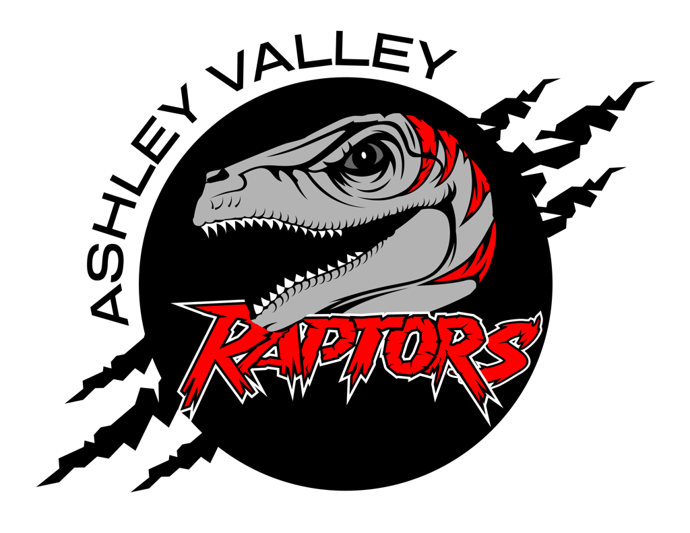
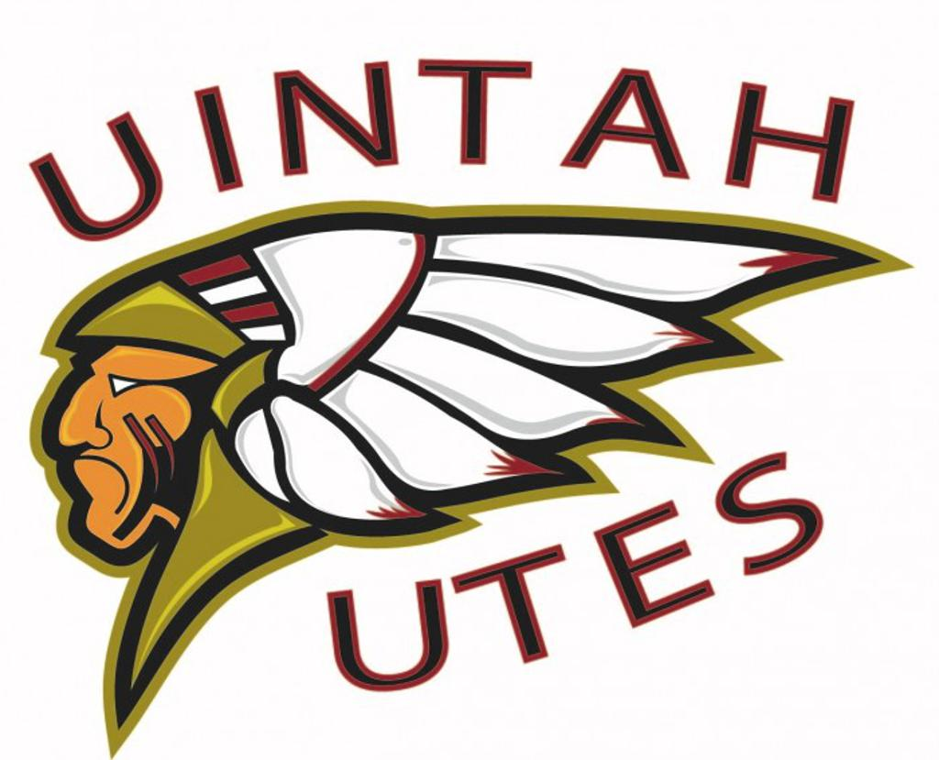
A.V.A.H.A.
ASHLEY VALLEY AMATEUR HOCKEY ASSOCIATION

Date: March 11, 2024
Time: 5:15 pm
Place: Uintah County Library Upstair Conference Room
Attendees: Missy Huber, Walt Wootton, Cherei Miller, Crista Gordon, Stormie Trevizo, Danielle Cipriano, Michelle Stearns,
______________________________________________________________________________
NEXT MEETING: April 8, 2024

OLD BUSINESS

NEW BUSINESS
- League Research: Morgan Richardson - 5:15 pm - 5:25 pm
- Parent Player Removal: Cherei Miller - 5:25 pm - 5:35 pm
- AVAHA Annual Banquet - 5:35 pm - 5:55 pm

