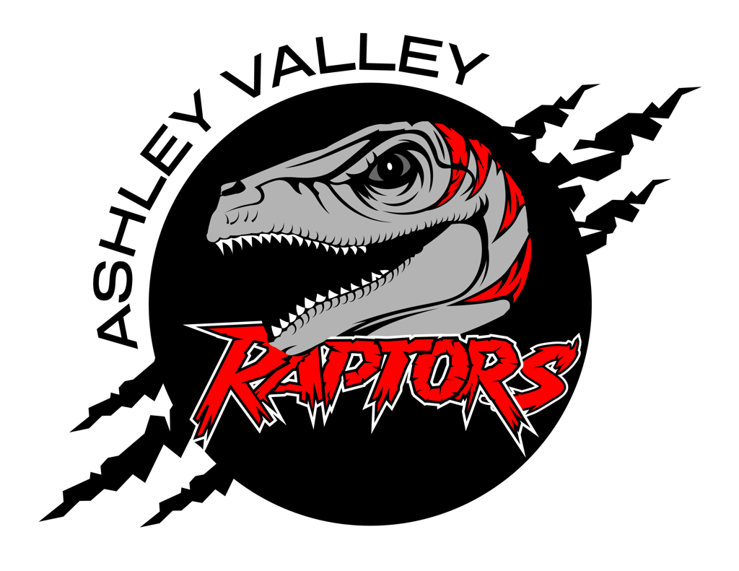

A.V.A.H.A.
ASHLEY VALLEY AMATEUR HOCKEY ASSOCIATION

Date: April 19, 2023
Time: 6:00 pm
Place: Ledge Stone Conference Room
Attendees: Denim Simper, Crista Gordon, Cherei Miller, Stormie Trevizo, McKenzie McNeil, Sam and Ashley Searl, Ashleigh Lindquest
______________________________________________________________________________
NEXT MEETING: June 14, 2023

OLD BUSINESS

March Minutes
- Crista motioned to approve the March Board Meeting Minutes.
  - McKenzie seconded
  - Cherei aye
  - Denim aye
  - Stormie aye
  - Crista aye
  - McKenzie aye
  - Motion Carries. March meeting minutes are official and approved.

Board Meetings
- Crista presented to the Board the following policy for Agenda, Board Minutes, and Closed Board Minutes.
*BOARD MEETING, MINUTES, & AGENDA POLICY
BOARD MEETING
- Meeting notice will be posted the morning of the board meeting on social media sites. The notice will include:
  - Date.
  - Time.
  - Location.
AGENDA
- Secretary will email/post the agenda to the board the week before the board meeting for review.
- Board Members can message or email agenda items as needed.
- Agenda will be posted on www.avaha.net 24 hrs. prior to the board meeting.
- Association members can add agenda items, proposals, or discussions by following the “Submit an agenda item/discussion” policy located on www.avaha.net.
MINUTES
- Open meeting minutes are public record.
- Written minutes will be released to the members of the board 1 week prior to the board meeting for review.
- “Unapproved Final Draft” minutes will be released the Monday before the next board meeting, posted on www.avaha.net.
- Final approval for minutes will take place at the following board meeting. Example: May board minutes approved at June board meeting.
CLOSED MEETING
- Closed meetings will be voted on to close by a ⅔ vote.
- Closed meetings can and will happen when discussing the character, actions, professional conduct, physical health, mental health, or misconduct of individuals.
- Minutes of Closed Meetings are not public record.
- Following will not happen during a closed meeting:
  - Approve any ordinance, resolution, rule, regulation, contract or appointment.
  - Interview a person to fill an elected position.
  - Take final action.
  - Final votes must be open and on the record (except as allowed specifically by statute).*
- Crista motioned that the policy be adopted into AVAHA’s Policies and Proceedures.
  - Stormie seconded
  - Denim aye
  - Cherei aye
  - McKenzie aye
  - Crista aye
  - Stormie aye
  - Motion Carries. The Agenda, Meeting Minutes, Closed Meeting Minutes policy will be adopted and put in effect.
- The open comment section for a board meeting was adopted in a previous board meeting. It will be 3 minutes at the end of the meeting or during, as deemed necessary, to give a chance to have a discussion with members of the association.

NEW BUSINESS

Rental Gear
- McKenzie has jerseys back from West End. West End did a great job and it was highly suggested that AVAHA continue to clean rental jerseys to keep them nicer longer.
- McKenzie also handed in the Equipment Manager’s forms and binder.
- AVAHA needs to update the rental jersey form to add a replacement jersey amount. It needs to be made clear the amount that it will cost a member if the rental jersey is damaged.
- Helmets, a lot of extra small and smalls were not used. Medium helmets were heavily used. When ordering more helmets it was suggested that AVAHA order more larger sizes than smaller ones.
- Rental gear needs to be ordered bigger (10U size).
  - When considering ordering maybe order at least 10 sets in 10U size.
  - Ask Pure Hockey if there are discounts for ordering more sets.
  - Contact UAHA and ask about the USA Hockey gear match.
    - Crista will email and ask UAHA about the USA Hockey gear match.
- End of Year order form for Game Jersey Replacement. It was suggested that an end of year order form be created for replacement jerseys. This will allow us to keep track for when Tina places the jersey orders.

New Rink/Gear Locker Move
- Denim will contact Melani to see if AVAHA needs to get out stuff out and if we need to Denim will find a storage unit for AVAHA to rent.
- After Denim finds out information on the gear locker, Crista will set up a moving day to go through gear and inventory.
  - This would be a great opportunity for volunteer hours for a last chance to get the volunteer refund.

Loss in UAHA
- Stormie will get a card and send to the family on behalf of AVAHA.

May Agenda
- Ashleigh requested UBIC be put on the May agenda.

Open Comment Section
- Sam asked if UAHA had made a decision on how they would proceed for this next season. UAHA has determined that 2023-2024 season will continue like the 2022-2023 season. Levels will be D2, D1, and then travel tiers.

Board Member Elections
- Votes have been totaled and the following Board Members have been voted in. New Board Members will be inducted in on May 10, 2023 at the May Board Meeting.
  - Vice President: Walter Wootton
  - Treasurer: Danielle Cipriano
  - Fundraising Director: Marilynn Erickson

4/20/2023
- Missy was contacted by Melanie. AVAHA needs to clean out the gear closet asap. They will begin demolition on Monday for the Western Park Ice Rink remodel. AVAHA needs to get everything out by Wednesday at the latest.
- Denim was able to find the following storage units:
  - 10x10-$50
  - 10x20-$70
  - 10x30-$90
  - He will also be able to get AVAHA a Uhaul by Saturday.
- Eric motioned that AVAHA get a 10x20 storage unit for $70 a month until we are able to move back to Western Park.
  - Crista seconded the motion
  - McKenzie aye
  - Michelle aye
  - Cherei aye
  - Stormie aye
  - Eric aye
  - Crista aye
  - Motion Carries. Denim will get the storage until set up asap.
- Missy has declared that she will be continuing at scheduler next season. She has asked for the Board’s support in this decision and has asked that the Board has her back when it comes to the schedule. She has been doing this for many years and has gone over every angle possible when it come to scheduling ice for AVAHA.
- The AVAHA Board has Missy back and will have their complete support when it comes to the AVAHA schedule.
- Eric has asked, at the coaches’ request, that we review practice times. He has asked for that to be put on the May agenda for discussion.
- There is concern for Men’s league. With Denim not on the board and not having a key any longer will Men’s league be out of ice?
  - AVAHA would like to see the Men’s league and grow. Board members have offered to take turns helping opening up the rink for Men’s league. It would be nice to see Men’s league succeed.

April 21, 2023
- Denim can get AVAHA into the storage unit Monday, April 24, 2023.
- Missy on behalf of AVAHA voted for UAHA.

April 22, 2023
- Missy put out a call for volunteers. AVAHA will start cleaning out the gear room on Sunday, April 23, 2023 at 3 p.m.

April 24, 2023
- AVAHA is officially moved out of the Western Park Ice Rink. The storage unit is at Timberline Storage.

April 27, 2023
- Missy put out a message to the league. Melanie was misquoted. The Western Park Ice Rink will have ice by October 1, 2023. AVAHA’s 2023-2024 season will continue as planned. Please don’t call Western Park.
- Crista and Stormie have requested a chance to take on home tournaments this year. It was agreed upon that they have a chance to put together the home tournaments.

