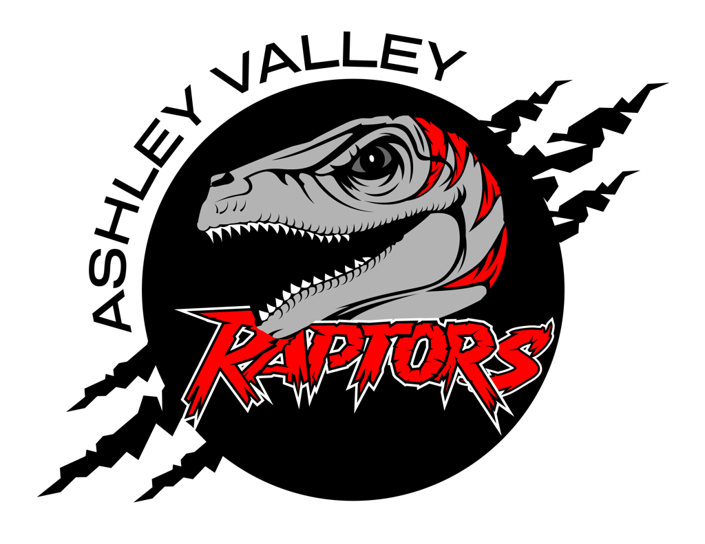
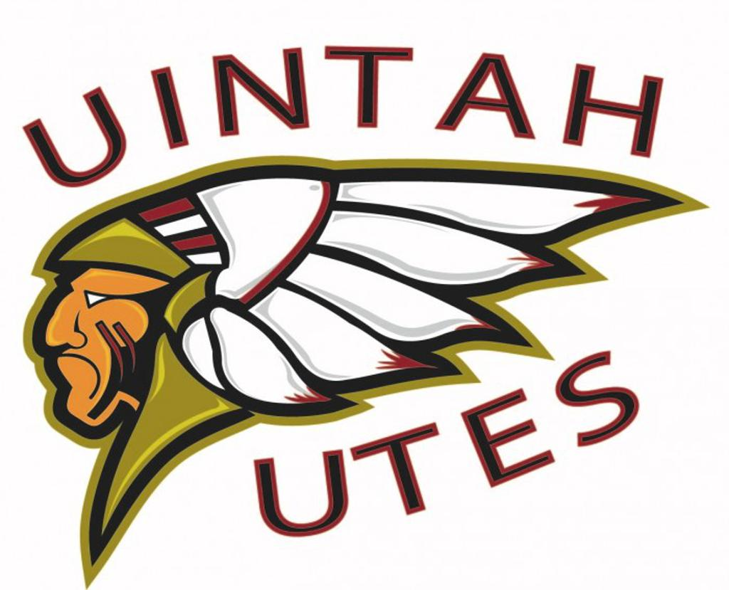
A.V.A.H.A.
ASHLEY VALLEY AMATEUR HOCKEY ASSOCIATION

Date: March 8, 2023
Time: 6:00 pm
Place: Uintah County Library, Upstairs Conference Room
Attendees: Stormie Trevizo, Cherei Miller, Denim Simper, Crista Gordon, Eric Gunter, Taryn Howcroft, Jody Howcroft, Morgan Richardson,
______________________________________________________________________________
NEXT MEETING

- Table Wreaths until April Board Meeting
- Table Social Media until April Board Meeting
- Table League Structure until April Board Meeting
- Minutes/Agenda’s Policy
- Rental Gear

MEETING MINUTES

- Crista researched how to make the minutes better and more efficient. She learned that all minutes need to be voted on for approval at the beginning of board meetings.
- Crista motioned to approve February’s Board Meeting Minutes.
  - Cherei Seconded.
  - Stormie aye
  - Eric aye
  - Crista aye
  - Cherei aye
  - Motion Carried. February’s Board Meeting Minutes were accepted and approved.

LEAGUE STRUCTURE
- UAHA is voting to take away D1 and D2. The levels will be replaced with something similar to D2 becoming house/rec and D1 becoming travel B.
- House/Rec will fall under the WRHL
- Travel will be governed by UAHA
- League Structure will have to be tabled until UAHA decides what they are doing. Table until April.

Team Managers
- A policy for training needs to be created. Stormie will take over team managers training and start putting together a policy.

TAPE RECORDING
- Crista asked to board to purchase a tape recorder to record meetings.
- By recording board meetings she can go back over and make sure all minutes are accurate.
- This will also allow for the Secretary to participate in meetings and not have to worry about missing information.
- The board agreed this would be beneficial.
- Crista motioned for the purchase of a tape recorder.
  - Eric Seconded.
  - Stormie aye
  - Cherei aye
  - Denim aye
  - Crista aye
  - Eric aye.
  - Motion Carried. Denim will be in charge of purchasing a tape recorder for the league.

COACHING
- A meeting needs to be set up for coaches.
- Messages need sent out via email, social media, and SportsYou.
- Coaching Director application and Coaching application need to be digitized. Crista will create a google doc for both.
- Coaching Meeting will be Monday, March 27, 2023.
  - Crista will schedule a meeting place.
- Eric will lead the meeting.

PICTURES
- Cherei will be incharge of pictures next season 23-24.
- Cherei suggested doing pictures at the very first of the season.
- Have groups come on days that they aren’t practicing. This way they don’t miss practice.

MINUTES & AGENDAS
- After finding this information on Park City’s website, it was suggested that AVAHA adopt this policy.

PCIM Board meetings are typically held on the 3rd Monday of each month, but the schedule is subject to change. The schedule is posted to the Events Calendar on the homepage.

Meetings are open to the PCIM community.

TO SUBMIT AN AGENDA ITEM/ DISCUSSION TOPIC

Please copy and paste questions below in an email, add responses, and send to the Board Secretary at stephanie.macdonald@pciceminers.org.

- NAME:
- PROPOSED AGENDA ITEM:
- PROPOSED MEETING DATE (OR FUTURE MONTH):
- PROPOSAL/ DISCUSSION TOPIC OR QUESTION:
- REQUEST FOR BOARD ACTION (IF ANY):
- Crista motioned to adopt Park City’s agenda items submission policy.
  - Stormie Seconded.
  - Cherei aye.
  - Denim aye.
  - Crista aye.
  - Eric aye.
  - Stormie aye.
  - Motion Carried. AVAHA will adopt Park City’s policy for members to add agenda items.
- Crista has been researching how to properly record minutes and agendas. During her research she has found when minutes need to be released. When board meetings need to be announced. What the state of Utah requires for closed door meetings, and other relevant information. Crista has requested that she can prepare a policy for the board to review in April and vote on to have a policy put in place.
- The board agreed. Crista will create a policy for Minutes and Agendas and bring it to April’s Board Meeting.

END OF YEAR
- AVAHA used to host an End of Year/End of Season dinner.
- Several members have asked about the end of year and why AVAHA no longer hosts it.
- It was canceled due to Covid in 2020 and it hasn’t been brought back. Team parties have been taking place of the End of Year/End of Season Dinner.
- Cherei motioned that AVAHA bring back the End of Year Dinner for the 2023-2024 season.
  - Stormie Seconded.
  - Denim aye.
  - Eric aye.
  - Crista aye.
  - Cherei aye.
  - Stormie aye.
  - Motion Carried. AVAHA will bring back the Year End Dinner next season 2023-2024.

GEAR, SUPPLIES, & REMODEL
- AVAHA needs more pucks for next season.
- Upstairs Room doesn’t close properly. AVAHA needs to inventory and possibly pack everything to move during the remodel. Cherei, Crista, and Stormie will inventory and pack. Crista will contact Toni and find out what she hasn’t already inventoried.
- AVAHA needs to look into the gear program and purchase gear. It should have opened in March. Taryn will get the contact information to a board member.

MITES IRON CUP
- 8U has asked for AVAHA to reimburse the Mite’s Iron Cup tournament. Totaling $1200.00.
- The 8U (Mites) have been to the following tournaments:
  - Steamboat-$600
  - Rock Springs-$620
  - Pinedale-$310
- Crista Motioned to reimburse the 8U parents for the Iron Cup Mite Tournament.
  - Cherei Seconded.
  - Denim aye
  - Stormie aye
  - Eric aye
  - Crista aye
  - Cherei aye
  - Motion Carried. Denim will reimburse the 8U parents the amount they paid for the Iron Cup Tournament.

TEAM MANAGER POLICY
- Jody asked the board to reconsider the team manager policy.
- There is concern that the current policy will limit the pool for volunteers.
- Cherei brought attention to the conflict of interest that spouses who hold positions as coaches and managers can be in.
- It was brought to our attention that UAHA also has a similar policy regarding this.
- Some coaches have also said that they feel more comfortable handling the conflict instead of team managers.
- AVAHA will re-evaluate this policy and others with the new board in place.

POLICY AND PROCEDURE
- It has been brought to the board’s attention that there is a policy to hold everyone other than the board accountable.
- A policy needs to be created for the board, to hold the board accountable.

COACHES RIGHTS
- Coaches should be able to remove/request parents to leave a practice if the parent is being disruptive. The coach/team manager should also communicate with the board if this happens so that the board can support the coach as needed.

MISC.
- Board Applications are due by March 17, 2023. Applications will close on this date.
- UAHA release new bylaws this year. As soon as the new bylaws are released Crista will post them to AVAHA’s website.
- Taryn urged the board to change the perception of the board. The board is viewed as a scary thing and AVAHA members should feel welcome to approach the board meetings and feel comfortable.

MARCH 21, 2023
- Board Candidates were introduced. The following candidates are running for the following positions:
  - Vice President: Ashleigh Lindquist, Sam Searle, and Walter Wootton.
  - Treasurer: Danielle Cipriano.
  - Fundraiser: Marilyn Erickson.
- Coaching Meeting will be held at the Ledge Stone at 6 pm on Monday, March 27, 2023.

MARCH 22, 2023
- It was requested that the board meeting for April be moved from April 12th to April 19th. Same time. Crista will see if she can get the library, if it is unavailable she will see if she can schedule the Ledge Stone.

MARCH 31, 2023
- Steve Picano contacted Missy to remind AVAHA about the UAHA Board Vote. Missy asked if we had anyone assigned to do this. Missy was assigned last year to cast AVAHA’s vote for UAHA Board. The board agreed to have Missy be the assigned person representing AVAHA again this year during the vote.

APRIL 4, 2023
- McKenzie asked for approval to drop rental jerseys off to be cleaned at West End Cleaners. All rental jersey’s have been returned and/or addressed. It will be $2.60 per pound to have them cleaned.
- McKenzie motioned to invest the money to have our rental jersey’s professionally cleaned to keep them nice and in good condition.
  - Eric Seconded.
  - Stormie aye.
  - Cherie aye.
  - Crista aye.
  - McKenzie aye.
  - Eric aye.
  - Motion Carried. McKenzie will drop the jerseys off at West End Cleaners.

APRIL 5, 2023
- CornHole on Ice.
  - Michelle asked if we were doing the cornhole tournament in August. The rink and beer garden are reserved if we do.
  - The board agrees that this is a good fundraiser and should be continued. Crista will create a flyer and start getting the word out. Michelle will get Crista the information she needs to get the word out.

APRIL 8, 2023
- Michelle proposed a budget for thank you gifts to our sponsors. The budget is as follows and will allow AVAHA send thank you gifts to our banner, board, and ice sponsors.
  - Banners, Thank you notes-$15
  - Boards-$270
  - Ice-$325
- Michelle motioned to purchase thank you gifts for our sponsors.
  - Eric Seconded.
  - Stormie aye.
  - Crista aye.
  - Michelle aye.
  - Eric aye.
  - Motion carried. Michelle will get thank you gifts together and get them to our sponsors.

