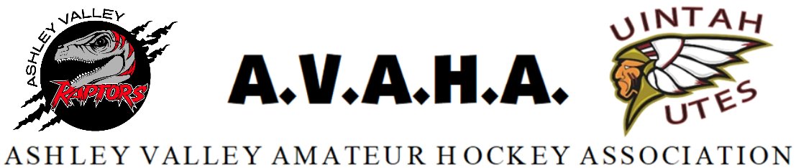

Meeting Minutes
Date: 8/6/2024

Time: 6:00pm *** Closed door session 5:30-6:00***

Place: Uintah County Library

The following are current officers for AVAHA Board of directors:
(*Names crossed out were not present)
President: Walt Wooton | Vice President:Kyle Fuller | Secretary:Morgan Richardson
Treasurer:Danielle Cipriano | Registrar:Cherei Miller | Safe Sport:Shannon Uasilaa
Fundraising:Ari Smuin (by phone)
Additional Attendees: none

**a closed door session with the board started at 5:30 and went until 6:00** Open door meeting began at 6:00pm. No motions were made or carried.

Last Meeting follow up:
- Motion to approve June board minutes- seconded and approved without dissent.
New Business:

UAHA sent out their membership agreement to the associations in the state to sign. There was discussion about the financial reporting. It was agreed upon that the new wording of the agreement was rephrased better than the last agreement that was sent to AVAHA. There was also discussion about the requirement to only play in sanctioned events and games as per USA Hockey. The members decided to reach out and get some clarification.
- Motion to sign agreement with UAHA after final clarification on sanctioning of opponent teams was seconded and carried without decent.

Tryouts for the travel teams were discussed. AVAHA plans to hold tryouts the second week of September as long as there is ice available. There was discussion to have a coaches meeting before tryouts to discuss ideas and format of tryouts. It was mentioned that the tryouts need to run oldest to youngest as to allow any players who are possibly playing up to tryout. It was decided that if someone doesn’t attend tryouts they will be placed on the Travel B team. A parent meeting will need to happen prior to tryouts. We will look to schedule this the first week of September. After tryouts the coaches of Travel B teams will have the discretion to add players to their rosters up until the USA Hockey deadline in December. There was discussion about how to handle the tryout process. Cherei offered to present some ideas from other associations to Kyle and coaches involved.

A revision of the Play-up Policy was presented to include players needing to be approved by coaches and then attend a tryout before they are placed. It was also added that roster numbers need to be considered before moving players up in any age group.
- Motion to approve the revision to the Play up Policy was seconded and carried without dissent.

Ari gave an update on the Cornhole Tournament coming up this Saturday. It was said we would like to have more items for the live auction event.
- Motion to approve $1000 more for the Cornhole budget was seconded and passed without dissent.

In the past AVAHA has used an unwritten rule that any board member needing to spend less than $100 could be approved without a vote if a receipt is presented to the treasurer. The members agreed to keep this unwritten rule for the season.

Coaching gifts were discussed and suggestions on gift ideas were presented. Some items brought up were blankets, cups, coolers, gas or restaurant cards and hoodies. The board agreed to discuss further into the season but to gather sizes for coaches and managers to order hoodies for them with the raffle registration order. It was also presented that board members can buy the hoodies at cost in the same order.

Cherei brought up pictures for the league and if AVAHA wanted to do anything different this year. It was agreed that Cherei would look into options and would handle the details of that.

Section Reports:
Coaches-nothing to report

Managers-nothing to report

Safesport-Shannon will reach out to Wendy and request a letter that was sent.

Treasury-nothing to report

Fundraising-sponsorships need to get sold, Ari has called many companies. New ideas were given and recorded in the spreadsheet.

Western Park-AVAHA would like to move the items in the storage unit to the Western Park building ASAP in order to stop paying for storage. We will try to be out before the end of August. Western Park is working on getting us keys to the upstairs room.

Open floor: Nothing to report

