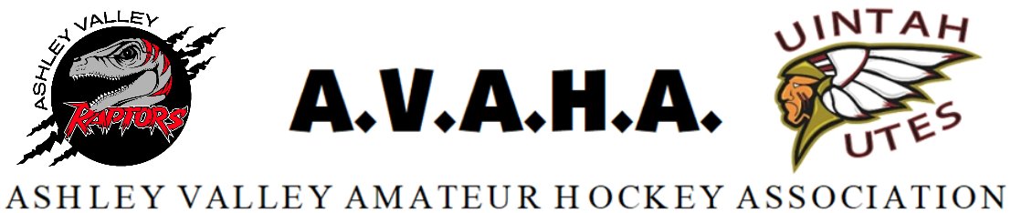

Meeting Agenda
Date: 10/22/24

Time: 5:30pm

Place: Western Park- party room
The following are current officers for AVAHA’s Board of directors:
President: Walt Wooton | Vice President: Kyle Fuller | Secretary: Morgan Richardson
Treasurer: Danielle Cipriano | Registrar: Cherei Miller | Safe Sport: Shannon Uasilaa
Fundraising: Ari Smuin
Greeting and introduction………………………………………………………………………………………………..President

Last Meeting follow up:
Approval of September board meeting minutes……………………………………………………Morgan
Old Business:
Website/Messaging platforms………………………………………………………………………………..Morgan
RMHS………………………………………………………………………………………………………………………Shannon
New Business:
Stick holders…………………………………………………………………………..……………………………………..Kyle
Tryouts………………………………………………………………………………………………………………………….Kyle
Men’s league……………………………………………………………………………………………………………Danielle
UAHL…………………………………………………………………………………………………………………..……Morgan
Tournament…………………………………………………………………………………………………………….Morgan
Section Reports:
Coaches
Managers
Safesport
Treasury
Fundraising
Western Park

Open floor:
Help keep the promise to hold the meeting to ONE HOUR!
Please be prepared, stay informed, and stay on topic.
If you have a problem, propose a solution.

