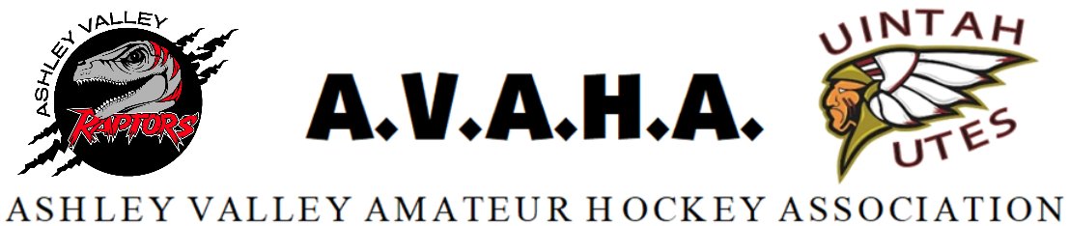

Meeting Agenda
Date: Nov. 13th

Time: 5:30pm

Place: Google Meet https://meet.google.com/gno-zpao-wdk?authuser=0
The following are current officers for AVAHA’s Board of directors:
President: Walt Wooton | Vice President: Kyle Fuller | Secretary: Morgan Richardson
Treasurer: Danielle Cipriano | Registrar: Cherei Miller | Safe Sport: Shannon Uasilaa
Fundraising: Ari Smuin
Greeting and introduction………………………………………………………………………………………………..President

Last Meeting follow up:
Approval of October minutes
RMHS update……………….………………………………………………………………………………………Morgan
Crossbar meeting…………………………………………………………………………………………………Morgan

New Business:
Logo sharing……………………………………………………………………………………..…………………Cherei
Tournament Banners…………………………………………………………………………..……………..Morgan
Volunteer hours…………………………………………………………………………………………………..Danielle
Section Reports:
Coaches
Managers
Safesport
Treasury
Fundraising
Western Park/Scheduling
Utah Meeting/UAHL
Registrations

Open floor:
Help keep the promise to hold the meeting to ONE HOUR!
Please be prepared, stay informed, and stay on topic.
If you have a problem, propose a solution.

