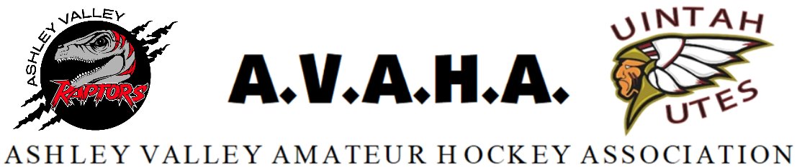

Meeting Agenda
Date: September 3rd, 2024

Time: 5:30pm

Place: USU-Vernal upstairs conference room Room 221R
The following are current officers for AVAHA’s Board of directors:
President: Walt Wooton | Vice President: Kyle Fuller | Secretary: Morgan Richardson
Treasurer: Danielle Cipriano | Registrar: Cherei Miller | Safe Sport: Shannon Uasilaa
Fundraising: Ari Smuin
Greeting and introduction………………………………………………………………………………………………..President

Last Meeting follow up:
Approval of August meeting minutes……………………………………………………………………Morgan

New Business:
Practice time for 14u/House league…………………………………………………………………………..Cajun
Roster numbers Team plans…………………………………………………………………………………….Cherei
RMHS………………………………………………………………………………………..…………………………….Shannon
Coach meeting / locker rooms………………………………………………………..………….………..Shannon
Scheduling………………………………………………………………………………………………………………Morgan
Website/Messaging platforms……………………………………………………………………………….Morgan
Parties……………………………………………………………………………………………………………………Danielle
Tryouts……………………………………………………………………………………………………………….Kyle/Cherei
Oilers……………………………………………………………………………………………………..……..Mitchel Knight
**closed door session@ end of meeting*****
Section Reports:
Coaches
Managers
Safesport
Treasury
Fundraising
Western Park
Open floor:
Help keep the promise to hold the meeting to ONE HOUR!
Please be prepared, stay informed, and stay on topic.
If you have a problem, propose a solution.

