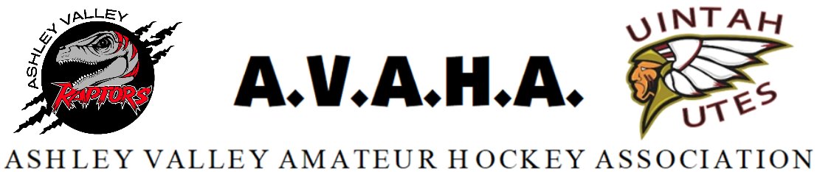

Meeting Agenda
Date:

Time: Meeting was skipped for Dec and items put on Jan.

Place:
The following are current officers for AVAHA’s Board of directors:
President: Walt Wooton | Vice President: Kyle Fuller | Secretary: Morgan Richardson
Treasurer: Danielle Cipriano | Registrar: Cherei Miller | Safe Sport: Shannon Uasilaa
Fundraising: Ari Smuin
Greeting and introduction……………………………………………………………………………..President

Last Meeting follow up:
Approval of November meeting minutes………………………………………………………………..Morgan
New Business:
End of year Banquet………………………………………………………………………………………………Danielle
Section Reports:

Coaches
Managers
Safesport
Treasury
Fundraising
Western Park/Scheduling
Utah Meeting

Open floor:
Help keep the promise to hold the meeting to ONE HOUR!
Please be prepared, stay informed, and stay on topic.
If you have a problem, propose a solution.

