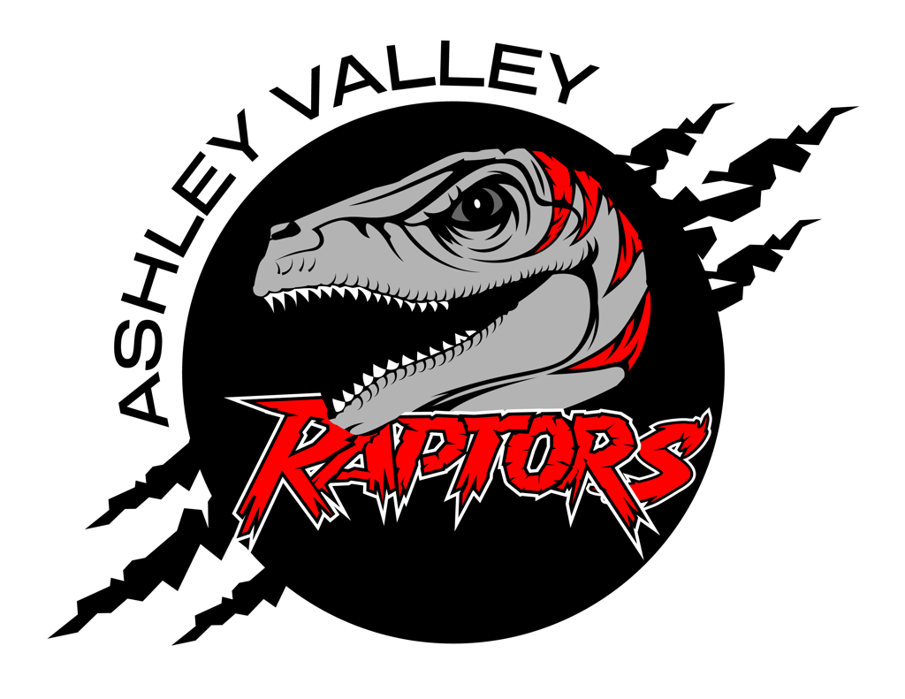

A.V.A.H.A.
ASHLEY VALLEY AMATEUR HOCKEY ASSOCIATION

Date: January 8, 2024
Time: 6:30 pm
Place: Ledge Stone Conference Room
Attendees: Missy Huber, Michelle Stearns, Cherei Miller, Crista Gordon, Stormie Trevisio, Walt Wootton
______________________________________________________________________________
NEXT MEETING: 2/12/2024

OLD BUSINESS

NEW BUSINESS
- UAHA Board Meeting: Zoom -7:00-8:15
- Mite Jam: Michelle 8:15-8:25
- League Declaration: Crista 8:25-8:30

