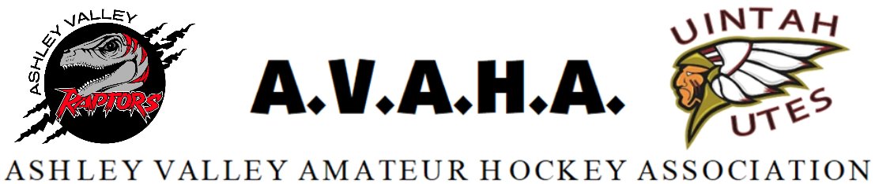

Meeting Minutes
Date: 9/4/24

Time: 5:30pm

Place:USU-Vernal

The following are current officers for AVAHA Board of directors:
(*Names crossed out were not present)
President: Walt Wooton | Vice President:Kyle Fuller | Secretary:Morgan Richardson
Treasurer:Danielle Cipriano | Registrar:Cherei Miller | Safe Sport:Shannon Uasilaa(zoom)
Fundraising:Ari Smuin
Additional Attendees: Cajun Laub

Greeting and introduction…………………………………………………………………………………………..President/VP

Last Meeting follow up:
- Motion to approve August board minutes- seconded and approved without dissent.

New Business

Cajun Laub the 14U coach was concerned about sharing ice with the house league for skill and safety reasons. It was mentioned that it was minimal and the majority of the time the 14U team would still have full ice, not sharing with other teams as the rest of AVAHA. However it would benefit that team to move if they could. There was some available ice time on Tuesday at the same time that last season was used for clinics put on my Ryan Howse. It was decided to move the 14U there and keep the house team on Mondays at 3:45pm. When the house league is not playing AVAHA will use it for stick and puck.

The board took a phone call from Western Park and reminded us to please let them know anytime we schedule something there. During the meeting AVAHA had volunteers making ice and checking out gear at the rink at the same time. Western park is hoping we would have ice next Monday but there could be hang ups.

Ari needed to step out to get to the rink for banners.
There was discussion about who we have for coaches over the teams. It was discussed that because of the lack of willing head coaches, the coaches' players would be given priority to the roster of that team in order to support them. Until tryouts it would be hard to know but we should be covered. Because of the numbers at the time the 10u and the 12u will need to be split. It was discussed that we could do a tryout and only permit one team but AVAHA doesn’t want to deny kids who want to play travel.

Our current scheduler is moving to another association. It was discussed about different options about how to handle the scheduling and who would be a good fit. It was decided that AVAHA needed someone within the league and going to board meetings regularly to know any changes happening in the association. Morgan offered to schedule if needed but would need to take a step back from the secretary duties other than taking minutes if doing both jobs. Shannon will take over the managers.

The board decided to put it out to the league and find someone who would be willing to take this on for 4 years plus, and will have a strong commitment to the job. We will open it as a position to apply for when the board positions come up. The board would vote them in versus the league because it is not a voting position on the board.

Danielle will be getting taxes done this month and edit our budget.
Danielle brought up team parties. In the past AVAHA had a league wide end of year party. When Covid hit they switched to individual team parties. The league would like to go back to that and give the managers a lower budget. AVAHA will cover coaches' gifts as a whole and managers can use the funds on the players. $250 per team with an end of year banquet as a league. Daneille will plan the banquet.

Tryouts were discussed and it was originally planned to hold them next week, but because of the ice situation it needed to be pushed one more week. September 16-17th for 12u and 18-19th 10U. 14U will be one team. 8U can start September 23rd no tryouts needed. Cherei will get approval from Robyn, the state registrar, to push our September 15th deadline. Morgan will print the evaluation papers. Kyle will finalize all tryout plans. We will reach out and try to find a neutral party to help with tryouts. The board decided to go through all tryout evaluation sheets to approve them before rosters are put out.

Danielle needed to step out.

Morgan proposed that we don’t allow parents into tryouts because players perform better when parents aren’t around. Kyle was concerned the parents wouldn’t see the performance of all players. It was discussed that we could keep them back away from the glass so they weren’t as distracting. Morgan will add it to the chat for more board members to have input, as some needed to leave.

Cherei brought up the Oilers wanting our players to participate in their pre games and intermission events of their games. It was also suggested to them that they replace the sponsorship program with individual players and replace it with a clinic they put it on. The board agreed this would all be good changes.

Because of time restrictions and board members scheduled some items were table until the next meeting.

RMHS with Shannon will be tabled.
Website/Messaging platforms with Morgan will be tabled.
Fundraising ideas will be added to the October meeting it was tabled from August.

Open floor:

None

Meeting adjourned.

