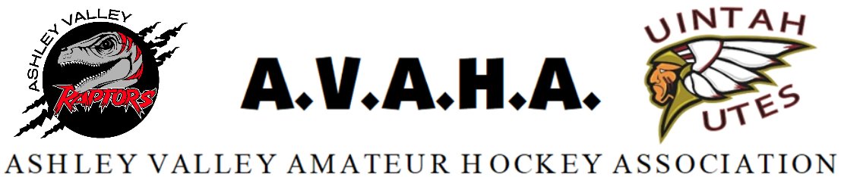

Meeting Minutes
Date: 11/13/2024

Time: 5:30pm

Place: Google Meet

The following are current officers for AVAHA Board of directors:
(*Names crossed out were not present)
President: Walt Wooton | Vice President:Kyle Fuller | Secretary:Morgan Richardson
Treasurer:Danielle Cipriano | Registrar:Cherei Miller | Safe Sport:Shannon Uasilaa
Fundraising:Ari Smuin
Additional Attendees:
none
Greeting and introduction……………………………………………………………………………..President/VP

Last Meeting follow up:
- Motion to approve October meeting minutes-seconded and approved without dissent.

Morgan spoke with Rocky Mountain Hockey School to come to Vernal for a league wide clinic Jan. 6th-9th. This will be paid for by AVAHA and have no additional fee to parents. AVAHA will try to get more ice from WP to give more clinic time to players and coaches. There will be 2 coaches coming to the clinic and consultation.

Morgan met with Crossbar again, and Sports Ninja is still emailing us and promising their individual registration will be included in their platform. UAHL is still looking into Gamesheets, which works seamlessly with Crossbar. However if they don’t pay for Gamesheets we will lean more toward Sports Ninja as long as they get their individual registration up and running before we commit.

New Business:

Cherei brought up the league sharing the logo with people. She mentioned the previous board that originally switched the logo, did so because the logo was lost and getting distorted. People also were not ordering items from the store and going elsewhere which AVAHA doesn’t get a kickback from. It was discussed and decided to try to keep the logo to vendors only from now on. Some members have the files already, but keeping it to vendors from now on will help slow the spread of it.

Morgan brought up remaking the old state champions banners that were lost, in the remodel of the rink. AVAHA needs to decide if they do that will they remake all the tournament banners from tournaments so they are uniform or do they just hang what they have been given and can find. Western Park plans to hang these over the ice with a wire. It was decided to give WP what we have and get a quote to decide if we should remake the lost ones.

A parent was asking if student coaching can count toward volunteer hours. The board discussed the topic and it was decided that volunteer hours should come from parents themselves. Student coaching is more of a privilege and there are many volunteer opportunities that we need adults for. Student coaching will not count towards a family's volunteer hours.

Danielle brought up renewing the insurance, Walt will check the email and get it signed and sent back.

Kyle updated the board on the house league. The first day was pretty chaotic but now that parents are getting in the routine it is getting better. There should be more coaches getting certified soon that will be able to help on the ice soon. There are a variety of skills in this group and it has been a challenge to coach to the players' needs when there has been a shortage of coaches. The numbers have shown the in house was a need for the community.

There is still a need for a manager for the older in house group. Some parents have reached out but they haven’t got their USA hockey numbers and safesport yet to Cherei.

Danielle is going to check with the accountant about why the taxes haven’t been filed.

UAHL is talking about doing an end of year state tournament. It will be $500 per team which is a cheap tournament. However, some games may be during the week. Vernal is not sure if we will participate in it this year as most of our schedules are already set. Morgan will try to gain more info on their plans and then decide.

Danielle was asking about plans for our fundraising profits. Some teams are not doing as many tournaments as others but they are still doing the same amount of fundraising. She was asking for ideas if AVAHA wanted to do something extra for the teams that don’t have as many tournaments but are contributing. It was suggested to give those teams an extra ice time with the RMHS clinic if time slots allow.

Walt brought up a player/parent that was asking the board about ADA accommodations. After conversations with the coaches, and USA hockey/Utah hockey, it was decided that these accommodations can not be made for a Travel A or B team player. If the player requires a less committed option the player can move to the in-house team.

Open floor:
None

Meeting adjourned.

