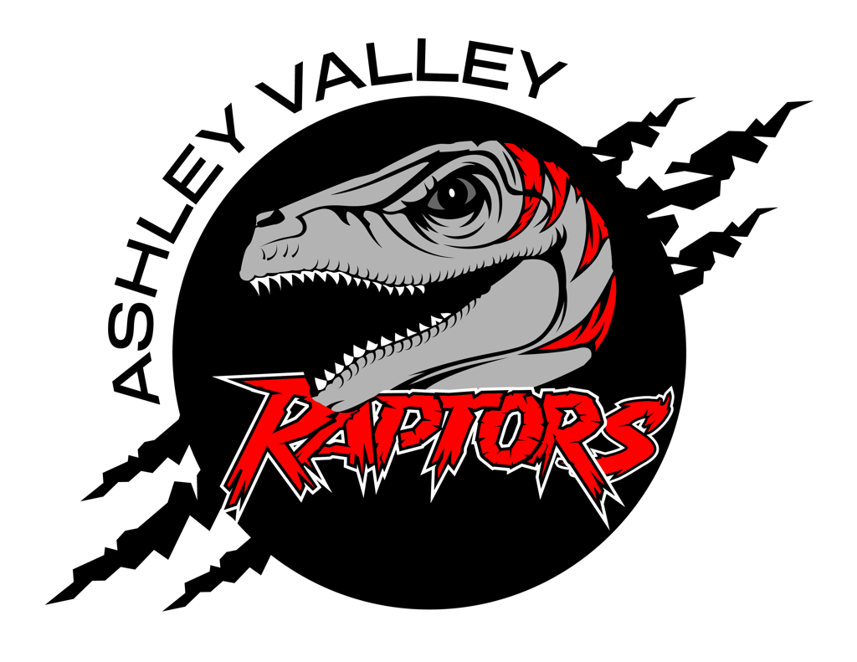

A.V.A.H.A.
ASHLEY VALLEY AMATEUR HOCKEY ASSOCIATION

Date: February 19, 2024
Time: 6:30 pm
Place: LedgeStone Hotel Conference Room
Attendees: Missy Huber, Danielle Cipriano, Stormie Trevizio, Crista Gordon, Cherei Miller, Walt Wootton, Michelle Stearns
______________________________________________________________________________
NEXT MEETING: March 11, 2024

OLD BUSINESS
- Approval of all Minutes to date: Crista - 6:30 to 6:40
- Utah Member Agreement - 6:40 to 6:50
NEW BUSINESS
- Finances: Danielle - 6:50 to 7:00
- Learn to Skate/House Rec - 7:00 to 7:10
- Board Elections: Crista - 7:10 to 7:20
- Future Board Position: Danielle - 7:20 to 7:30
- Ref Pay: Danielle - 7:30 to 7:40

