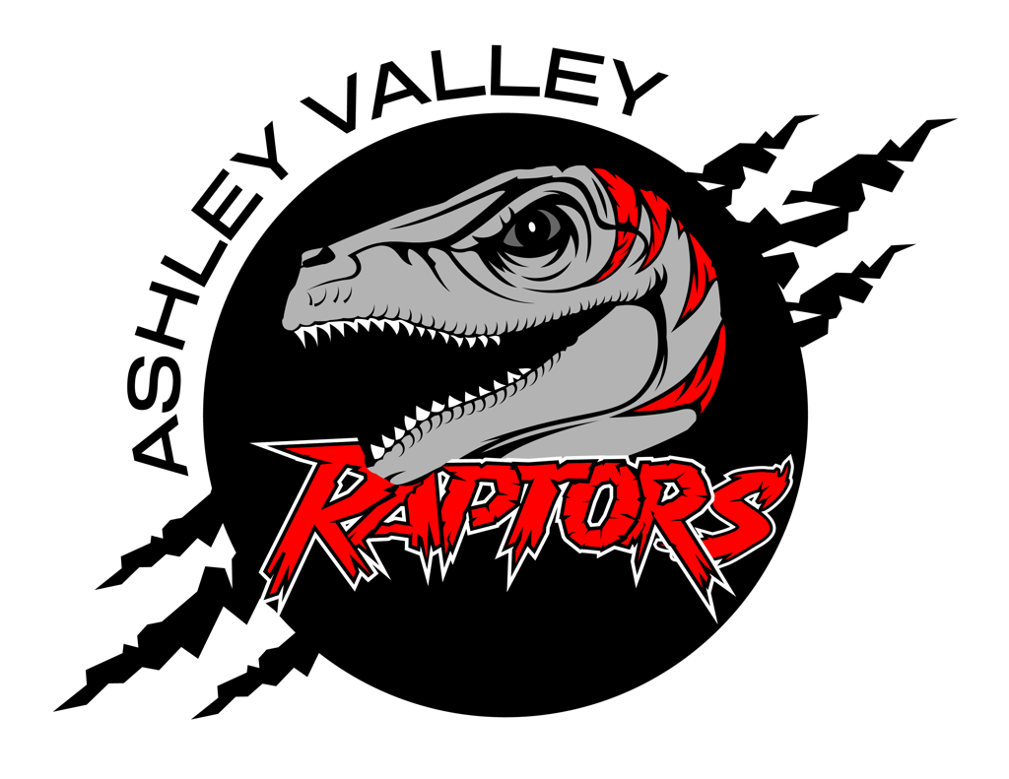

A.V.A.H.A.
ASHLEY VALLEY AMATEUR HOCKEY ASSOCIATION

Date: MAY 10, 2023
Time: 6:00 pm
Place: UINTAH COUNTY LIBRARY, UPSTAIR CONFERENCE ROOM
Attendees: ERIC GUNTER, CRISTA GORDON, CHEREI MILLER, DANIELLE CIPRIANO, JACK CIPRIANO, WALTER WOOTTON, MARILYNN ERICKSON
______________________________________________________________________________
NEXT MEETING: JUNE 12, 2023

NEW BOARD 2023-2024
- Welcome to the new board members. The official AVAHA board for 2023-2024 season is as follows:
  - President - Eric Gunter
  - Vice President - Walter Wootton
  - Secretary - Crista Gordon
  - Treasurer - Danielle Cipriano
  - Registrar - Cherei Miller
  - Safety - Stormie Trevizo
  - Fundraising - Marilyn Erickson

YOUTH COORDINATOR
- The Vernal Oilers are bringing in a new assistant coach from Canada.
- He wants to relocate and make Vernal his long term home.
- The following was presented to AVAHA for the opportunity to hire him as the programs youth coordinator.
At the meeting in March, it was discussed to hire a Youth Coordinator. We all thought it was a good idea if the right person came along. The Oilers have hired a coach that plans on making Vernal his home town. He wants to move to the Basin. The Oilers hiring him gives AVAHA a unique teaching opportunity. As a board could you please discuss the following:
Hire Oilers Coach for 20 hours a week. He reports directly to the President of AVAHA. His duties would be the following.
Help Coaches as needed with practice plans.
On ice with each team a minimum of once a week (includes the high school and JV teams).
Fill in for practices or games as needed if a Coach is not able to be at the scheduled event. If there is a conflict, the Oilers schedule is his priority. AVAHA to reimburse traveling expenses per our league procedure if needed.
This is the pay information I was able to find for a Hockey Coach, Coaching Director, etc. There wasn't a lot.
Zip Recruiter $18.86 an hour
Salary.com $21.23 an hour
Comparably.com $16.85 an hour
Indeed (Provo) $16.50 an hour (no on ice is included in this amount)
Averages out to be $18.36 an hour.
Proposed 20 hours a week beginning mid September and ending mid March 24 weeks.
Cost to league $7344.00
Last year the league paid Jonathan Cosman $5000.00 to come to Vernal at put on a skills clinic. We charged our players $100.00 to participate. We pay the Oilers Coach to put on a clinic like Jonathan Cosman did last year. If 75 players participate that is $7500.00.
Pay the Coach $5000.00
Ice time 20 hours $1200.00 We already pay this ice time. We might as well get some good use out of it.
This leaves the league with $1300.00 to help offset the cost of paying for the coach. More if we have more than 75 players participate.
If the board decides that this is the route to go and take advantage of this opportunity, we should have a written contract in place to protect both parties.
Please let me know your thoughts. I would like to add this to the May agenda if possible.
- The coach is highly qualified
- He would also love to run clinics for AVAHA.
- He wants to help AVAHA players grow and flourish.
- Eric will print out the information so the incoming board can go over the information.
- The Board will discuss and make a decision at the June 2023 board meeting.

REIMBURSEMENTS
- Danielle will get a total cost together, so AVAHA can reimburse coaches.
- Crista will get Danielle the list of volunteers so they can get reimbursed as well.

EVENTS/FUNDRAISING
- CORNHOLE
  - Corn hole is a go. Crista will forward all the information she has to Marilynn.
  - Corn Hole is August 12, 2023 at the Western Park.
- REGISTRATION RAFFLE
  - The item we will raffle this year is a Black Stone duel grill with air fryer.
  - Stormie will still take charge on the registration raffle.
- PARADES/COMMUNITY
  - AVAHA needs to be out in the community helping and supporting it.
  - We need to be an active part of our community.

COMMUNICATION
- SportsYou will remain our official communication app.
- Crista will set up a new group for the board on SportsYou.

BOARD MEETING
- Eric proposed that we change the board meeting day.
- This would give the opportunity for others to attend that can’t usually attend.

P&P’s
- Crista will email p&p’s to the board members.
- The board will start discussing the upcoming p&p’s for the 2023-2024 season in June.

AVAHA Board is a Board of 7

BANTAM PRACTICE
- As the scheduler, Missy needs to be involved in this discussion.
- Eric suggested having a meeting with Western Park to discuss ice times.
- Missy’s hands are tied. She does what she can with the ice time she is given. She gives her best and does a really good job managing our schedule.

June board meeting will be… to be determined. Eric will get with Missy and see when she can meet since we need to discuss the upcoming schedule for AVAHA.

Crista look into the interview process. See what we need and don’t.

MAY 12, 2023
- Cherei was approached by Dinosaur Roundup Rodeo. There is an opportunity for AVAHA to sell food/have a food truck at the rodeo on the east side.
- The vendor they originally had fell through and they are looking for one.

MAY 22, 2023
- Eric was approached by Sam Searl about gaging the interest in a tournament/travel team for the 12U and 14U teams.
- There is interest from a potential coach, as per usual they may be looking to reimbursed for their time and expense.
- AVAHA has never discussed a paid coach from a travel/tournament perspective.
- Is there interest for this?

MAY 30, 2023
- Inperson meeting with Missy
  - The schedule has very little wiggle room.
  - AVAHA has Tuesday stick and puck that could be looked into shifting.
  - Eric wants to go to Western Park and have a meeting to discuss somethings with them.
  - AVAHA pays a really good price per hour for ice time. Most associations have to pay double that if not more.
  - AVAHA’s at home tournament is in FEBRUARY
  - Coach Incentive: It is difficult to find coaches.
  - AVAHA has to have a set schedule.
  - Danielle is going to take a crack at looking at the schedule and see if we can gain some wiggle room. Stipulations:
    - We can’t cut into Western Park’s time.
    - We can’t displace another team
    - We can’t move a team just to benefit another team.
    - We can’t take another team's practice time.
- Tournament/Travel Team
  - UAHA had all travel teams have their tryouts by the end of May. A list has to be submitted by June 6th, it is believed.
  - The deadline for tryouts is past.
  - A tournament team would basically be a D1 team and go to 2 extra tournaments.
- Put on June Board Agenda- AVAHA needs to have away tournaments schedule set by August.
  - Possible tournaments:
    - The Grizz Cup - MLK weekend
    - My Hockey Gold Medal Games - Dec. 1-3

MAY 31, 2023
- Guy Collett was contacted. AVAHA is down for the concessions at the Rodeo.
  - Guy advised selling more snack type foods:
    - Nachos, popcorn, chips, cotton candy, ect.

