Team Staff Tips and Tricks
As a team staff member, you have access to helpful & efficient features on your organization's website and within the Crossbar Mobile app. These features include: Email & App Messaging, Event management, Team Contacts, Event Assignments, Player RSVP's & Attendance, & more.
Communication from the Mobile App:
- Team Chat: The Team Chat feature is a great place to communicate with your whole team from the Crossbar Mobile App. Sending messages in the Team Chat will send to all player and parent devices. Team Chat's will not show on the Team Feed on the website.
- Emailing from the Mobile App: On your Roster page for your Team in the Mobile App, you can choose to Email your Team. Here, you can choose to email individual families, your team staff, or everyone on the team. When sending this message, you can also choose to send the message in the Team Chat, ensuring folks on your team receive the note in both places.
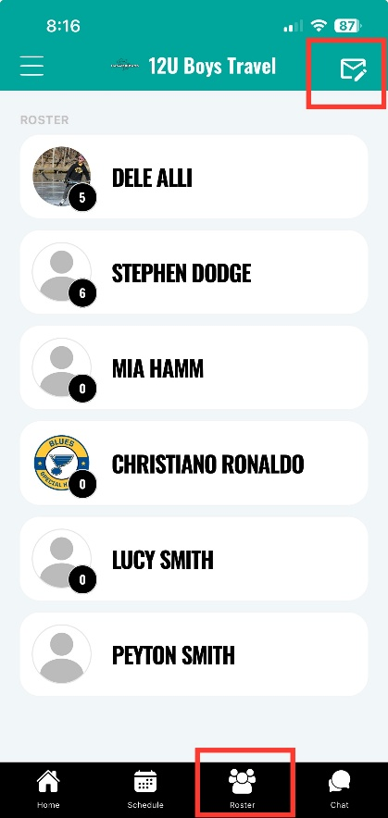
Ensuring Notifications Set Up for Parents & Players
- From the app, select Notifications, and follow the redirect to the Site where you'll select "All Events" from the Mobile Notifications dropdown
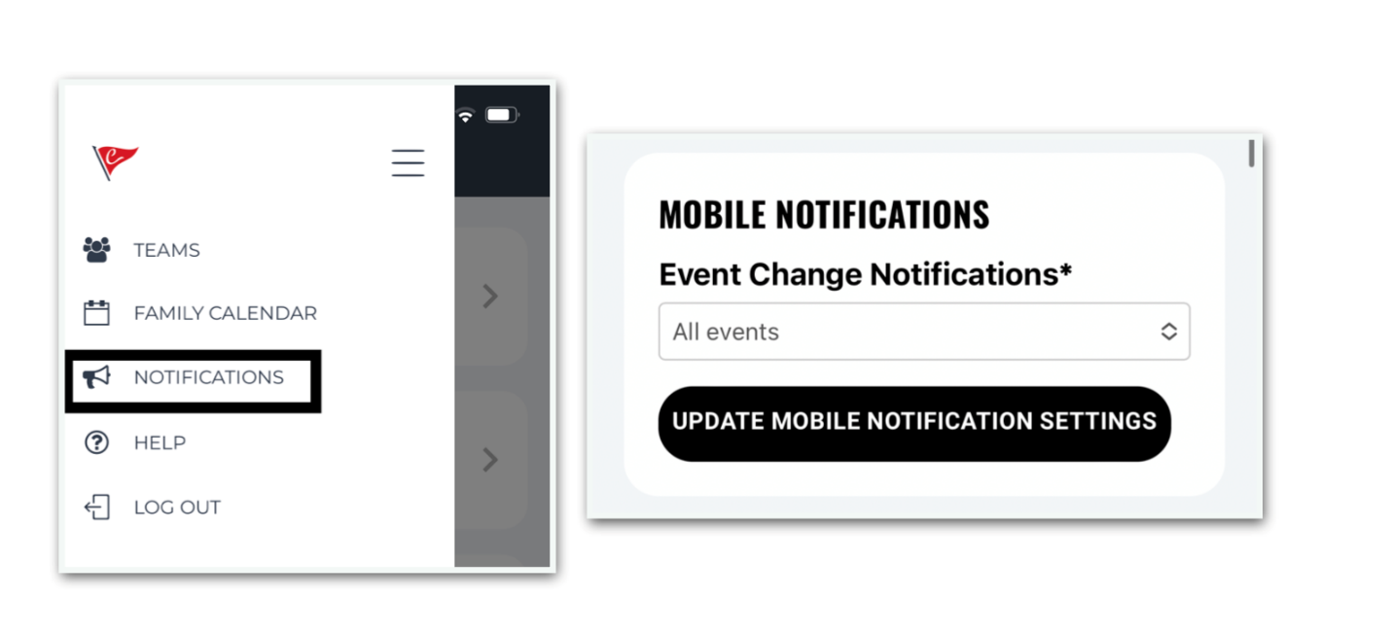
Communication from the Site:
- On your Team Page, the "Team Feed" is the best place to email all players and parents.
  - Team Feed posts will prompt emails that individuals can respond to, but the Team Feed posts will not also post in the App's Team Chat.
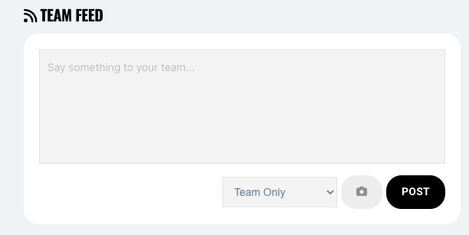
- Parents set their own Email Preferences under their Account on the Site and under "Settings" on the Team Page.
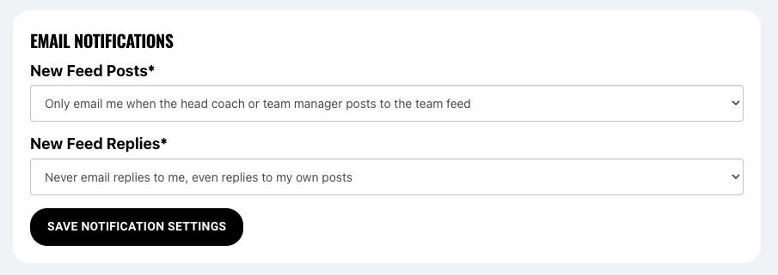

Calendar & Events:
- Viewing the Schedule:
  - From your Team Home Page
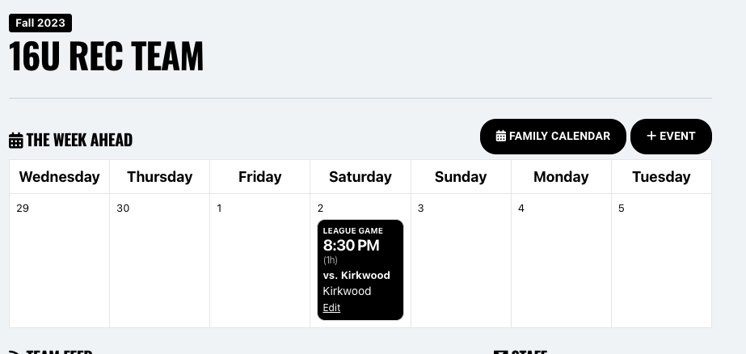

- The Schedule Tab on your Team Page
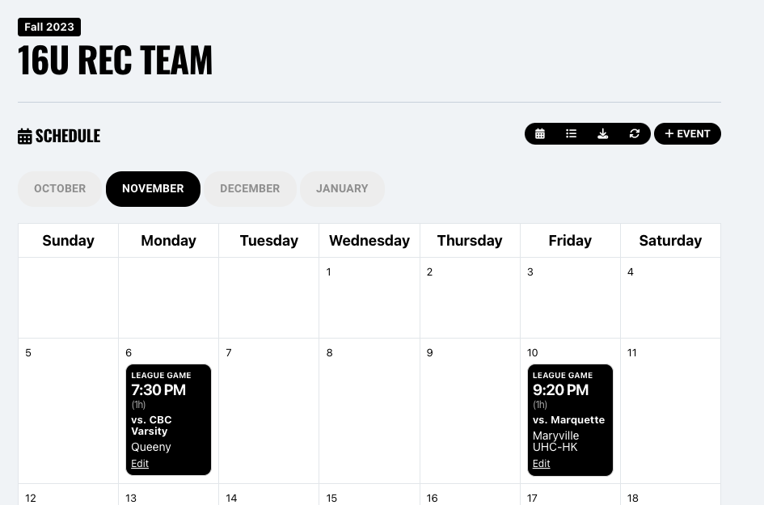
- Games Tab on your Team Page
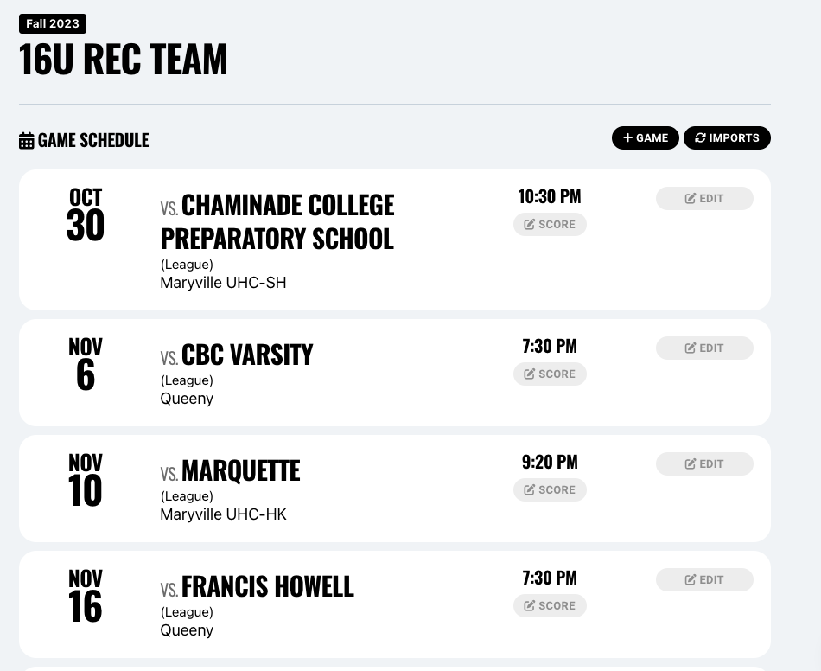
Adding Events:
- Events can be added by Team Staff on your Team Page by selecting “+Event.” This will allow you to add Games, Meetings, Practices, or Other events.
- When adding events, the system will ask for a location and will attempt to pre-fill the address with information from Google; this can be overridden for events that with TBD details, and you will be able to edit those details for the event when the details are available (helpful for tournaments).
- When adding Home Games, the “Date & Time” drop down will give you options to convert times your club Scheduler has assigned to you as Practice into Games on that home ice.
- Once added, Events can be edited to fill new information or cancelled from the schedule. If swapping assigned times with other teams, it is important to confirm with your club’s scheduler to be sure the space assignment is updated, which will update the Team Schedule with the changes.
Player Availability:
- There is an option to enable Availability tracking for players; players/parents are the only ones who can update their Availability status for each event.
- The feature is on a team by team basis, and it can be enabled by going to the Team Page -> Settings -> Select "Enable Availability"
  - Parents & players will be notified that you have enabled this feature.
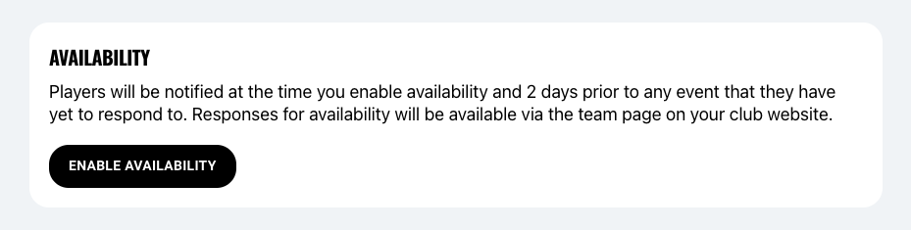
- Once enabled, the Availability Tab on your left menu will allow you to see who has responded for each event.
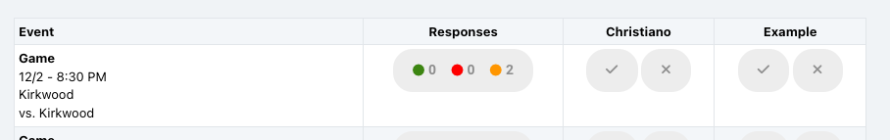

Player Attendance:
- To track attendance in the app, your team staff should first enable this setting under their Team Page > Settings:
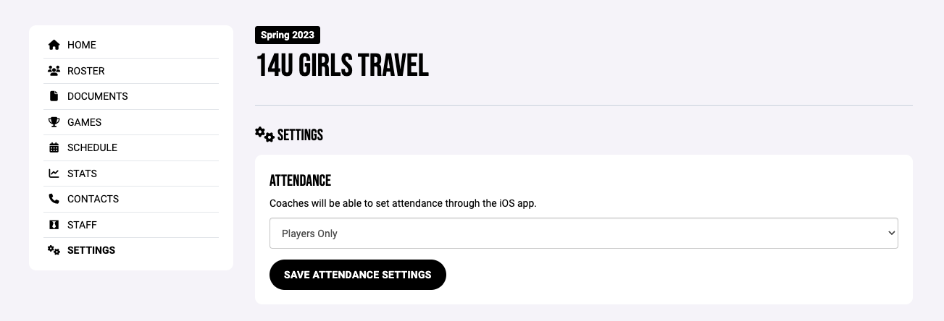
- This can be enabled by Staff or Team Staff on the team page.
- Once enabled, after a game or practice is completed, you can report the attendance for that event:
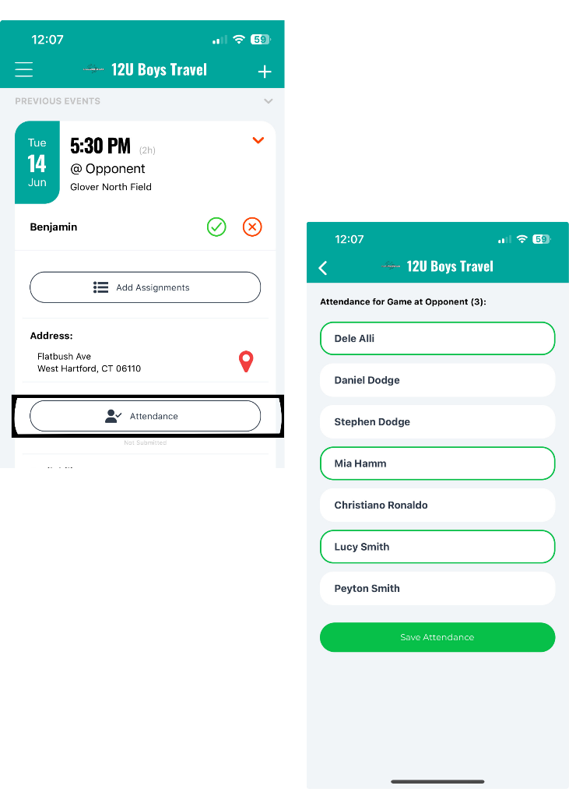
Jersey Numbers:
If your player numbers are assigned per season, you can add those directly to your team roster. For instructions to do so, click here!
Your Contact Information:
- When you accept the invitation to join your team as a staff member, you'll see the below message:
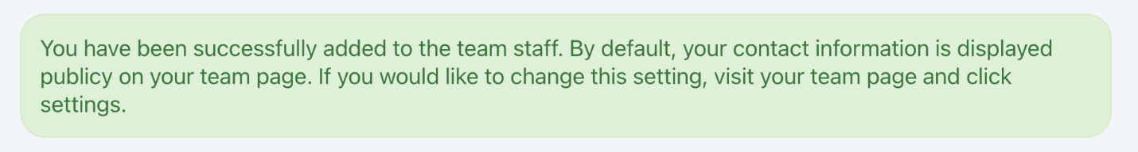
- If you need to update your privacy settings, please navigate to your Team Page > Settings, where you can control what contact information is displayed on your team page:
