Player Statistics

If you're interested in tracking your players' statistics throughout the season, your Crossbar site has a tool to help! The option to use Player Stats can be enabled for each team by site administrators or team staff on the Team Page under "Settings."
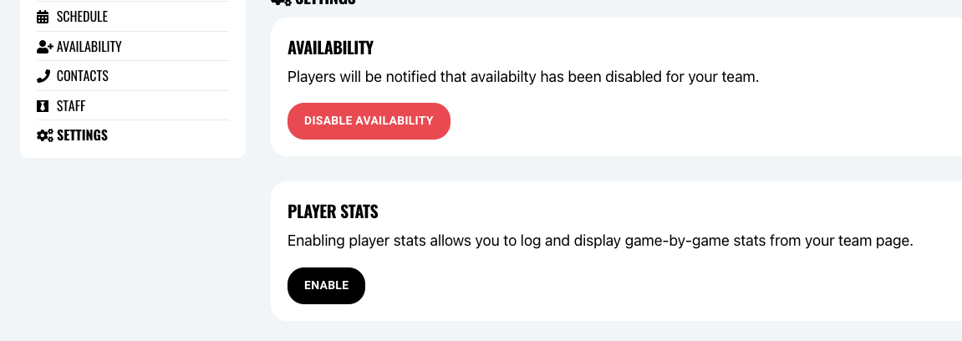
*Note: if you do not see the option to "Enable" Player Stats under your Team Page Settings, please reach out to the YLM site administrator, who will be able to adjust that option in the Program Settings of your Registration Dashboard.
After you've enabled player stats on your team page, you'll be able to configure the statistics to ensure you track only the statistics meaningful to you and your team.
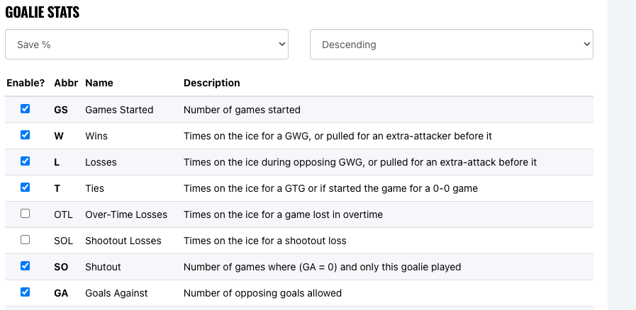
Once configured, Player Stats are entered through games played on your team's schedule.
After each game is over, the Edit Score option will show for that Game on the schedule:
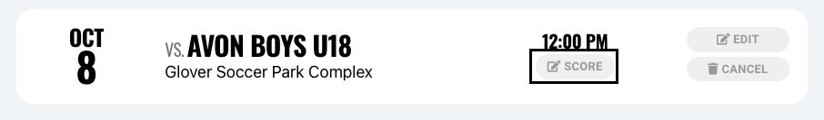
After you enter the score for that game, you will then be prompted to enter the statistics for that game next.
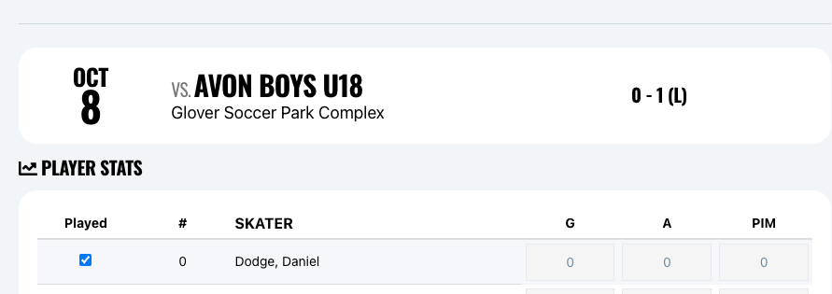
If you do not have the statistics to enter at that time, you can always come back to the same page where the option to add/edit player stats will show for that game under the Edit Score button:
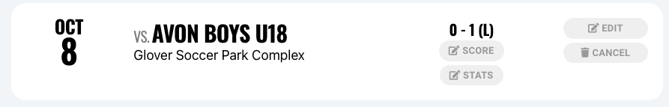
Finally, as you enter statistics for each game throughout the season, the "Stats" option on the Team Page menu will show a summary of all player stats throughout the season (filterable by Game Type).
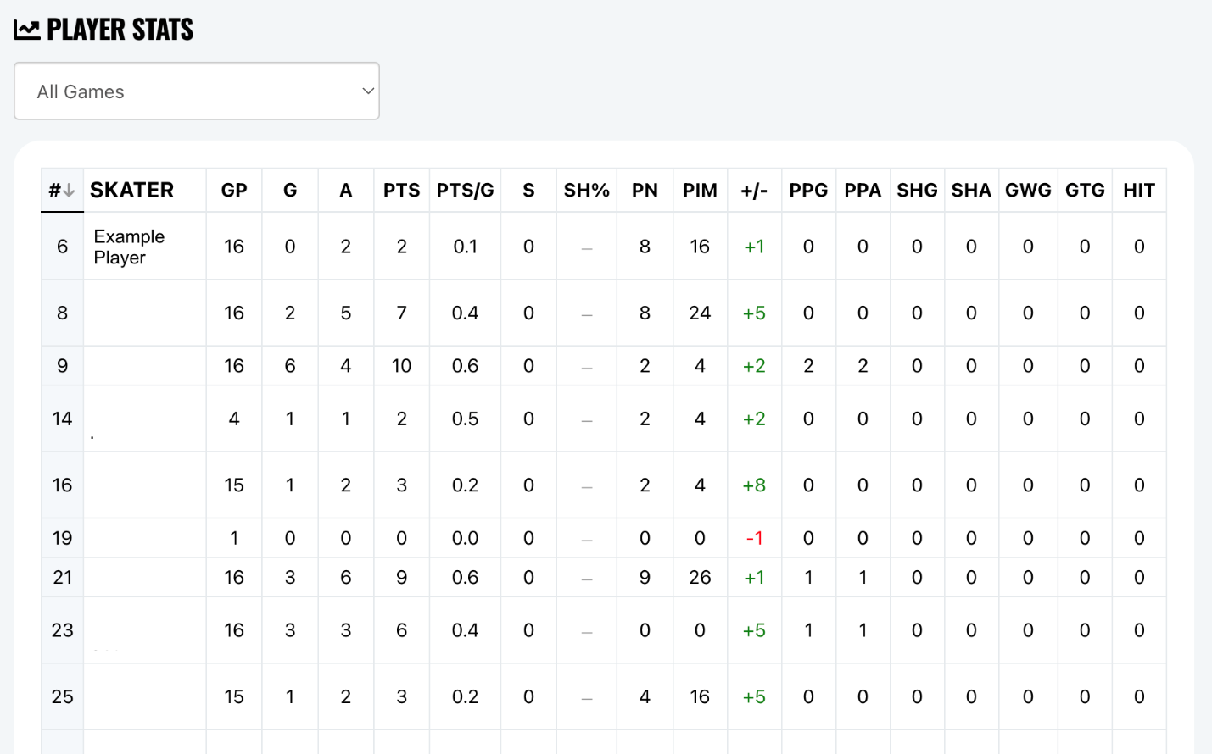
You can control who is able to see the player stats tracked when configuring your player stats under the Settings on your team page:
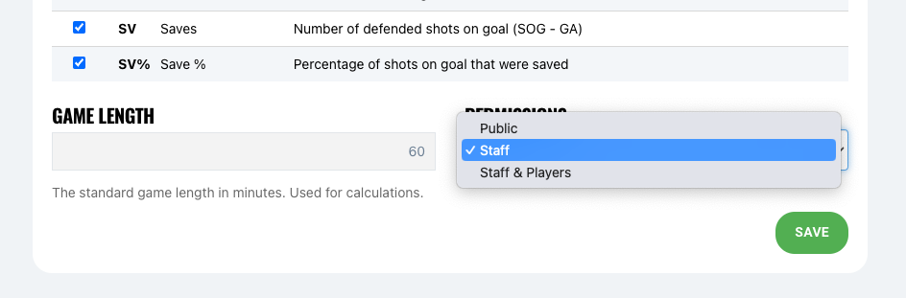
To get more information about Player Stats or for help setting up your team's statistics, reach out the YLM or Crossbar at help@crossbar.org.

