Volunteers and Coach Requirements

1. You must join USA Lacrosse as a COACH member - cost is $60 and reimbursable
Once you are in the site you must complete the FREE background check for USA Lacrosse and complete the bronze coaching certification. The amount of time to complete the certification is about 1.5 hours. Once complete, your profile on USA lacrosse will look like this:
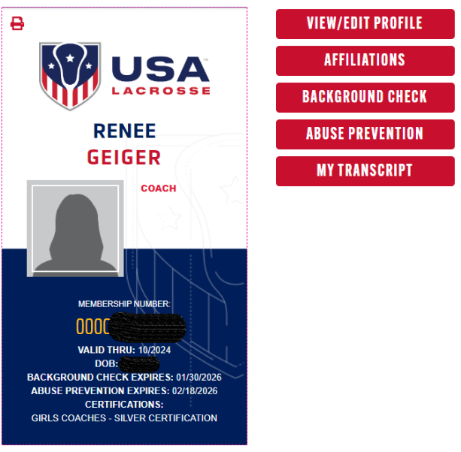

-Completion Certificates for all coaches:
1. NFHS - Coaching Girls Lacrosse​ (every 5 years) cost is $65 and reimbursable
- Click Here
2. Heads Up - Concussions in Youth Sports​ (every 2 years) - Click Here
3. CPR/1st Aid ​(every 2 years)- May be obtained in person or at www.icpri.com
Submit your bronze certificate, USA Coach Number, NFHS Certificate, Heads Up Certificate and CPR/ First Aid Certificate to Renee.

​CLEARANCES-REQUIRED FOR ALL COACHES *MUST BE RENEWED EVERY 3 YEARS*
Submit all completed clearance checks to Renee - FBI is not necessary if you meet the criteria below *PLEASE READ*
Pennsylvania State Law (Act 15) requires that EVERY volunteer who has direct contact with children have the clearances below on file.
Listed below are the details for required clearances, including costs and timelines.
PA Criminal Record Check
Cost: Free if you are a volunteer.
Expected Wait Time: Should be received within two weeks
Manner Received: You will receive your results online
How To Obtain: https://epatch.state.pa.us/Home.jsp
​PA Child Abuse History Clearance
Cost: Free if you are a volunteer
Expected Wait Time: Should be received within two weeks
Manner Received: Online
How to obtain:https://www.compass.state.pa.us/cwis/public/home
​​Federal (FBI) Criminal History Record Check
Cost: $22.60
Payable With: Online with a credit card, money order, or cashier's check
Expected Wait Time: Should be received within two weeks
Manner Received: Mailed to your home
Other Important Information:
- The fingerprint background check is a multiple-step process.
- The applicant must register prior to going to the fingerprint site:
  - Registration is completed online 24 hours/day, seven days/week at https://uenroll.identogo.com or by calling 1-844-321-2101 Monday through Friday between 8 AM and 6 PM. Please use 1KG756 as the Service Code when registering.
  - The fee is $22.60 for the fingerprint service, payable with major credit cards, money orders, or cashier's checks payable to "Morpho Trust." No cash or personal checks will be accepted.
- Once you register, you have 90 days from the registration date to go to one of the fingerprint locations to get your fingerprints. To see a list of approved fingerprint locations, please click here.
You do NOT need the FBI Clearance if you meet the following TWO criteria:
- You have been a resident of Pennsylvania for the ENTIRETY of the past 10 years AND
- You have NEVER been convicted of a Disqualifying Offense (Criminal Homicide, Aggravated Assault, Stalking, Kidnapping, Unlawful Restraint, Rape, Statutory Sexual Assault, Sexual Assault, Involuntary Deviate Sexual Intercourse, Aggravated Indecent Assault, Indecent Assault, Indecent Exposure, Incest, Concealing the Death of a Child, Endangering the Welfare of a Child, Dealing in Infant Children, Prostitution and Related Offenses, Crimes Related to Obscene and Other Sexual Materials and Performances, Corruption of Minors, Sexual Abuse of Children, Named as the Perpetrator of a Founded Report of Child Abuse OR WITHIN THE 5-YEAR PERIOD IMMEDIATELY PRECEDING, convicted of a Felony Offense under The Controlled Substance, Drug, Device and Cosmetic Act).
If you can answer "yes" to both of the above points, you are eligible to waive the Federal Criminal History Record Check (FBI Fingerprint). Click here to download and complete the necessary form to waive this clearance and submit with your other clearances.

