Aberdeen Cougar Hockey 101

Welcome to Aberdeen Cougar Hockey!

This booklet is designed to help you throughout your first year of hockey. If you ever have any questions, please do not hesitate to ask!

Our Aberdeen Hockey Association is divided into two sections:

Development League
- Our younger group is called the Development Level. This includes:
6U – ages 4, 5, 6
8U – ages, 7, and 8 (people might refer to these as Termites (ages 4, 5, 6) and Mites (ages 7 and 8)
10U/Squirts – ages 9 and 10
- At this level the main goal is to develop hockey skills in each player.

State League
Our older group is called the State League. This includes:
- Girls:
14U Girls* – ages 14 and under girls
Junior Varsity Girls – ages 15 -18
Varsity Girls – ages 15 – 18
- Youth:
12U or PeeWees* – ages 11 and 12
14U or Bantams – ages 13 and 14
Junior Varsity Boys – ages 15 - 18
Varsity Boys – ages 15 - 18
*Girls at this level can choose to play either U14 or PeeWees

USA Hockey (Step 1)
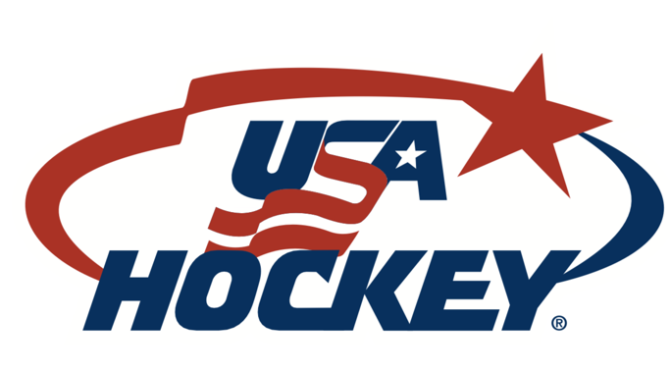
Each fall every player needs a new USA Hockey number. The cost changes from year to year. The current cost ranges from $17 to $79, depending on birth year.

The confirmation number is a series of 9 numbers and 5 letters. It is different for each person, each season. The confirmation number is included in the email sent immediately after registration. You have to do this before you register for hockey on AHA.

As the National Governing Body for the sport of ice hockey in the United States, USA Hockey’s mission is to promote the growth of hockey in America and to provide the best possible experience for all participants.

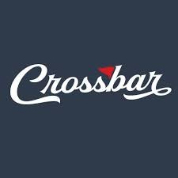
Crossbar (Step 2)

How to set up your Crossbar account

Create Your Account
1. Click on "Sign Up" at the top left of the site over our logo.
2. Enter the email address and password you'd like to use for your Crossbar account. Click on "SIGN UP."
3. A verification email will be sent to the email you entered to activate the Crossbar account.
4. Click on the link within the verification email.
5. You will now be brought to the "Account Login" screen, enter your email address and password and click on "LOGIN."
6. You will now be prompted to complete your profile. Enter your name and phone number to complete the account profile and click on "SAVE."
7. Next step is to add your Participants, look to next section for instructions.

Adding Your Participant(s)
After you complete your account setup, you'll be prompted to add a Participant/Player to your account. Enter your participant's first and last name, birthdate, upload their image, and click "SAVE."
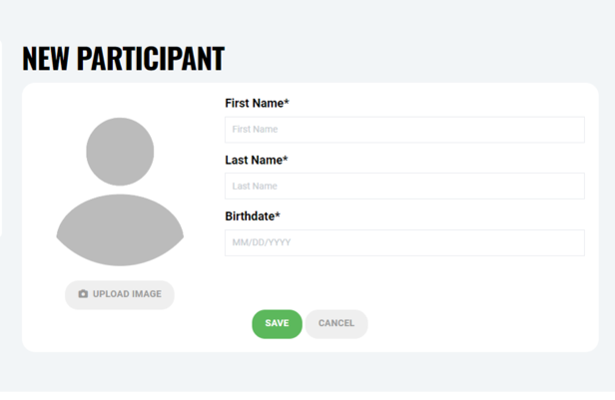

Adding Additional Participants To The Parent Account
If you need to add another participant to your account at any time, you can follow these steps:
- Log into the Parent Account by clicking on "Log In" on the top navigation of the website.
- Select "Account" in the navigation on top of the website.
- Click on "Participants" in the left navigation.
- Click on + (the big circular plus button) to Add Participant.
- Complete Player Profile (name, birthdate & player image).
- Click "SAVE."

Adding USA Hockey Membership To Your Participants
- Be sure to register for your USA Hockey number before trying to add it to your player's profile.
- Sign up here: https://membership.usahockey.com/
- Log into the Parent Account by clicking on "Log In" on the top navigation of the website.
- Select "Account" in the navigation on top left of the website.
- Select the Player Profile icon (left icon) below the player name that you want to add the USA Hockey number to.
- After clicking on "+ADD", click on the Association* dropdown and select USA Hockey. Enter your USA Hockey Membership number (make sure it is for the current season) in the textbox and click "ADD ASSOCIATION."

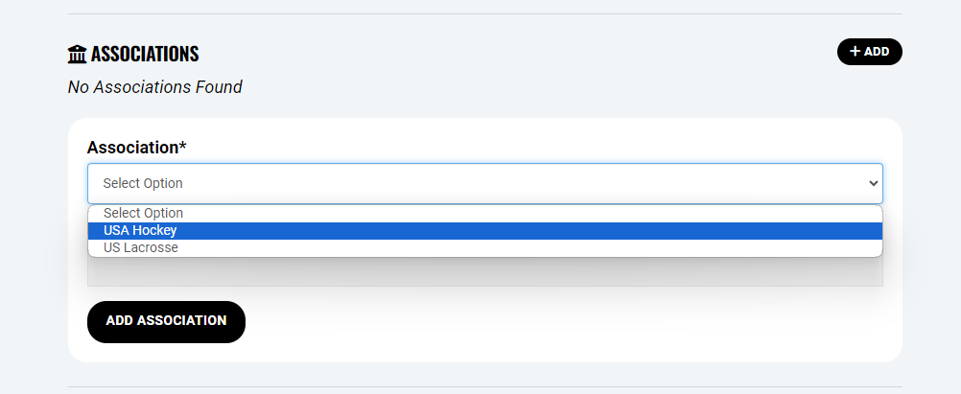

Aberdeen Hockey Association (Step 3)
Once you have your USA Hockey Number and your Crossbar account created, you can go to Aberdeenhockey.com and register your child. You will need your USA Hockey number ready as you will need that to move on with your registration. Once you have completed this step you are ready to play hockey!

DIBS
Our hockey association is one of very few in the state that owns our own rink. And as a member of the association, YOU own the rink. We lease the Expo rink but we OWN the Odde rink. We have full responsibility for the maintenance, cleaning, and upkeep of it. As owners of the rink, it is each of our responsibly to volunteer time to work the concession stand, clean the lobby, assist with a fundraiser, etc.

For every game we play in our rink, we are inviting guests into our hockey home. Wherever they come from, the lobby is the first thing that they see then, maybe the rest room - all the while, whether they know it or not, they are seeing our rink and determining if they like it here or not. The parents won’t touch the ice, so what does that leave them to judge? The building and how clean it is, the condition of the locker rooms and friendliness of the concession staff.

We hope that each of you will have a sense of pride when it comes to our building, keeping it clean and reminding younger children and siblings that it is not a playground. It is our hockey home, and we ask you each to do your part in keeping it looking nice and leaving it in better shape than was left to us. The rink was built by incredible volunteers in 2001 and there have been many improvements along the way. We owe a huge thank you to the volunteers who have helped this building progress to what it is today!
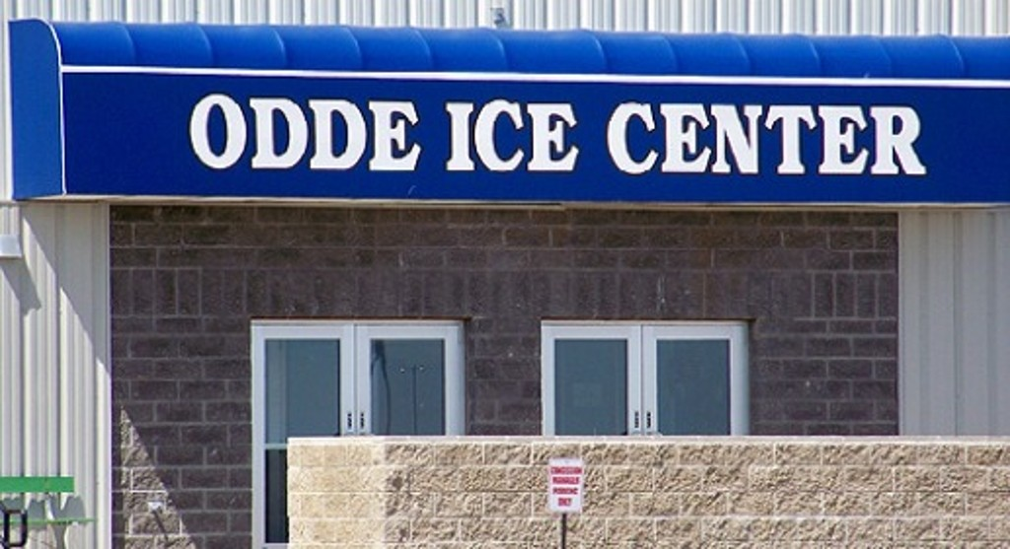

Dibs Description
- Wings Beer Sales
  - Arrive at 6:00pm. Sign in at Wings ticket table. 2 selling beer up front and 2-3 in back restocking cooler or filling buckets. Check ID’s and give bracelet. Gather buckets at end of game. Dump ice in sink. Sweep up floor. Officer in Charge (board member) will assist.
- Wings Penalty Box
  - Arrive at 6:45pm. Sign in at Wings ticket table. Report to penalty box. Announcer/Timeclock worker will have instructions and clipboards for what you keep track of. Let players in and out of penalty box.
- Cougar Gate
  - Arrive by time listed on Dib’s page. A Coordinator will bring the money, Square machine, price sheet and programs. Collect money from spectators. Area students get in free. If Termite/Mite games are happening at the same time as State League games, people attending only the Termite/Mite games do not have to pay. A coordinator will check in often for questions. A note of names/phone numbers is included to reach out if you need immediate assistance.
- Cougar Announcer & Scorekeeper (Music)
      - Report 15 minutes early to score’s table
  - Announcing: Team line up, penalties, goals. (Ref will communicate this with you)
  - Scorekeeper: All scoring is done via GameSheet on an Ipad
  - Music: All Ipads have music. First game of the day must play the National Anthem. You can pick whatever songs the ipads have to play during “down time”. Music cannot play when the puck is in play or when a player is injured. The Coordinator will have the Ipad ready. Spotify is available or Apple Music.
- Cougar Time Clock
  - Report 15 minutes early to score’s table
  - Cheat sheet for period length, intermission length and zam schedule laminated by timeclock along with written instructions on “how to run the timeclock”.
- Cougar Penalty Box
  - Report 15 minutes early
  - Open door for players coming in and going out of penalty box.
- Cougar Security
  - Report 10 minutes early
  - Wear orange vest and watch crowd for unruly spectators. Be familiar with the Zero Tolerance policy. If a ref throws a spectator out of the game, assist person to the exit.
  - If there is a person who is removed from the game/facility for poor behavior, you must complete an incident report. These are in the boardroom. If you have questions, ask a coordinator or board member for assistance.
All Cougar Game duties are the same for games either in the Expo rink or Odde rink. The Dib page does not state where games are being played; it is your responsibility to check the calendar to know what time games start and where they are located.
Please feel free to go to our website to view our volunteer policy. www.Aberdeenhockey.com

Fundraising
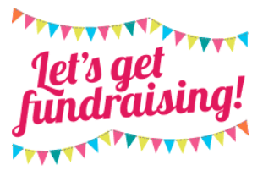

The Board of Directors is required to set the Annual Fundraising Requirement by July 1st each year to be effective the upcoming hockey season. In addition, the Capital Fees and Tournament Fees are identified by level below, all of which are eligible to be paid for through fundraising.

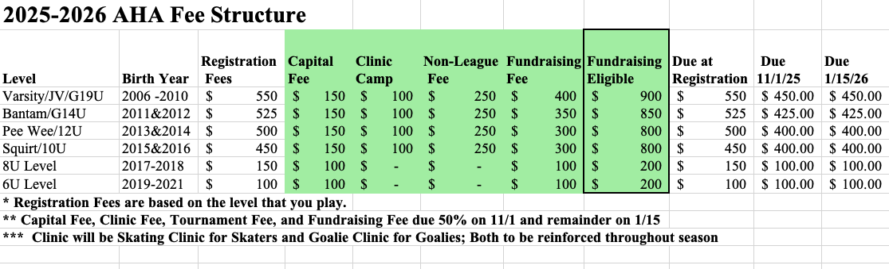
To provide members with additional time to fundraise, there will be two cutoff dates for payment for the Fundraising Fee, Capital Fee, and Tournament Fees to be paid.
- The remainder of the fees will be due 1/15 each season
*Note that if your fees are not paid, your membership will be considered not in good financial standing, and your player will be prohibited from participating in AHA events including practices and games until your
membership returns to good financial standing.

AHA FUNDRAISING CREDIT OPTIONS
As indicated in the AHA fundraising policy and registration, each member is required to meet or exceed their annual fundraising commitment that is set by the Board of Directors. The AHA Board of Directors has made the below fundraising options available to its membership. The AHA fundraising committee will keep a record of each member’s fundraising activities and calculate any respective member credits. The member must indicate how they wish to utilize the credits as per the AHA fundraising policy. Those credit totals to be posted on the fundraising tab on our website www.aberdeenhockey.com/fundraising
1 Annual Raffle Ticket Program:
i) Raffle Tickets will be available in quantities of 5 tickets or $50 value.
ii) Members may elect to sell more or less raffle tickets to meet their fundraising
commitment
iii) If a player chooses to sell additional raffle tickets, AHA will collect an additional
deposit check for the value of the tickets before releasing to the player.
*See the Annual Raffle Policy for additional details.

2 SCRIP Fundraising:
i) Available fundraising option for AHA members for year-round fundraising through
normal family/household purchasing
ii) Multiple options available
(1) National Retail Gift Cards (2) EScript Gift Card
(3) Local Gift Cards
(a) Credits vary greatly depending on the type of purchase
*See the Scrip Fundraising Policy for additional details.

3 Kuchen Fundraiser:
i) AHA will do a minimum of 1 with a maximum of 2 Kuchen fundraisers annually
ii) The fundraisers will be geared towards the holiday seasons of Easter and
Thanksgiving/Christmas
*See the Kuchen Fundraiser Policy for additional details.

4 Charity Mania Fundraising:
i) AHA will make available tickets from AHA for $20/ticket
ii) Sell ticket for $20
iii) Memberreceives$10fundraisingcreditforeachticketpurchased/sold iv) Tickets may be purchased from any member of the board of directors *See the Charity Mania Fundraising Policy for additional details

5 Sponsorship Sales Fundraising:
i) AHA will make available specific sponsorships for the membership to sell throughout
the season
ii) Member receives 20% of sponsorship in fundraising credit
*See the Sponsorship Sales Fundraising Policy for additional details

Katie Linke will be your contact if you would like to know how much money you have raised on Scrip Cards or Kuchen Sales. Please email Katie at klinke@primroseretirement.com to find out how much is in your fund.

Please feel free to go to our website to view the Fundraising Policy.
www.Aberdeenhockey.com
Equipment

The Aberdeen Hockey Association has equipment available to rent for the season. Rental fees are as follows:
Level | Rental Fee | Deposit Check
6U | $75 | $150
8U | $75 | $150
10U/Squirt | $75 | $150
Goalie | $100 | $300

*Equipment is not provided for State League players.

** Due to the high cost of this protective gear, AHA will refund the registration portion of players registered and rostered in the goalie position after December 15th of each season.

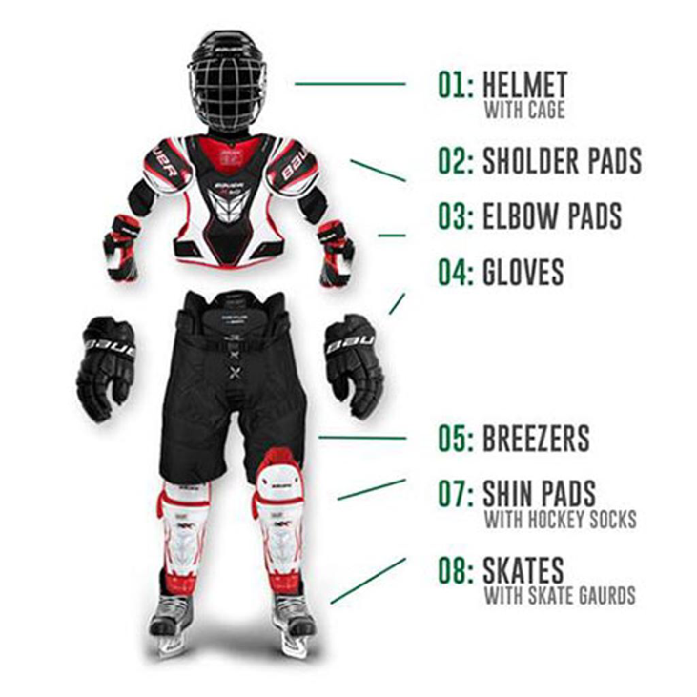
Equipment included in rental:
- Shin pads
- Breezers
- Elbow pads
- Shoulder pads
- Gloves
- Helmet

Equipment not provided by AHA:
- Hockey socks
- Mouth Guard
- Hockey Stick
- Hockey Skates

WHAT CAN GO INTO THE MACHINE:
- Base Layers
- Socks and athletic supporter
- Jersey and breezers (on delicate wash)
- Elbow pads
- Shoulder pads
- Gloves - Note: Do not place gloves in the dryer; the heated air may damage the leather pads. Instead, prop them open and allow them to air dry or place them on a boot and glove dryer.
- Air Dry all equipment!!!

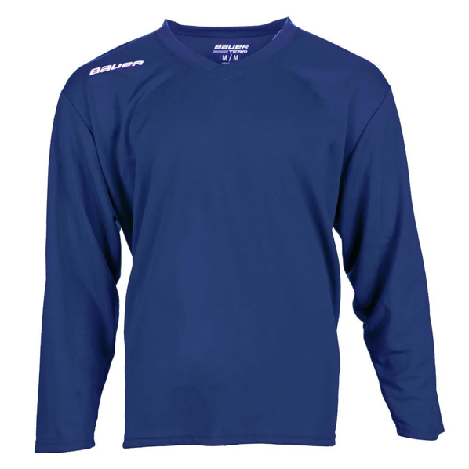
Jerseys

Jerseys are provided by AHA to use during the season, except at the Junior Varsity and Varsity level. You will return these jerseys at the end of the season. You will give AHA a deposit check for your jersey. The check will be returned when the jersey is returned.

Hockey Sticks

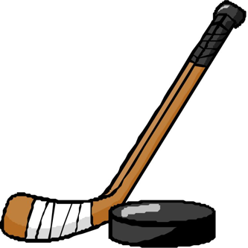
HOW TO DETERMINE THE PROPER HOCKEY STICK LENGTH
The hockey stick length is generally the easiest variable to determine, and it is imperative for a player's success in the game. Sticks usually come in four sizes: senior, intermediate, junior, and youth. Each descending size is shorter and normally offers a smaller shaft circumference and a softer flex. Senior sticks are usually used by players ages 14 to adult; intermediate sticks by players ages 10-15 and by some adult female players; junior sticks by ages 7-12; and youth sticks by players ages 4-8.
Knowing how to measure a hockey stick will ensure you easily find the right length. Have the player stand without skates, and then place the toe of the stick on the ground between the player's feet, positioning the stick vertically against the body. The general rule for the proper hockey stick length is that the end of the stick should come to about the nose. If the player's skates are on, the stick should come up to the chin. Please note that this is a general rule of thumb for hockey stick height and can change with personal preference.
If the stick is too long, simply make a mark at the correct place and cut the handle of the stick accordingly. If the stick is too short, extend its length by inserting an end plug at the top of the shaft. An end plug can is handy for rescuing a stick if a player cut it too short, or prolonging the life of a stick if the player has experienced a growth spurt.

Sharpening Skates
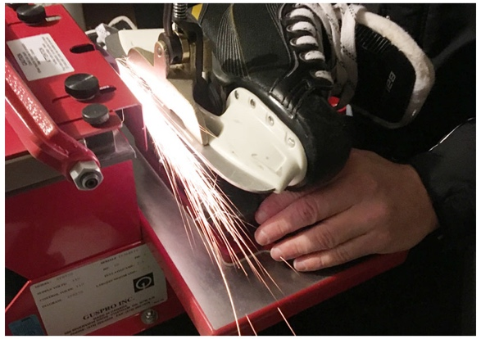
The rule of thumb is to sharpen ice skates after every 15-20 hours of use. This is typical for athletes who play hockey or figure skate multiple times on a weekly basis.

Skates can be sharpened at Dakota Outdoors. The charge is $5 each time you get them sharpened.

What is Fall Hockey and Spring Hockey?

Fall and Spring Hockey are extensions of our Aberdeen Hockey seasons.

Fall Hockey will be before the season starts. It is an opportunity for players to get on the ice before the season starts. There could be a game of 4 players against 4 players. Coaches are often there to coach or give feedback to players. Many times this is played cross ice or half ice. Or coaches may utilize this time as a skills session. This is usually for returning players. Cost is $120 for all sessions and $10 for a drop in session.

Spring Hockey will be after the season. This is an opportunity for players to get more ice time after the season is over. There will be a game of 4 players against 4 players. Coaches are often there to coach or give feedback to players. Many times this is played cross ice or half ice. Or coaches may utilize this time as a skills session. This is usually for returning or first year players. Cost will be determined.

**Fall Hockey and Spring Hockey are OPTIONAL. It is up to the player to decide if this is something they want to do. **

Rinks
There are two rinks that AHA players will utilize for practice and games.

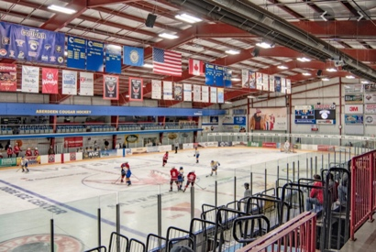
Odde Ice Center – This is the main sheet of ice. This is where most of the games will be played.
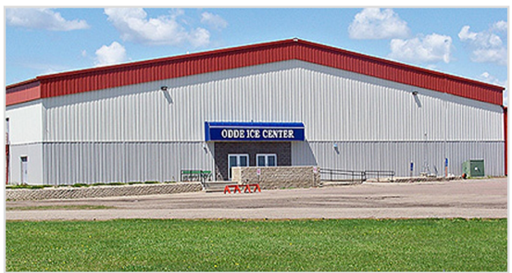
Holum Expo Building – This is the secondary sheet of ice. Many practices will be held here. There are also a few games played on this sheet of ice on busy weekends where the Odde is already being played on.
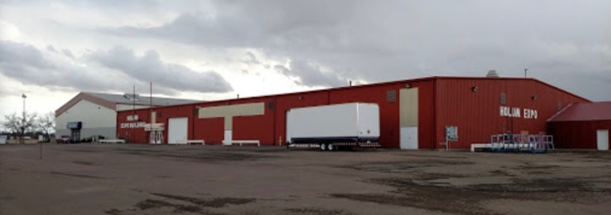

Locker Rooms
There are many locker rooms at the Odde Ice Center. The first thing to do each weekend is to look at the Locker Room Assignment Board (the TV) located by the doors to the Odde Ice Arena. This TV will tell you where your child should get dressed on the weekends.

These locker rooms are all found down the main hallway in the Odde Ice Center (behind the main bleachers)

There are also Boys Varsity/JV and Girls Varsity/JV Locker rooms located by the home bench.

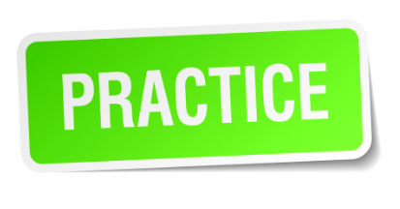
Practice Information
Practice times for each level will vary depending on age and number of players participating. Practice times and dates will be on the Crossbar app. It will also be located on the AHA website.

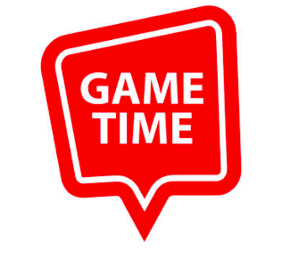
Game Information
In house games usually played each Saturday morning. Be sure to check your Crossbar app the morning of the game to see what time games are and where they are going to be played. Coaches will also put on Crossbar what color jersey your child should wear.

Cougar Apparel
Cougar apparel can be found on our website at Aberdeenhockey.com. Go to the main menu and find merchandise. You can order Cougar apparel at Geoffdog here in Aberdeen. You can also order Cougar apparel at Quality Quick Print here in Aberdeen.
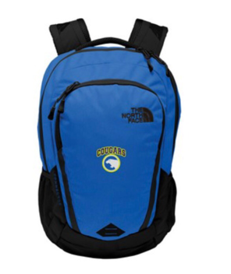
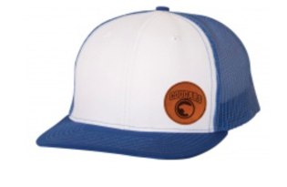



Coaching
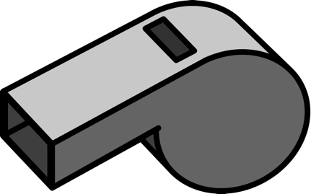
If interested in coaching for AHA contact:
Mike Schmidt
Director, Hockey Operations
Michael.schmidt@northern.edu

Your Hockey Family to Contact:

Name: _______________________________________

Phone Number: _______________________________________

Email: ________________________________________

Please don’t hesitate to contact this family for any questions – no matter how big or small you think they are! Welcome to Aberdeen Hockey!

