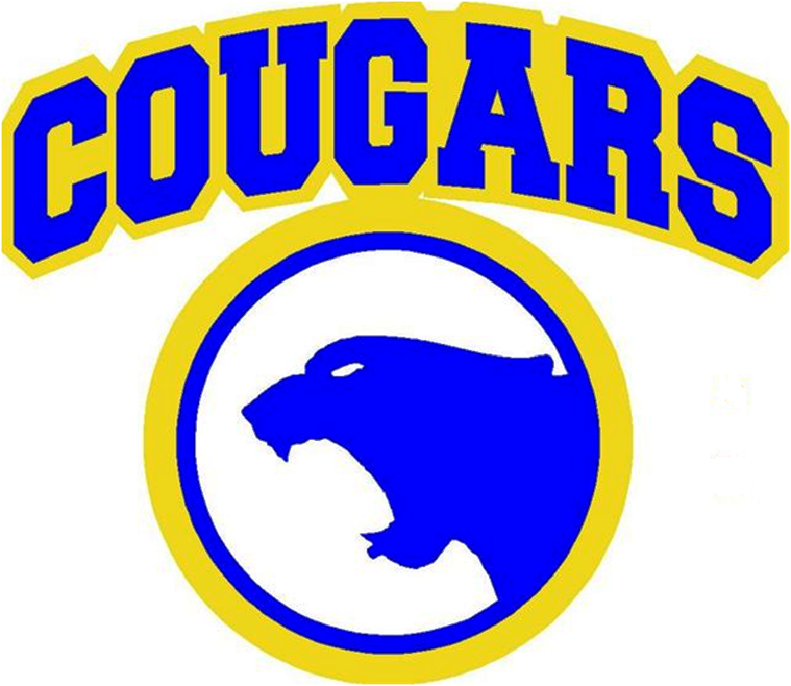 AHA Hockey Code of Conduct
In the effort to make ice hockey a more desirable and rewarding experience for all participants, the USA Hockey Youth, Junior, and Senior Councils have instructed the Officiating Program to adhere to certain points of emphasis relating to sportsmanship. The campaign is designed to require all players, coaches, officials, team officials and administration to maintain a sportsmanlike and educational atmosphere before, during and after all USA Hockey-sanctioned games. The policies set forth in this Code of Conduct are in effect from September 1st through May 1st. The Code of Conduct is also in effect for the players outside the season while in the Ice Center or when representing AHA at any event. If there are fees or fines assessed to AHA by SDAHA or USAH based on your behavior or actions, these will become your responsibility. AHA reserves the right to discipline, revoke, and deny membership for failure to abide by these standards.
PARENTS:
- Show a positive attitude towards the association, games, coaches, and all participants, including on social media.
- Do not embarrass yourself, our town, and our association by yelling at players, coordinators, coaches, or officials.
- Ensure that your team coordinator or head coach is contacted in advance if your player is unable to attend a practice or game.
- If you have issues with the program, coach, or officials, file a formal complaint through our website portal. You will be contacted by one of the Association leaders and the matter will be discussed. Avoid voicing opinions and comments to the general population or via social media.
- A 24- hour waiting rule will be in place for any communication from parents to coaches, on-ice officials and/or Board of Directors. This would include game play, playing time, and policy changes. All game/practice communication needs to be directed to the HDC Development Director. All other communication can be communicated with any AHA board member.
- If the 24-hour rule is broken, the following penalties will be served by the parent’s player: If profanity or threatening language is used by the parent, it constitutes a second offense.
- 1st offense – Suspension of 1 period for the next game
- 2nd offense – Player will be suspended for the next game, to be served within same season as offense
- 3rd offense – Player will be suspended for the next two games, to be served within same season as offense
PLAYERS: ** A separate copy of this form is required for each player**
- I will be a team player and get along with my teammates. I will show courtesy to other team players, officials and fans at all times.
- I will not swear or use abusive language on the bench, in the rink, or at any team function.
- I will not lash out at or disrespect any official, no matter what the call is. The coaching staff will handle all matters pertaining to officiating.
- I will skate directly to the penalty box upon receiving a penalty.
- I will conduct myself in a befitting manner at all facilities (ice rink, hotel, restaurant, etc.) during all team functions, including on social media.
- I will attend and be prompt for every practice and game unless excused by the coach.
- I will not misbehave during open skating, open hockey, 4X4, dryland, or hockey practice. If I abuse this, I understand that I may be removed from the facility and I may not practice or play game(s) for the period specified.
- I will not haze, fight with, or bully anyone.
- I will not steal or vandalize any property.
- I will not use or possess illegal drugs or alcohol.
- I will not use products containing tobacco and devices such as e-cigarettes or vaping devices with or without tobacco contents.
- I will not use a cell phone or any electronic device that can take pictures/videos in any locker room.
- I will abide by all team-specific rules as well as the HA Hockey Code of Conduct.
- I will abide by any new/updated rules approved and communicated from the AHA Board of Directors.
- If I choose not to abide by these rules or to violate the AHA Hockey Code of Conduct, I will be subject to disciplinary action by the team coach/discipline committee.

DISCIPLINE FOR VIOLATIONS OF THE CODE OF CONDUCT
Article 1-6: Coach’s Discipline
Articles 7: Dependent on infraction/Coach’s discipline.
Article 8. Coach’s Discipline
Article 9-11: First offense– 5 game suspension
Second offense- season suspension
Article 12-13: Coach’s Discipline
Article 14-15: Coach’s Discipline/Disciplinary committee
EVIDENCE OF VIOLATIONS
- Information received from law enforcement or court services personnel providing reasonable cause to believe an infraction has occurred.
- A coach or player is found guilty or enters a no contest plea in a juvenile court or an adult criminal court.
- A self-reported violation by a parent, coach, or player.
- A reported violation by a parent, coach, player, or anyone affiliated with AHA.
CODE VIOLATIONS AND CONSEQUENCES
  - The AHA Board of Directors, or its designee, shall be responsible for the fair and equitable administration of the Code of Conduct.
  - This Code of Conduct is in force beginning September 1st through the last state tournament for the entire AHA organization
  - The possession, use, distribution of tobacco, alcohol, anabolic steroids, or the possession, use or distribution of marijuana or controlled substances, as defined Chapters 22-42, SDCL 13-32-9, is a violation of the Code of Conduct.
  - Any violation of any city, state or federal law (excluding Class II Misdemeanors and all non- felony motor vehicle offenses) are a violation of the Code of Conduct.
COACHES’ CODE OF CONDUCT: I hereby pledge to provide positive support, care, and encouragement for all AHA participants by following this Coach’s Codes of Conduct Pledge.
- I will place the emotional and physical well-being of my players ahead of a personal desire to win.
- I will treat each player as an individual, remembering the large range of emotional and physical development for the same age group.
- I will insist that my team play in a safe and healthy environment.
- I will do my best to organize practices that are fun and challenging for all my players.
- I will lead by example in demonstrating fair play and sportsmanship to all my players.
- I will not cheat or engage in any form of unethical behavior that violates league rules.
- I will provide a sports environment for my team that is free of drugs, tobacco, and alcohol, and I will refrain from their use at all youth sports events.
- I will be knowledgeable in the rules of each sport that I coach, and I will teach these rules to my players.
- I will use those coaching techniques appropriate for all of the skills that I teach.
- I will follow the USA Hockey ADM age-specific guidelines for development where possible (station-based practice, small area games, age-appropriate skill development, etc.)
- I acknowledge that I am a youth sports coach, and my goal is to develop players/teams mentally and physically for success.

PLEASE NOTE: If a coach is found to be in violation of any of the above-stated Codes of Conduct, they are subject to disciplinary review and up to possible dismissal.
Player’s Signature Date:

Player’s Parent/Guardian Signature(s)______________________________________ Date:

Coach’s Signature Date:

I hereby grant permission to Aberdeen Amateur Hockey Association (AHA) to publish photographs/video of me/my child, containing clearly identifiable features, in any or all official AHA publications to be used on social media, the official Aberdeen Hockey Association website, or in local media (in print or online) without further consideration or compensation. Parent Signature:

--Adopted 09/17/2024 by the Aberdeen Hockey Association Board of Directors--

