NB Fastpitch Crossbar Quick Guide

- Getting access to the app
- Download the app in your app store. It should look similar to the below screenshots:
- Android version
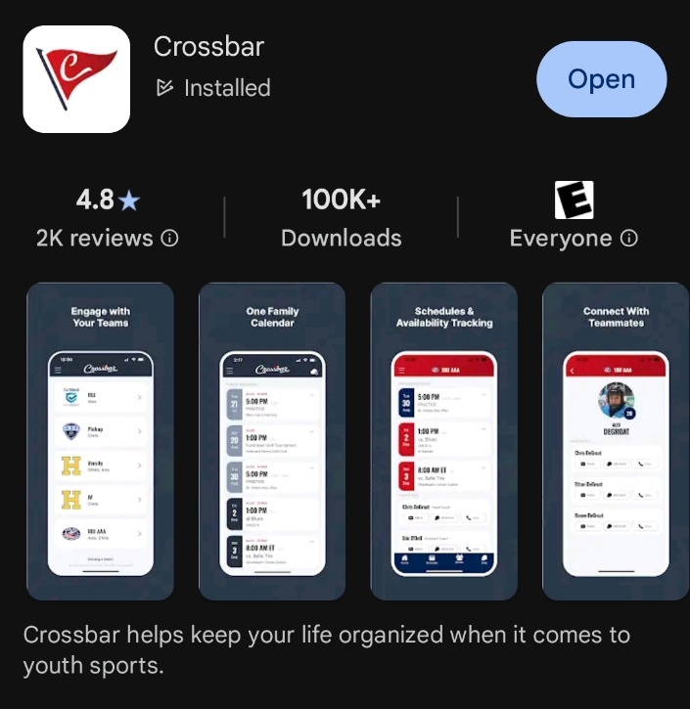
- Apple version
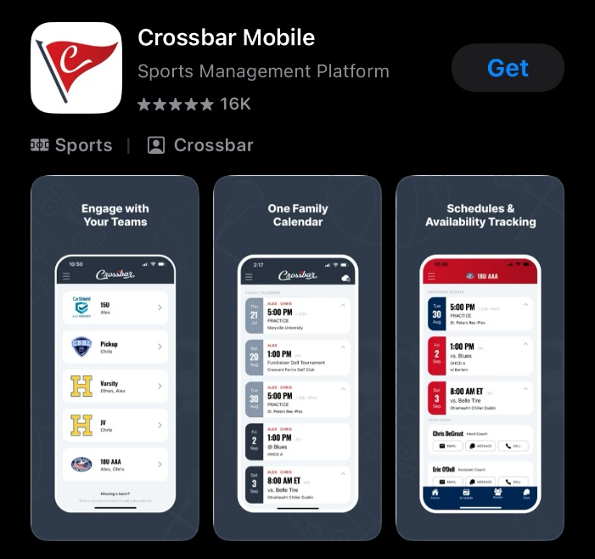

- Once you have downloaded the app, sign in with your email and password you used for registration.

- Using the app.
- The first page of the app should look similar to this.

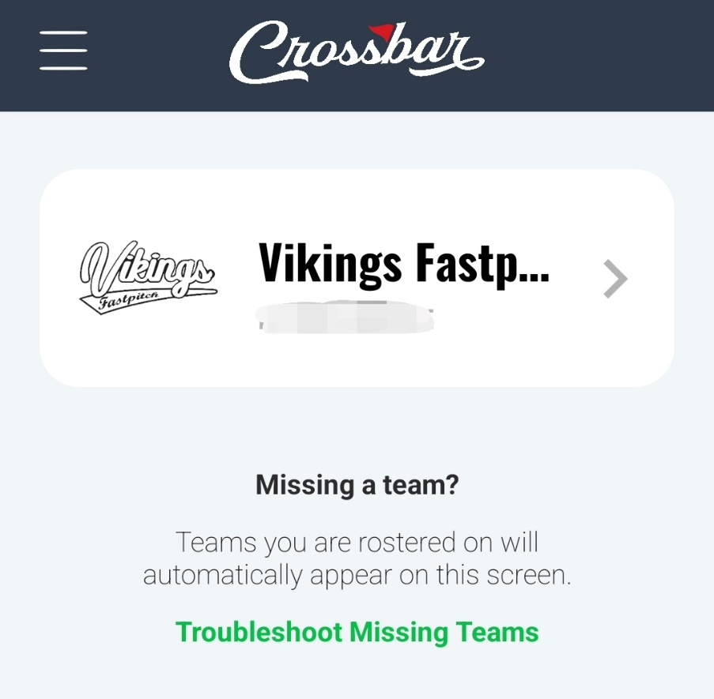
- After clicking on your team, it should open your team page and will look similar to the below:

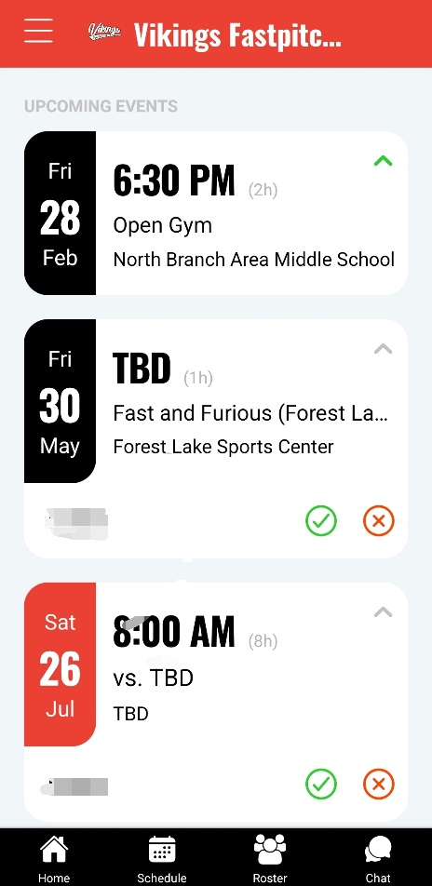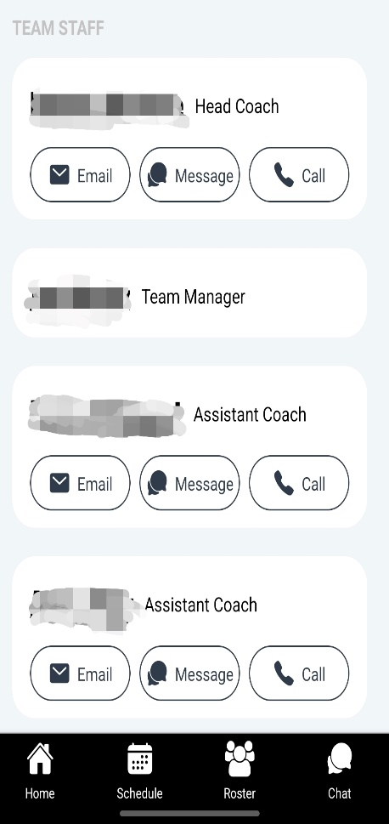
- From here you can see the team schedule, contact a team staff member, view the roster, and chat with the team and staff. Please keep in mind the chat function at the bottom right goes to the entire group of parents, players, and staff members of your team.

- Applying settings
- Click on the “hamburger” menu at the top left and it will open this window.
i.
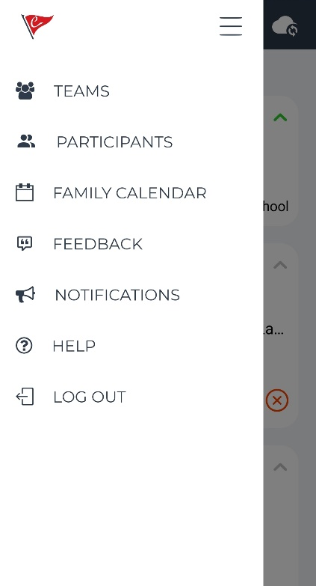
- Clicking on Notifications will bring you to the settings where you can update your preferences on what you receive through the Crossbar app for the team and what you receive by email. We recommend you have “Organization Communication,” and “Volunteer Reminders” checked. We also recommend that you have your Mobile Notifications set to “All events,” that way you should receive practice changes, game changes, etc.

