Rock Ridge Youth Baseball
Board Meeting Minutes
Monday, March 3, 2026, at 6:00 pm
Gun Club Virginia
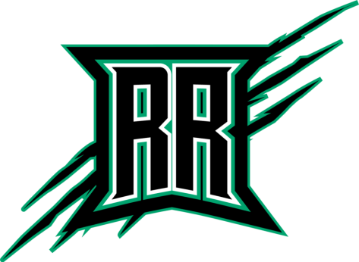

- Call meeting to order 6:00
Members Present: Kevin Brown, Alex Akerman, Ed Cremers, Ryan Jarvi, Carol Stavnes, Mike OBryan, Jenna Brown, Diana Harvey, Bruce Beck, Joe Hamble (present at 6:44)
Members Absent- Andrea Whitney
Guest- Jeff Henderson

- Approve minutes motion by Ed, second by Ryan,
- New Board Member- Player Agent: Caitlin Lung, nominated and voted unanimously via TeamReach
- Treasurer Reports-Ryan
- Sponsors
  - Current total is $3850. Used new google form to get logos and info with less
  - $42800 current balance in account
  - 2027 season- reface the current scoreboard, update colors and add option to have their name on the scoreboard each year. We should update this year anyways with RR colors. Will touch base with Mesabi sign
- Registration
  - Current: Jr Mini $50 early bird and then $75 Registration. $100 early bird March 1-15 for all other levels and then $150 March 15-31
  - Jerseys/hats- prefer adjustable hat, Richardson brand is preferred. 321 Graphix will be out design/supplier. Board all approves the use the same jersey style as last year.
  - Early Jr Mini requests- we have required parent to coach. Or do we add a 4yr old Tee ball once a week for 60 minutes and offer skills, Born 5/1/2021-4/30/22, would be $15 Registration. Parents are required to be on the field with their child. Start June to mid July (6 weeks). Will use the Lakeside field. Each player will get a RRYB Teeball shirt and hat. RRYB will provide helmets, bats and will get wiffle balls. Kevin will reach out to Parent and see if interested in being main coach.
- Scrimmages with Greenway/NK- Greenway parent reached out to Jenna as they are no longer a part of Grand Rapids League. They are similar to our Majors for in house, consider scrimmages for Minors. Board approves ongoing discussion, Jenna will be the liason
- Equipment update
  - Will need to order balls. Catchers gear all had velcro and this did not last, will keep as back up set. Bruce already has the new chalker for Gilbert. Brian Silber has new rubber for the pitching mounds.
    - Can we put together a swap for used bats, gloves, cleats etc and coordinate with the Batter up program
- Concession update- Carol asks for approval to buy excess supplies from RRYHA
  - Leftover water donation- will send 1-2 cases for each travel team tournament- Board approves
  - Carol feels we need an updated microwave for Gilbert as well as Keurig- Board approves
- Travel Team Update- all teams are signed up for 3 tournaments. Dates are posted on website. Birthday ranges are pulled from Little League. Birth certificates will need to be uploaded into Crossbar for all travel kids. Last year we ordered new jerseys for 13-14U, we will plan on holding on to them and rediscuss
- Virginia Elks program- Jeff Henderson. Batter up program 5/17/26, time to be determined- they are starting this back up. Dan Roerdink. 1 day at Olcott Field. Will need some help with set up and shag baseballs. Would be good opportunity to support Elks as they support Youth Programs. We can promote and offer concessions and offer. Prizes for each level and participation. Can we connect with the RRBA and get high schoolers involved as well. Ed will work with Caitlin to connect them. Diana will follow up with Dan R about the time.
- Current open board positions
  - Website/Scheduler- Jenna will plan to stay through the season and
- RR Travel Tournament update- cancelled due to low number. Will refund Hibbing and notify Cherry. This date was conflicted with Duluth, Cloquet teams. Will coordinate scrimmage with local team, will keep date on the calendar May 31st, utilize this as a pregame for a tournament
- Foul lines- Ed has volunteered to paint the foul lines, paint the foul poles.
- 2nd batting cage at Olcott- we have the equipment but need volunteers to put this together. Should we offer a volunteer day for people to just show up- Coordinate this with The Batter Up day with the Elks program May 17th
- Next Meeting April 1st 6pm Kline Cuppoletti
- Adjournment 7:47 pm Motion by Ryan, second Ed.

Update jr mini to 3 runs or 3 outs
Andrea- order shed and order agrilime, chalk

