2024/2025 AAA Blues Partner Hotels
All Located 5 - 10 Minutes from Centene Community Ice Center
1 Complimentary Coaches Room for every 20 Paid & Complimentary Hospitality Space based on Availability

Sheraton Westport Plaza and Chalet
900 Westport Plaza Drive, St. Louis MO 63146 – Plaza (indoor pool)
191 Westport Plaza Drive, St. Louis MO 63146 - Chalet (outdoor pool)
Plaza Hotel Rooms Fully Renovated in 2024,
Complimentary Shuttle to the Airport, Complimentary WIFI in Guest Rooms and Mini Refrigerators
The Sheratons are located in Westport Plaza - Westport Plaza is a 42 acre entertainment complex featuring 12 restaurants,
Comedy club, jazz club, Westport Social, Westport 360, 20,000 square feet of Green space and nightly entertainment www.westportstl.com

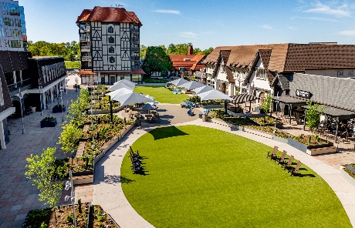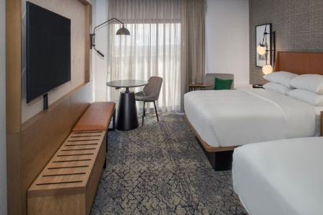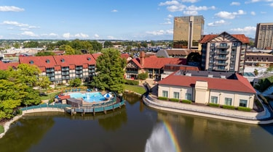
Double Tree Westport
Hot Breakfast Sandwich plus Continental Included in Room Rate
1973 Craigshire Blvd, ST. Louis MO 63146
Indoor Garden Pool with adjoining Patio Complimentary Shuttle to the Airport & Westport Plaza
Located ½ mile from Westport plaza
Complimentary WIFI in Guest Rooms and Mini Refrigerators
Double Tree Cookies upon arrival, 2 Queen size beds in all double Rooms

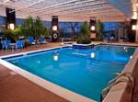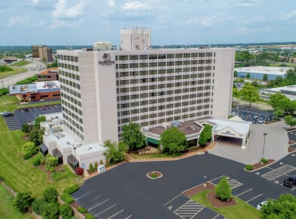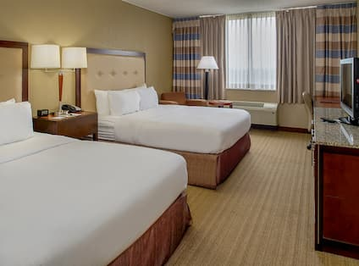
Homewood Suites Westport
Full American Hot Breakfast Buffet Include in Room Rate
2434 Old Dorsett Road, Maryland Heights, MO 63043
Indoor Pool, Onsite Laundry, Outdoor Putting Green, Outdoor Patio with BBQ Grill, Pet Friendly
Full Kitchens and Comp Wifi In Guest Rooms

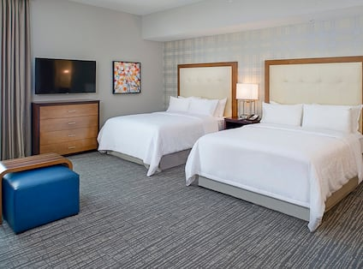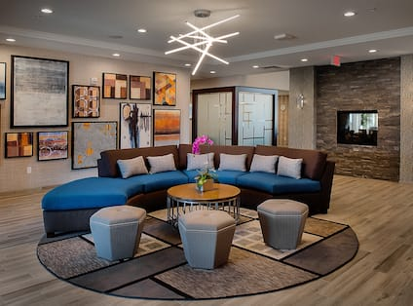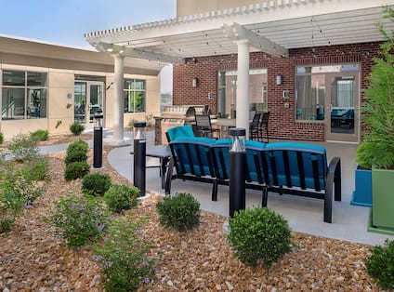

For more information or to reserve a block of rooms at any of our partner hotels please contact Patti Miller Patti.miller@swphotels.com or 314-212-2150

