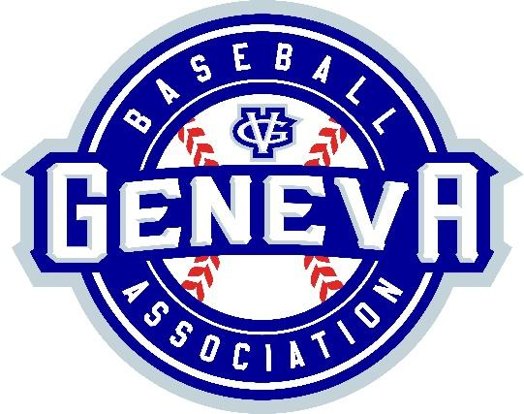
Spring Training Academy 2026
Registration Is Now Open

Happy New Year from GBA and Champion Craft! It’s time to dust off the bat and glove and start preparing for opening day! GBA is once again excited to be partnering with Champion Craft to offer to our members the Spring Training Academy.

This comprehensive 5-week training program will cover hitting, pitching, throwing, fielding, and much more. Classes will be conducted by the outstanding coaches from Champion Craft and will address many of the specific skills needed to be successful at your current level of baseball and beyond. Rookie and Mustang levels will be 60-minute sessions while Minor and Major levels will be 90 minute sessions.

When: February 15th through March 25th 2026 (wrapping up prior to Spring Break)

Where: Champion Craft 303 N 4th St., St. Charles, IL.

Rookie & Mustang (6 to 8 years old) STA | Minor & Major (9 years and up) STA
5 1-hour sessions | 5 90-minute sessions
$140 | $195

Level | Day | Time | Specific Dates
Rookie/Mustang | Mondays | 4:30 PM-5:30PM | Feb 23 thru March 16
Rookie/Mustang | Wednesdays | 4:30PM-5:30PM | Feb 25 thru March 25
Rookie/Mustang | Fridays | 4:30PM-5:30PM | Feb 20 thru March 20
Rookie/Mustang | Sundays | 4:30pm – 5:30 PM | Feb 15 thru March 15
Rookie/Mustang | Sundays | 5:30pm – 6:30 PM | Feb 15 thru March 15
Minor/Major | Sundays | 6:30pm – 7:30 PM | Feb 15 thru March 15

How: To register, visit our website www.genevabaseball.com, go to the Registration tab and then click 2026 Spring Registration.

Highlights of GBA’s Spring Training Academy:
- Convenient location and great indoor facility at Champion Craft Training Center
- Each participant will receive a GBA Merch!
- Small group instruction with low player to coach ratio
  - Extra coaching support provided at each session at the lower levels
- Players organized by league allowing coaches to stress those fundamental skills needed at each league
- Spring Training Academy concludes before Spring Break and prior to the start of spring practices

For questions concerning the Spring Training Academy, contact Brandon Bordner, GBA Board Member, at contact@genevabaseball.com.

For questions regarding registration and payment, contact Kyle Schott, Director of Registration, at registration@genevabaseball.com

Class sizes are limited to 12 participants and are expected to fill up quickly.
Secure your spot early and register now!

Registration for In-House Spring Baseball will begin on January 5th, 2026.

