Load the Game:
1. Tap +New Game and then Load from Schedule.
2. Locate your game and tap the Load Game button. If you do not find your game in the schedule, tap Back to active games and create a new game from scratch. (Games should all be loaded)
3. Touch the game to begin.
**Open the app
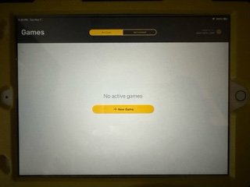
**click new game
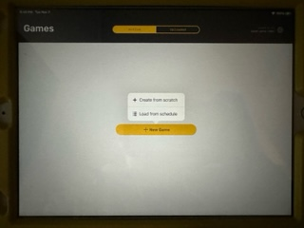

**select from list of games. You can change the date and the level of play to narrow down the list. Then select load game.
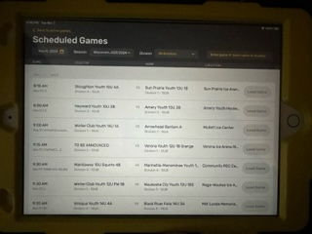

**Once selected your game will appear on the active game list
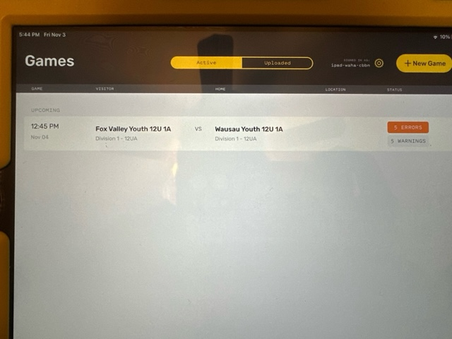

Coaches Signature:
This needs to be done by both Home & Visiting Head Coaches before the game starts.
1. Under Game Details click either Visitor Roster or Home Roster. (Coaches should verify their rosters and assign the player or players that may play goalie in the game. Then they need to make sure that their starting goalie is assigned AND any player not playing in that game needs to be assigned a status other than “playing”)
2. At the top of the roster page is the coach information. Click on the blue squiggly Sign and have the Head Coach use their finger to sign. (If the coach does not have the signature spot, make sure they are assigned as coaching)
3. Click Save.
4. Once saved, it will have Signed for that coach.
5. Repeat for both coaches.

Setting the Starting Goalie:
1. Navigate to the Home or Visitor Roster page.
2. Locate the Starting Goalie field and tap where it says Select.
3. Tap to select the starting goalie from the roster.

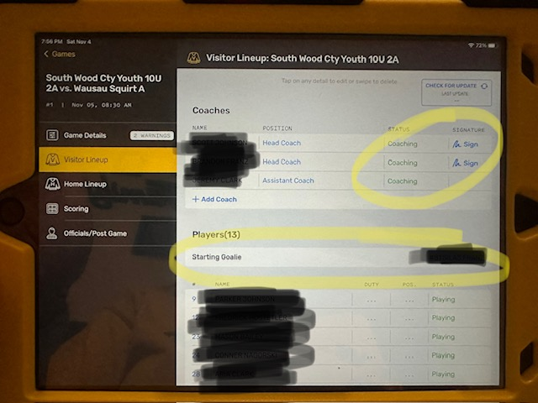

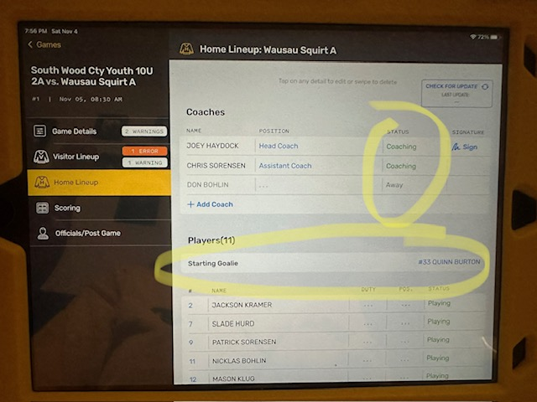

Score the Game:
1. Tap Game Details on the left side.
2. Fill in any missing details and confirm the period lengths are correct.
3. Enter the Start Time, e.g. 7:01pm when the puck is dropped.
4. Tap Scoring on the left side to enter the game scoring page.
5. Record the game’s events - goals, penalties, etc. as relayed to you by the referees
6. Make sure that the periods at the top of the page are correct when entering goals, penalties and shots on net. The period selector is at the top of the page.

**Make sure that the Official Score Keeper puts their name in the section for it. The phone number is not required.
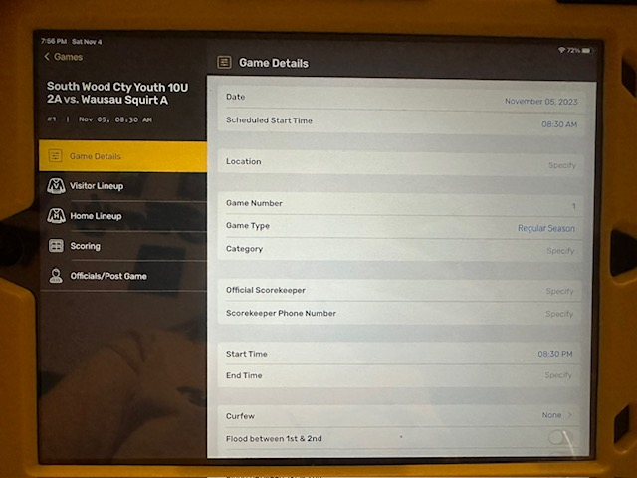

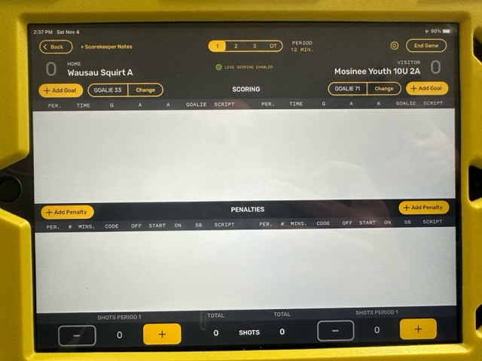

Shots on Net:
If the shot tracker is used, the Save Percentage for the goalies automatically calculated.
1. The Shot Tracking tool is found on the bottom row of the Scoring Page. The shots are entered for each period. When the period selector is moved from one period to another, the shot tracker also moves to that period.
2. Shots are entered for the team that takes the shot (the system will then use this number to calculate the Save Percentage for the opposing team’s goalie).
3. When a Goalie Change has been made, any shots entered after that change will be assigned to the new goalie. (Add the shots up until that point and click on change goalie up near where you add a goal, this will then make sure that the shots are assigned to the correct goalie.)

Adding a Goal:
1. Tap the +Add Goal for the team that scored.
2. Add the time of the goal.
3. Add the player that scored along with any assists.

Adding a Penalty:
1. Tap the +Add Penalty for the team that was assessed the penalty.
2. Add the following:
a. # of minutes for the penalty
b. What penalty was called c. When the penalty will start
d. Player who was assessed the penalty. End time will be filled in once over.
e. If the penalty is being served by another player, enter that player under SB (Served by).

Ending the Game:
1. Once the game is over, click on the End Game in the upper right corner.
2. This will take you to the referee page.

Referees Signature:
This will need to be done by all the refs at the end of the game.
1. Click on the blue squiggly Sign and have the referee use their finger to sign.
2. Click Save.
3. Once Saved, it will have Signed for that referee.
**If the referee wants a copy of the score sheet due to a major penalty or other reason the toggle next to their name (in the photo is toggled “on”). You can tap the line next to that and a window will appear for the reff to enter their e-mail that they would like it sent to.
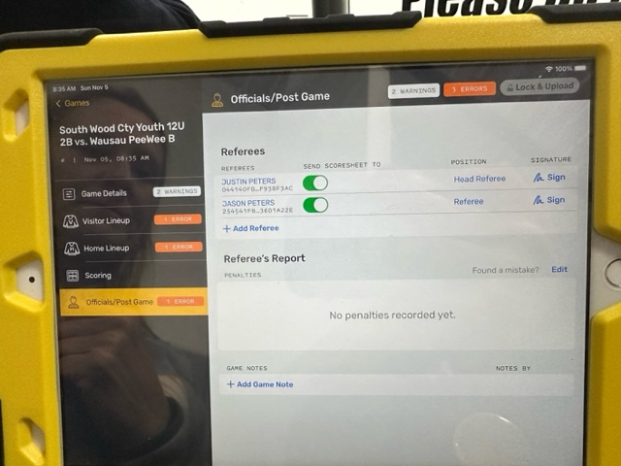
Lock Game:
The referee may do this, but if not follow these steps (pending no errors on the Game Details page).
1. Click Lock Game in the upper right corner.
2. Once on the Ready to Upload page, click on the blue Upload to Cloud button on the right. (If the iPad is not connected to the internet this step will have to be done in the lobby with an internet connection. The game will save on the active games list until it is uploaded. There is a cloud that will appear to continue upload with an internet connection.)
**The game will not be on the active list after it is completed

