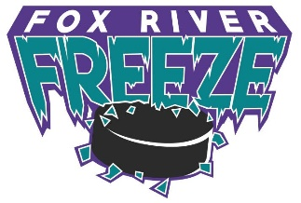
Appleton Area Hockey Association Team Sponsorship
AAHA is a non-profit 501(c)(3) organization that provides hockey for youth ages 4-14 living in or attending Appleton, Kimberly, Kaukauna, Little Chute, and Freedom school districts. AAHA is supported through player registration fees, sponsorships, advertising, and donations.
AAHA nearly 400 youth registered for the 2025-2026 season. This year the Association is hosting 11 tournaments (Mite, Girls U10-U14, Squirt, and PeeWee tournaments) drawing more than 100 teams to the area.
Your investment supports player development and helps teams with ice rental and tournament entry fees.
TEAM ADVERTISING AND DONATIONS
Gold Level: Total Donation $600+
- Name and Logo on AAHA organization main website page
- Name and Logo on team website
- Name and Logo displayed in all AAHA sponsored tournament books
Silver Level: Total Donation $300-$599
- Name and Logo on team website
- Name and Logo displayed in one AAHA sponsored tournament book
Bronze Level: $50-$299
- Name and Logo on team website
Individual teams may have unique opportunities for sponsors. Contact the team representative for more details.

Please complete the following form, mail with payment to the address below or return to the team representative.
Company Name
Contact Name
Phone Number
Email
Team(s) Sponsoring
Ex: “Freeze U10” or “Squirt A”

Make checks payable to:
“Appleton Area Hockey Association, Inc.”
501(c)(3) EIN 39-1986417

Mailing Address:
Appleton Area Hockey Association
PO Box 1771
Appleton, WI 54912

Updated 2025/10/25

