New clock/scoring system

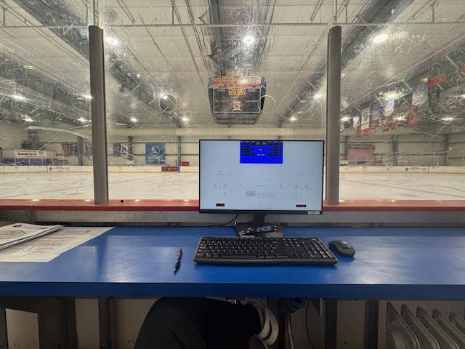

- The keyboard does nothing; you will have to use mouse for everything.

- If the screen is blank, please ensure the monitor is on by clicking the power button.

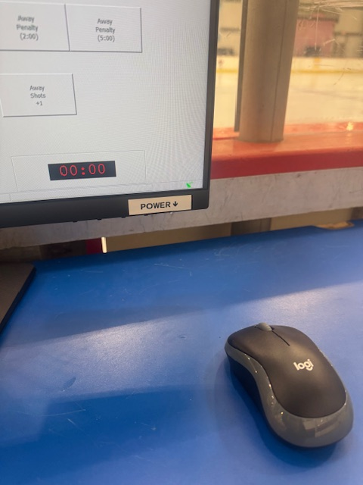

CBHL GAMES

You will still need two people as you will still use the iPad for scoring.

For the clock, you will click the “clock mode” option.

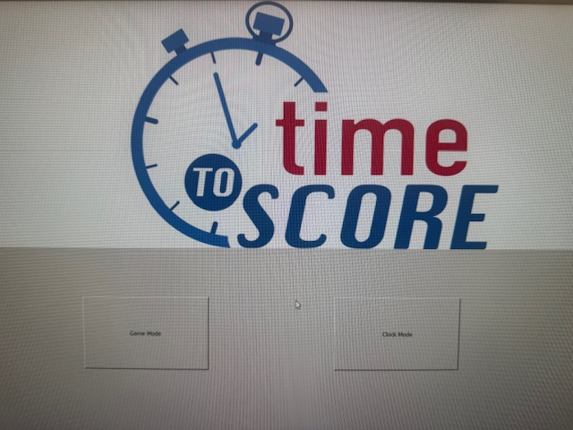

- Once in clock mode, I can’t stress enough how important it is to ensure you DO NOT CLICK EXIT. Doing so will erase everything and bring you to a blank screen once you come back in. You will have to reenter everything.

- To change the time, click on the time and change it, using the mouse.
  - Ensure “No Int Horn” is selected for full ice games.
  - For mites, please make sure “2 Min Horn” is selected
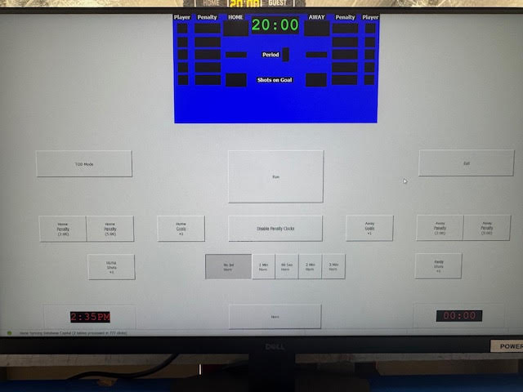

- To change the period, you simply click on the box where the period number will be, and it will change. It should automatically change after the time expires each period, but just in case you need to change it manually, you are able to do so by clicking in the box.

- To run the clock, you simply click the “Run” button. To stop the clock, you simply click the “Stop” button.

- Should you ever need to change the time on the clock, for whatever reason, you can do so clicking on the time and changing the numbers. Just remember there is a millisecond so for 15 minutes you will need to enter 15:00.0.

- Shots on goal does not matter as it does not show on the scoreboard. Please continue to manage them on the iPad.

- To enter a goal you simply click “Home/Away Goals +1”. Should you need to change the amount of goals, you click on the box where the goal count is. If you need to delete a number you can click blank. For example, if you need to change it from 10 to 9, you click blank to remove one of the numbers and then enter the single digit number.

- To enter a penalty, you click “Home/Away Penalty”
  - To enter the players’ number, you just click in the player number box.
  - At this moment, all penalties are set at 2 minutes, so you will need to change the time from 2 minutes to 1:30. To do so click in the penalty time box and correct the time.
  - You can enter up to 4 penalties on each side if needed. Hopefully you will never need to do that.

- Should you ever need to buzz the horn for any reason you can just click the horn button.

- If you are the last game of the day, please click exit, clock mode, and then TOD (time of day) mode to return the scoreboard back to the time, and turn the monitor off by clicking the power button.

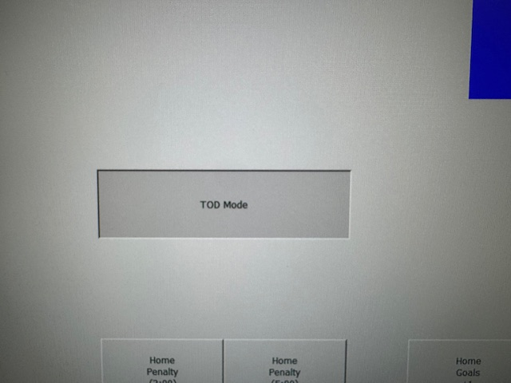

AHF GAMES

You will only need one person as the computer will be used for both keeping score as well as the clock.

You will click “Game Mode” on the main screen. if it is currently “TOD Mode”, simply click exit and then “Game Mode”.

- Because there were no games entered in the system, I wasn’t able to get screen shots. However, to those that have used “Time to Score” before, it will be just the same as it is on the iPad.

- To those who have not used “Time to Score”, or even those who have, I have included a link to a written tutorial, as well as the youtube video, below.

Time to Score Quick Tutorial
https://atlantichockeyfederation.com/wp-content/uploads/2023/08/Time-To-Score-Quick-Tutorial.docx

Time to Score YouTube
https://youtu.be/9DfHf3bu8gE?feature=shared

