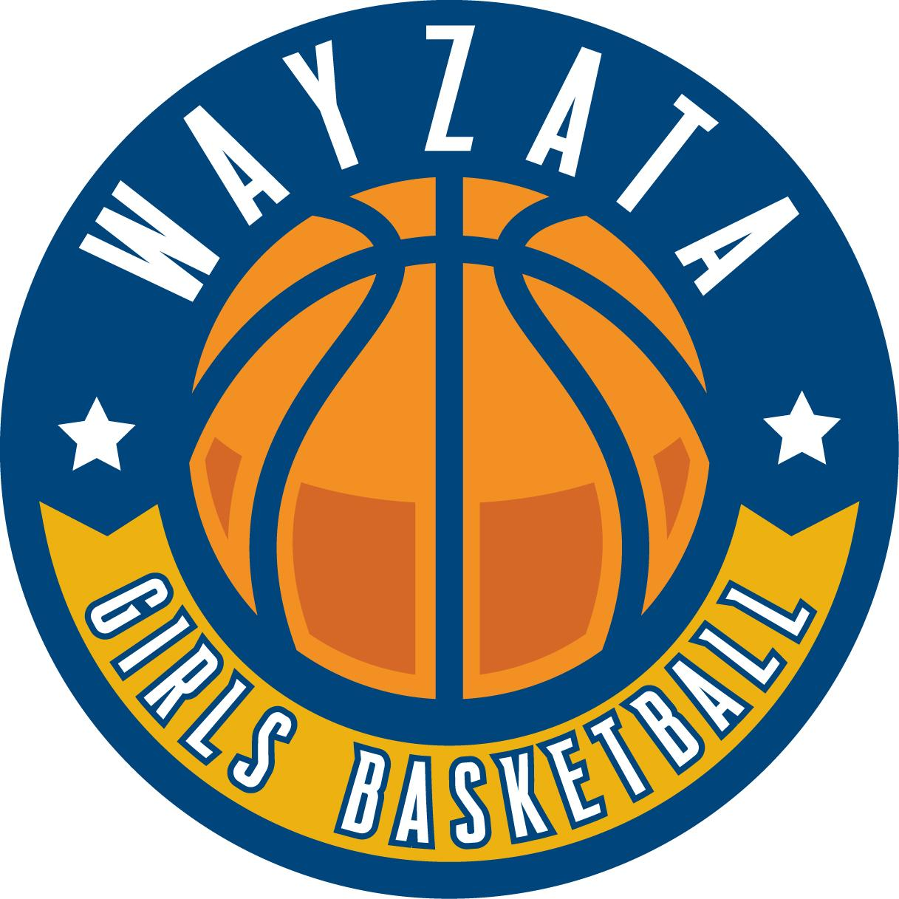

Summer Shooting & Dribbling Club Challenge

Blue Level:  Make 6,000 Shots  Dribble 1,000 Minutes | Gold Level:  Make 10,000 Shots  Dribble 1,500 Minutes
Recognition on WGBA Website & Newsletter | Recognition on WGBA Website & Newsletter
Recognition at Varsity Game | Recognition at Varsity Game
Member Hoodie | Member Hoodie
 | $75 Gift Card

Each player must complete the requirements on the provided form and have each session initialed by their parents or guardians. Sessions can take place June 6 - September 1, 2025. Completed forms & hoodie size must be submitted via email to wayzatagba@gmail.com by September 15, 2025. Blue and Gold level players will be recognized at the WHS Girls Basketball Youth Night (date to be announced)!

