Moose Cup 2025!
Hi everyone! Thank you for signing up for the Moose Cup 2025! We are so excited to welcome your teams to the Moose Sherritt Arena in Monticello. We have a total of 12 teams for the Squirt A tournament and it should be a great weekend of hockey. What better way to start the holiday season then for some hockey and Christmas celebrations!

Bracket/schedule:
Attached you will find the bracket for the tournament. As a reminder all teams a guaranteed 3 games with the potential for more depending on play. There will be 3 awards given (1st, 2nd and 3rd place). We will be following the MN Hockey guidelines for play and tournament policies.

Below are the pools for the weekend for the pool play portion.

 | Pool A | Pool B | Pool C | Pool D
1 | Monticello | Champlin | Orono | Sartell
2 | Roseville | LDC | River Lakes | Mound WT
3 | Moorhead | Rochester | Mankato | Woodbury

Pool A:
Date | Time | Home | Away
Friday Dec 5th | 3:30 pm | Monticello | Roseville
Saturday Dec 6th | 11:45 pm | Roseville | Moorhead
Saturday Dec 6th | 4:45 pm | Moorhead | Monticello

Pool B:
Date | Time | Home | Away
Friday, Dec 5th | 4:45 pm | Champlin | LDC
Saturday Dec 6th | 8:00 am | LDC | Rochester
Saturday Dec 6th | 1: 00 pm | Rochester | Champlin

Pool C:
Date | Time | Home | Away
Friday Dec 5th | 6:00 pm | Orono | River Lakes
Saturday Dec 6th | 9:15 am | River Lakes | Mankato
Saturday Dec 6th | 2:15 pm | Mankato | Orono

Pool D:
Date | Time | Home | Away
Friday Dec 5th | 7:15 pm | Sartell | Mound WT
Saturday Dec 6th | 10:30 am | Mound WT | Woodbury
Saturday Dec 6th | 3:30 pm | Woodbury | Sartell

Bracket play will be on Sunday. All first-place teams from the 4 pools will be in the gold bracket, 2nd place will be in silver bracket and 3rd place from each pool will be in the bronze bracket. Below are the brackets.

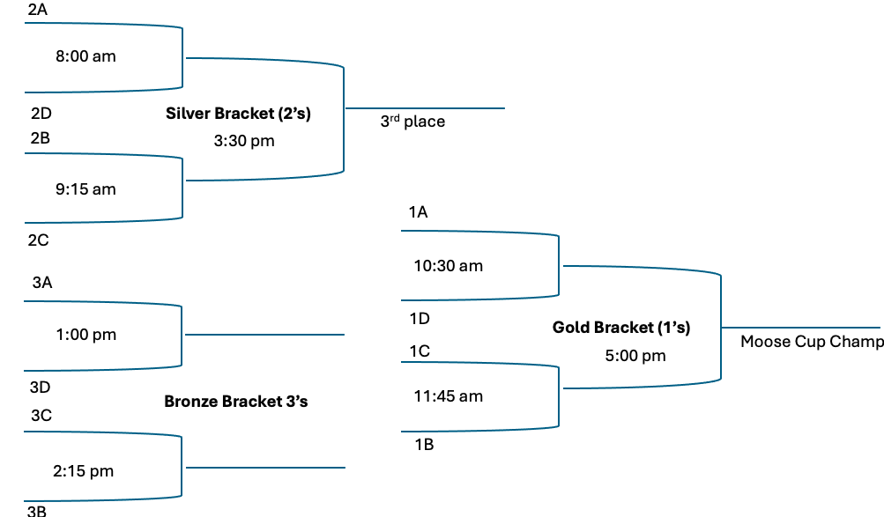

Rules:
Attached you will find the rules to the tournament.

Maps and parking:
Moose Sherritt Ice Arena | 800 Broadway St E, Monticello, MN 55362

Please park in the area marked on the map on Friday Dec 5th as school is still going on and the buses are needing to get out at the end of the day.

Sweatshirts:
We will be having a limited number of sweatshirts for sale at the tournament. The order form is attached. If each team could fill out the sheet together and then send it back to me that would be great. Venmo is preferred. The venmo handle is Samantha-Manning-29. If using venmo please indicate name and team. Otherwise, I can collect cash or check during the tourney.

Sweatshirts are $25 a piece. Team order form is attached. For ease, managers please complete one order form per team and submit to me by 11/20/25.
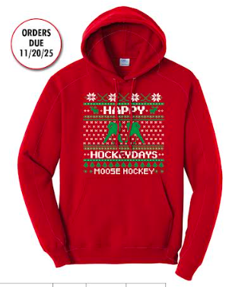
***** Instead of “Moose Hockey” at the bottom, it will say “Moose Cup’25”.
Think ugly Christmas sweater meets hockey!

Ugly Christmas Sweater Contest:
We cannot have a Christmas party without an Ugly Christmas Sweater contest! There will be prizes for the team with the most votes for their Christmas sweaters. If participating in the Ugly Sweater Contest, please have your team wear their sweaters to their first game of the tournament. They will have their photo taken and the photos will be displayed. The team with the most votes on Sunday will receive the prize!

Ornament Exchange:
There will be an ornament exchange occurring throughout the weekend. There will be a Christmas tree in the warming area (near the concessions) that will have different ornaments on there. Please bring an ornament to exchange. This can be any type of ornament (hockey related, fishing, video game etc). You then can place your ornament on the tree and take an ornament in exchange. Please make sure that these ornaments are appropriate. The ornament exchange is for any, just please bring an ornament and exchange it for another!

Photography on Site:
There will be Sportsline Photography on site taking pictures of the athletes throughout the weekend. These photos will be available for purchase. I will be sending out pre-order forms a prior to the tournament.

Looking forward to a fantastic Moose Cup ’25!

Happy Hockey Days!

-Samantha Manning
Moose Hockey Tournament director
763-670-5596

