Volunteering for Hudson Hockey Association
Below you will find all the information you need regarding Hudson Hockey Association volunteer opportunities as well as how to sign up to volunteer to meet your volunteer hours season requirements.
Volunteer Opportunities
Volunteer opportunities will be listed under the Volunteer tab in your Crossbar account. Here you will also be able to sign up for the volunteer opportunities. To access your Crossbar account and view and sign up for volunteer opportunities, visit the HHA homepage www.hudsonhockey.com follow the directions below.
- Click on Log In in the upper left corner of the homepage.
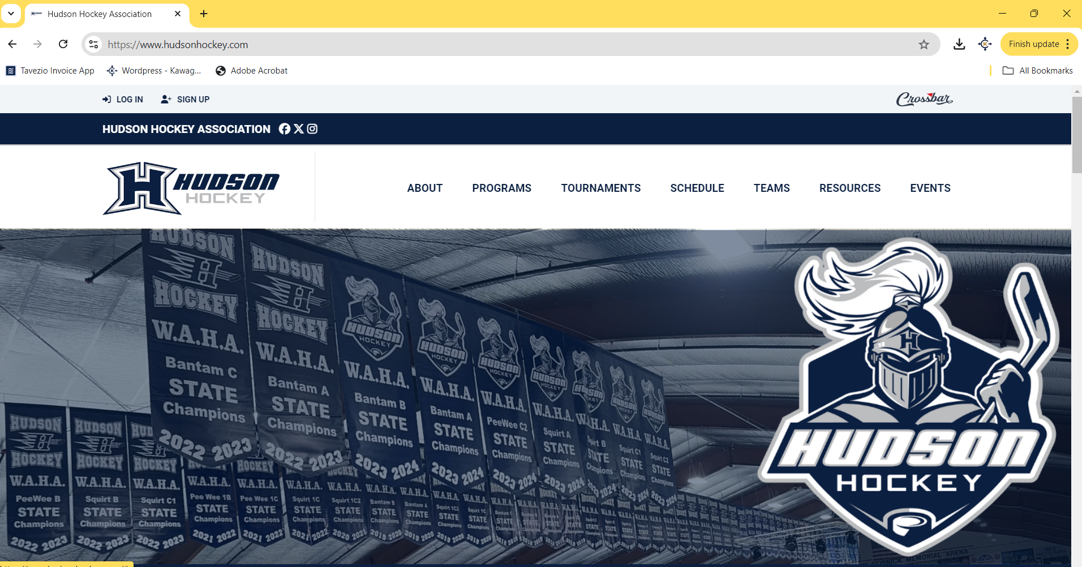

- Enter your Crossbar Account email address and password.

- Select the Volunteer tab on the menu bar to the left of the screen.
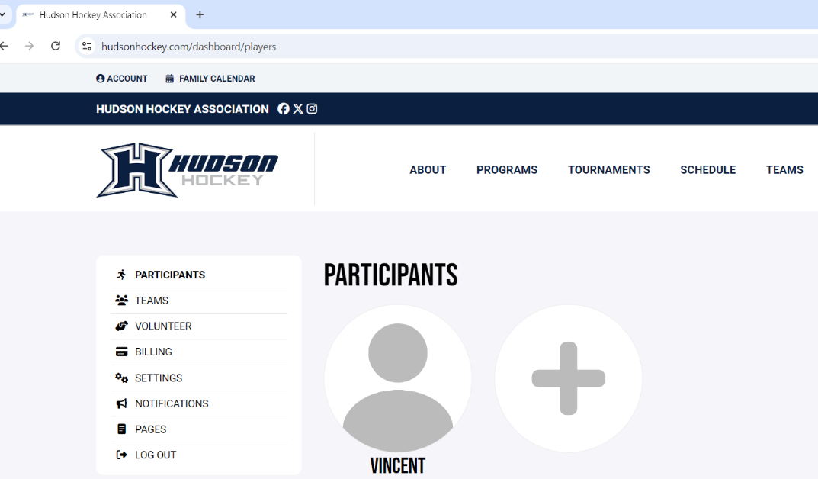

- Volunteer opportunities will be listed in bold. To see more information and to sign up for a volunteer opportunity, click on the More Information button below the listed opportunity.
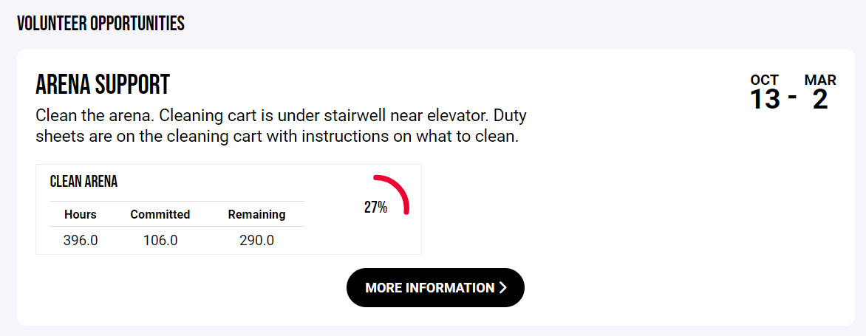

- To sign up, click on the green plus sign where an open slot remains and choose your name.
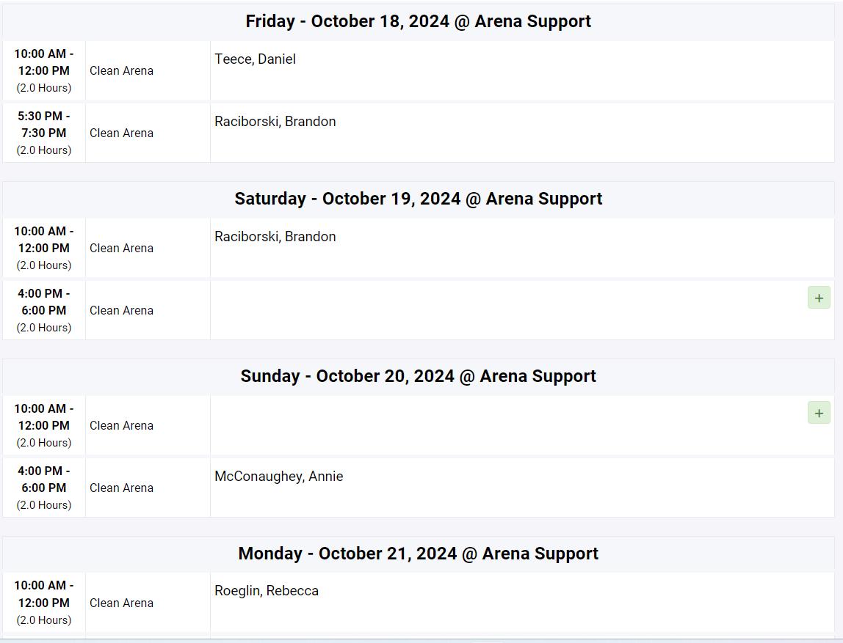
John Smith
John Smith

