Calumet Hockey Association

October Board Meeting
Location: Colosseum
Date: 10/21/24
Time: 6:00 pm
Members Present: |  | Members Absent: | Presiding Officer:
Jesse Patrick  Roy Loukus  Paul Moyryla  Ian Hodges  Joel Keranen  Bryan Miller  Christina Asiala  Rob Bohlsen |  | Adam Loukus  Joel Keranen | Jesse Patrick
 |  | Guests: | Recorder:
 |  | Roger Heikkila  Lars Hyrkas  Shanda Miller  Bruce Dessellier | Christina Asiala
Next Meeting: 11/18/24 6:00 pm

AGENDA ITEM | DISCUSSION | ACTIONS
Call to order | Meeting called to order at 6:01 pm
Public Comment | Roger discussed Zamboni driver schedule. Driver is needed from open until 4:30 on Saturdays  Shanda discussed the Gipp tournament plans  Bruce discussed issues getting volunteers to run the clock | Christina will send out an email to parents about running the clock and District 14B tournament.  The board will work on finding additional Zamboni drivers.
Approval of Minutes | September minutes reviewed. Motion by Bryan  2nd by Rob motion carried. | Minutes approved
Financial Report | Treasurer’s Report was presented, reviewed, and accepted. (see attached report)  Savings: $60,9221  Scholarship Savings: $2,502  General Fund: $157,552  CD account: $51,860 | Financial report accepted
14uB District tournament | Jan 21-Feb 2
14uAA state tournament | Rooms are saved for teams
All 12u skates | Discussion on changing to other nights besides Monday to accommodate our many players
Registration | Numbers are up this year.  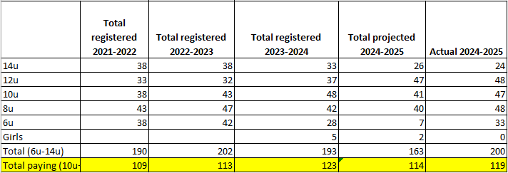
Ice Schedule | No update
Board Round table | Discussion on Zamboni driver wages.  Bryan thanked everyone who helped put the ice in this year. The logos worked very well.  The board thanked Bryan for heading up the ice making.  Discussion on NIHL  Christina announced her resignation. The board will look to fill her seat with the new candidate up for reelection April 2025..
Adjournment | Motion to adjourn by Jesse  2nd by Paul  Meeting adjourned at 7:20pm.

