
GRAND RAPIDS AMATEUR HOCKEY ASSOCIATION
ESTABLISHED 1972

Dear Sponsor,
The Grand Rapids Amateur Hockey Association, GRAHA, has been providing quality youth hockey programs in the Grand Rapids and West Michigan area since 1972. GRAHA celebrates over 50 years of hockey tradition, and we are proud of our continued relationship with the Grand Rapids Griffins, which allows us to have all our GRAHA teams skating with the Griffins logo on their jerseys.
GRAHA is a tax exempt, 501(c)3 non-profit organization that promotes civic awareness, responsibility, physical fitness, sportsmanship and academics. Our programs teach players that playing hockey is much more than just participating in a fun youth sport, it is about building character and learning valuable life lessons. GRAHA offers all levels of hockey from Learn to Skate to 19U. This past season, GRAHA had 525 skaters in both House and Travel programs, ages 3 to 19 years of age, 147of those skaters were female! GRAHA is proud to have a very large girls hockey program.
Join us in celebrating hockey in West Michigan! We are presently seeking sponsors for our hockey programs for the upcoming season. Team sponsors help us pay for such things as uniforms, assist families in need of scholarships and allow us to keep the player fees affordable for everyone so the children can continue to play the sport they love.
You can help us continue to provide our skaters with these opportunities by becoming a sponsor. The parents and athletes of GRAHA love to support the businesses that support them. This sponsorship gives you a direct connection to our parents, athletes and fans as an opportunity to extend special offers, discounts or messages of encouragement. You will find a summary of sponsorship details on our sponsorship form.
Your support is greatly appreciated as we plan for the fall hockey season! Please look at the enclosed information and consider how you or your business could get involved with GRAHA to help continue the passion of youth hockey in West Michigan! Please do not hesitate to call if you have any questions or would like to hear more about our sponsorship program.
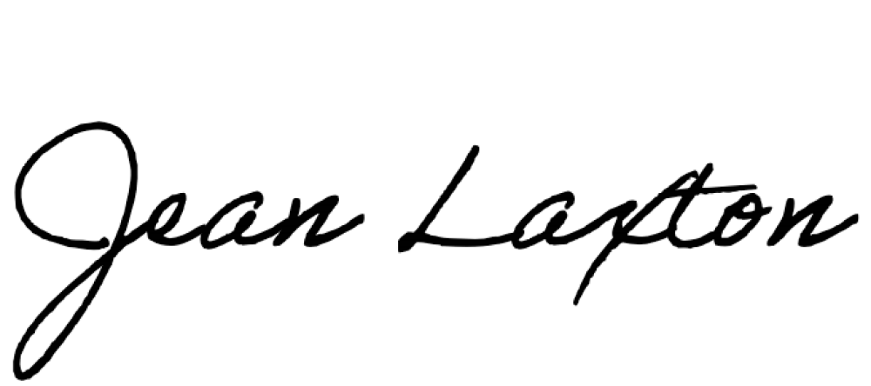

Jean Laxton
General Manager
P.O. Box 559 Ada, Michigan 49301| www.graha.org | 616.285.4600 office

