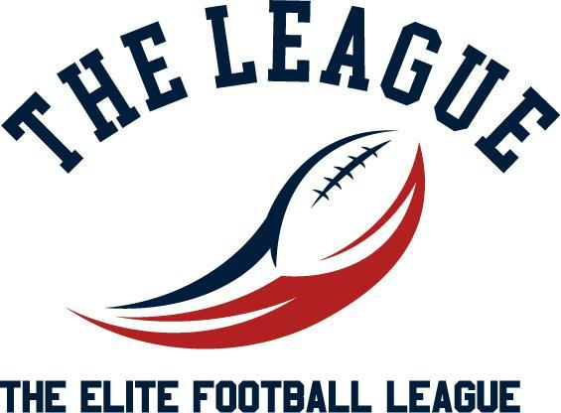

2025 PARTICIPANT CONTRACT AND PARENTAL CONSENT FORM

Special Note: This form must be completed, signed by the participant and, if the participant is under the age of 18, by the participant’s parent or legal guardian. The form applies only to the 2025 Spring season and it needs to be submitted prior to participation in any programs. By signing this form, the parent or legal guardian agrees to the terms and conditions outlined below.

Section I: YOUTH PARTICIPANT INFORMATION
First: Middle: Last: ________________

Date of Birth: Age: Male Female

Section II: PARENT/GUARDIAN INFORMATION
First: Last:
Address: City:
State: Zip:
Mobile Phone No: Alternate Phone No:
Email: Relationship to Child:

Section III: EMERGENCY CONTACT INFORMATION (if parent/guardian cannot be reached)

Name: Relationship to Child: Phone No:

Section IV: PARENT/GUARDIAN PERMISSION AND WAIVER

- PARENTAL PERMISSION: I am the parent or legal guardian of the above-named participant. I acknowledge that my child is in good health. I give permission for my child to participate in any and all Elite Football League activities run by Advantage Holdings LLC. I give permission for, and assume any and all risk of my child's use of various playing surfaces including natural and artificial grass, hard dirt, and under varying conditions, including, dry, wet and muddy, and I hereby understand that any surface may be regular or irregular.
- RISK INFORMATION: I acknowledge the inherent risk and danger of participation in any sport and I understand that participation in football, cheerleading and/or dance may result in BODILY INJURY, including by not limited to PARALYSIS, BRAIN INJURY, PERMANENT DISABILITY AND/OR DEATH. I acknowledge that protective equipment does not prevent all participant injuries and Advantage Holdings LLC makes no representations or warranties regarding the equipment or its fitness for use. I release, indemnify, hold harmless and waive any claim against the coaches, managers, volunteers, Advantage Holdings LLC, and any and all organizers, sponsors, supervisors, and participants, for any injury to me (or my child) whether the result of negligence or for any other cause.
- EMERGENCY MEDICAL AUTHORIZATION: I give permission for emergency medical/dental treatment or first aid to be administered to me (or my child) for any illness/injury/accident resulting from participation in Elite Football League activities.
- EQUIPMENT RESPONSIBILITY: I acknowledge that it is my responsibility to provide any and all equipment used in the activities and agree to only use helmets that have been certified for youth sports by NOCSAE (or the applicable industry certification organization) within the last two years.
- Image and Information Release. In consideration of participation in The Elite Football League run by Advantage Holdings, LLC, the undersigned agrees that their likeness, or the likeness of their child/ward may be photographed or videotaped, and that such image may be published in an outlet used to promote or publicize the sports program (including on our website) and / or be used for recruitment services for college coaches. I further acknowledge and consent to the distribution of my contact information to college coaches and recruiting services.
- ADHERENCE TO RULES AND PROCEDURES: I understand that it is my responsibility to comply with all rules and regulations of Advantage Holdings LLC and understand that non-compliance may be cause for discipline and/or dismissal of my child, myself, and/or other persons affiliated with me or my child. I understand that valid proof of age, a current calendar year’s signed medical form, and this form must be presented in order to participate in The Elite Football League activities (run by Advantage Holdings LLC). I understand that I am (and my child is) responsible for taking the Concussion for Students course at https://nfhslearn.com/courses/concussion-for-students and agree to do so prior to participating in any activities The Elite Football League activities (run by Advantage Holdings LLC).
- DISPUTE RESOLUTION POLICY; SEVERABILITY: I understand and acknowledge that all disputes with Advantage Holdings LLC and all affiliated parties will be subject to binding arbitration in Boston, MA in accordance with Massachusetts law. I hereby agree that this binding arbitration shall be in lieu of any litigation. I also understand and agree that if I contest any decision or ruling of Advantage Holdings LLC and seek other recourse, that I will reimburse Advantage Holdings LLC for all legal fees and expenses it reasonably incurs. If any portion of this form shall be deemed unenforceable, the reminder shall remain in full force and effect.

Section V: GENERAL CODE OF CONDUCT
The Elite Football League (run by Advantage Holdings LLC) is committed to cultivating a safe and welcoming environment for its events and programs that encourages and promotes good sportsmanship by student-athletes, parents, coaches, administrators and other spectators. We ask that event participants and attendees cooperate in being respectful at all practice and competition venues throughout the course of the events. All those involved with the event are expected to refrain from the following behaviors:
  - Acting in a way that is unruly, disruptive or illegal in nature.
  - Intoxication or other signs of impairment that may potentially result in bad behavior.
  - Excessive use of profanities and other vulgar language that that interfere with other attendees’ ability to enjoy the event.
  - Using bigoted, demeaning or abusive or other disruptive and intimidating language and/or gestures.
  - Verbal or physical harassment of officials, participants and coaches before, during and following the competition.
  - Disrupting the progress of competition (including physically entering or throwing objects onto the playing field or competition mat).
  - Interfering with or failing to abide by security or emergency procedures or response
  - Displaying signs that contain offensive language, or any graphic art that may be deemed disrespectful.
  - Defacing, destruction or theft of property associated with the event, including property of the opposing team or other participants, including officials, as well as official venues.
  - Violence or threats of violence against other individuals at any official venue.
  - Publicly criticizing or making derogatory statements of an official, opposing teams, event personnel or its policies, or other individuals associated with the event. This includes comments with respect to their conduct, character, competence, integrity or appearance. Note: social media is deemed a public forum.
  - Failing to follow instructions of event personnel.
  - Any behavior which otherwise violates conduct codes set by partner venues, hotels or ancillary venues including but not limited to theme parks, as enforced by those properties.
Failure to abide by these expectations are grounds for removal from competition. The Elite Football League (run by Advantage Holdings LLC) reserves the right to remove individuals or the entire team. Depending on the infraction, a one-year ban from Advantage Holdings LLC events and programs will be considered. A repeat offense of the same infraction may result in a permanent ban. All removals will be without refund.

Section VI: PARENT/GUARDIAN AUTHORIZATION
In consideration of participation in the Elite Football League (run by Advantage Holdings LLC) activities and by my signature below, I confirm that I have read, fully understand and voluntarily agree to be bound by all of the above and that all information provided by me is true and accurate.

Signature of Parent/Guardian: Date:

Section VII: PARTICIPANT AUTHORIZATION
In consideration of participation in the Elite Football League (run by Advantage Holdings LLC) activities and by my signature below, I confirm that I have read, fully understand and voluntarily agree to be bound by all of the above and that all information provided by me is true and accurate.

Signature of Participant: Date:

