HOCKEY MADE SIMPLE

THE PLAYERS
- Goaltender: The goalie's primary task is simple - keep the puck out of his own net. Offensively, he might start his team down the ice with a pass, but seldom does he leave the net.

- Defensemen: These players try to stop the incoming play at their own blue line. They try to break up passes, block shots, cover opposing forwards (center and wings) and clear the puck from in front of their own goal. Offensively, they get the puck to their forwards and follow the play into the attacking zone, positioning themselves just inside their opponent's blue line at the "points."

- Center: The quarterback on the ice, the center leads the attack by carrying the puck on offense. He exchanges passes with his wings to steer the play toward the opposing goal. On defense, he tries to disrupt a play before it gets on his team's side of the ice.

- Wings: The wings team with the center on the attack to set up shots on goal. Defensively, they attempt to break up plays by their counterparts and upset shot attempts.

THE OFFICIALS
- Referee: The referee supervises the game, calls the penalties, determines if goals are scored and handles faceoffs at center ice at the start of each period.

- Linesmen: One to Two are used. They call offside, offside pass, icing and handle all faceoffs not occurring at center ice. They do not call penalties, but can recommend to the referee that a penalty be called.

- Goal Judges: One sits off-ice behind each goal and indicates when the puck has crossed the red goal line by turning on a red light just above his station. The referee can ask his advise on disputed goals, but the referee has final authority and can overrule the goal judge.

- Official Scorer: He determines which player scores and credits assists if there are any. He might consult the referee, but the scorer is the final authority in crediting points.

HOCKEY'S THREE MAIN RULES
Offsides: When any member of the attacking team precedes the puck over the defending team's blue line.
Offside (or two-line)Pass: When a player passes the puck from his defending zone to a teammate beyond the red center line.
Icing: When a player shoots the puck across the center red line and past the opposing red goal line. Icing is not called if the player's team is killing a penalty, a teammate of the player shooting the puck touches it before a player from the opposing team, the defending goalie touches the puck first or if the puck travels through the crease (semicircle of blue paint at the "mouth" of the goal) on its way to the red line.

THE PENALTIES
A team plays shorthanded when one or more of its players is charged with a penalty. However, no team is forced to play more than two players below full strength (six) at any tiime. If a third penalty is assessed to the same team, it is suspended until the first penalty expires. When a penalty is called on a goalie, a teammate serves his time in the penalty box.
Minor Penalty: One to Two minutes - Called for boarding, charging, cross-checking, elbowing, holding, hooking, high-sticking, interference, roughing, slashing, spearing, tripping and unsportsmanlike conduct.
Major Penalty: Five minutes - Called for fighting or when minor penalties are committed with deliberate intent to injure. Major penalties for slashing, spearing, high-sticking, butt-ending and cross-checking carry automatic game misconducts.
Misconduct: Ten minutes - Called for various forms of unsportsmanlike behavior or when a player incurs a second major penalty in a game. This is a penalty against an individual and not a team, so a substitute is permitted.
Penalty Shot: A free shot, unopposed except for the goalie, given to a player who is illegally impeded from behind when in possession of the puck with no opponent between him and the goal except the goalie. The team which commits the offense is not penalized beyond the penalty shot, whether it succeeds or not.
Delayed Penalty: The whistle is delayed until the penalized team regains possession of the puck.
Top of page

PENALTIES AND REFEREE'S SIGNALS
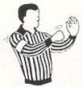  BOARDING  Called for driving, throwing, checking or tripping an opponent which causes the  opponent to be thrown  violently into the boards. |  | 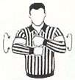  CHARGING  Called for running, jumping or charging into an opponent  (usually taking more than three strides before impact). |  | 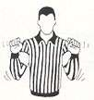  CROSS-CHECKING  Called when a player delivers a check with both hands on his stick and no part of the stick on the ice.
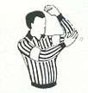  ELBOWING  Called when a player  uses his elbow to foul  another player. |  | 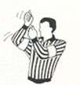  HIGH-STICKING  Called whan a player carries or holds his stick above the normal height of the waist of an opponent and the stick  causes injury to that opponent. |  | 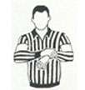  HOLDING  Called whan a player holds an opponent with his hands or stick. Holding the stick is  called for, well, holding an opponent's stick.
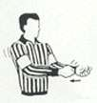  HOOKING  Called when a player impedes or seeks to impede the progress  of an opponent by "hooking" him  with his stick. |  | 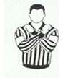  INTERFERENCE  Called when a player impedes  or seeks to impede the progress of an opponent who is not in possession of the puck. |  | 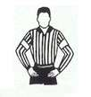  MISCONDUCT  Called for various forms of misconduct including the use of abusive language to any  person, challenging an official's ruling, etc. (also given to a player receiving two major  penalties in a game).
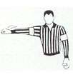  ROUGHING  Called when a player or players are deemed guilty of unnecessary roughness, engaging in fisticuffs and/or  shoving. |  | 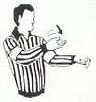  SLASHING  Called when a player swings  his stick at an opponent or  impedes or attempts to impede an opponent by slashing with his stick. |  | 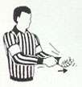  SPEARING  Called when a player stabs an opponent with the point of the stick blade while the stick is  being carried with one or both hands.
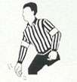  TRIPPING  Called when a player  places his stick, knee,  foot, arm, hand or elbow  in such a manner that it  causes his opponent to  trip or fall. |  | 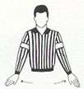  WASHOUT  When signaled by a linesman, it means there is no offsides or icing. The referee will also use this signal to "wave off" a  goal.
Top of page

COMMON QUESTIONS ABOUT THE GAME OF HOCKEY
What is the puck made of?
The puck is made of vulcanized rubber and is three inches in diameter and one inch thick, weighing about six ounces. It is frozen before entering play to make it bounce resistant.
How fast does the puck travel?
Some of the game's hardest shooters send the puck toward the net at speeds between 90 and 100 mph with the elite shooters easily topping the century mark. Making things even more difficult on the goalie is the puck will frequently curve in flight, much like a baseball.
Which shot is the hardest for a goalie to stop?
Generally speaking, it is one that's low and to the stick side. Some goaltenders overplay to the stick side, presenting a more inviting target on the glove side.
What about deflections?
Deflections aren't just luck. Players practice redirecting shots by standing at the side of the net and knocking a shot from the outside past the goalie into another area of the goal.
Which is tougher for the goalie to stop a slap shot or a wrist shot?
The slap shot, while it is harder and faster, is easier for the goalie to time than a wrist shot, which takes the goalie more by surprise.
How thick is the ice?
The ice is approximately 3/4" thick and is usually kept at 16 degrees for the proper hardness. The thicker the sheet of ice becomes, the softer and slower it is.
What are the standard dimensions of the rink?
The standard is 200' by 85', although some do vary.
Can the puck be kicked in for a goal?
Not intentionally. However, if a puck is deflected off a skate or off a player's body and no overt attempt is made to to throw it or kick it in, a goal is allowed.
What if an offensive player is in the crease?
If he is there under his own power and the puck goes in, the goal is disallowed. A goal can be awarded if the player was forced into the crease or held there by a defensive player. An offensive player is allowed to carry the puck into the crease and score.
Why do goalies frequently come out of in front of their net?
Usually when a goalie leaves the area immediately in front of the goal it is to reduce the shooting area, cut down the angle of the shooter or for the offensive player to release his shot before he would like to. After coming out of the net, the goalie is usually backing up slowly in an attempt to get the shooter to commit himself first.
Who gets credited for an assist?
The last player or players (no more than two) who touch the puck prior to the goal scorer are awarded assists. For example, if player A passes to player B who passes to player C who scores a goal; players A and B get assists.
Why doesn't the referee stop fights?
There are several. First, it is his job to watch what is going on and determine who should be penalized. Also, it is quite hazardous in close during a fight and since he is in sole control of the game, he has to protect himself from injury.
How are the markings - the red and blue lines, goal lines, crease and face-off circles - applied to the ice?
The ice is built up to a half-inch thickness by spraying water over the concrete floor, which has the freezing pipes embedded into it. Then the markings are painted on, after which additional water is sprayed to coat the markings and build the ice to the prescribed thickness.
What are hockey sticks made of?
Hockey sticks are made of wood, generally northern white ash or rock elm, or aluminum. The handle is one piece and the laminated wooden blade is affixed to it.
Are all sticks alike?
Far from it. Just as baseball players have individually personalized bats, so too do hockey players have their own patterned sticks. Flexibility, the angle of the blade, weight, etc., vary from player to player.
Top of page

HOCKEY TALK
For fans new to the game, hockey has a language all its own. The following guide should be helpful in picking up hockey's lingo.
Back Check: To hinder an opponent heading toward and into the defending zone.
Blue Lines: The pair of one-foot wide blue lines which extend across the ice at a distance of 60 feet from each goal. These lines break up the ice into attacking, neutral and defending zones.
Body Check: Use of the body on an opponent. It is legal when the opponent has possession of the puck or was the last player to have touched it.
Butt-ending: To hit an opponent with the end of the stick farthest from the blade. It is illegal and calls for a penalty.
Goal Crease: Area directly in front of the goaltender. It is four feet wide and eight feet long and marked off by red lines. Offensive players who do not have possession of the puck may not enter.
Deke: To fake an opponent out of position.
Face Off: The dropping of the puck between one player from each team to begin or resume play.
Forecheck: To check an opponent in his end of the rink, preventing an offensive rush.
Freezing the Puck: To hold the puck against the boards with either the skate or stick to get a stoppage of play.
Goal Line: The red line which runs between the goal posts and extends in both directions to the side boards.
Goal Mouth: The area just in front of the goal and crease lines.
Hat Trick: The scoring of three or more goals by a player in one game.
One-timer: Hitting the puck directly upon receiving a pass. The offensive player takes his backswing while the puck is on its way to him and tries to time his swing with the arrival of the puck.
Penalty Box: The area opposite the team benches where penalized players serve time.
Power Play: A power play occurs when a team has a one-man or two-man advantage because of an opponent's penalties.
Pulling the Goalie: Replacing the goalie with an extra skater in a high-risk attempt to tie the game. This primarily occurs when a team trails, usually by one goal, late in the game.
Save: A shot blocked by the goaltender, which would have bean a goal had it not been stopped.
Screened Shot: The goaltender's view is blocked by players between he and the shooter.
Slap Shot: Hitting the puck with the blade of the stick after taking a full backswing.
Slot: The area immediately in front of the goal crease. It is from this zone that most goals are scored and where the most furious activity takes place.
Splitting the Defense: The player with the puck attempts to squeeze between the opponent's defensemen.
Stick Handling: To control the puck along the ice with the stick.
Top Shelf: Term used to describe when an offensive player shoots high in an attempt to beat the goalie by shooting the puck into the top portion of the net.
Wraparound: A player skates around behind the opposing goal and attempts to wrap the puck around the goal post and under the goalie.
Wrist Shot: Hitting the puck with the blade of the stick using a quick snap of the wrist rather than a full back swing.
Rink Dimensions
Top of page

Lines
The center line divides the ice in half lengthwise. It is used to judge icing, meaning that if a team sends the puck across the center line (red line), blue line and then across the goal line (that is to say, shoots or dumps the puck past the goal line from behind their own side of the center line) it is said to be icing. It is a thick line, and in the NHL must "contain regular interval markings of a uniform distinctive design, which will readily distinguish it from the two blue lines." When discussing differences in the rules of the game, it is often said that a game is played with no red line. This simply means that there is no two-line pass violation. The center line is still used to judge icing violations.
There are two thick blue lines that divide the rink into three parts, called zones. These two lines are used to judge if a player is offside. If an attacking player crosses the line into the other team's zone prior to the puck crossing, he is said to be offside.
Near each end of the rink, there is a thin red goal line spanning the width of the ice. It is used to judge goals and icing calls.

Faceoff Spots and Circles

There are 9 faceoff spots on a hockey rink. Most faceoffs take place at these spots. There are two spots in each end zone, two at each end of the neutral zone, and one in the center of the rink.
There are faceoff circles around the center ice and end zone faceoff spots. There are hash marks painted on the ice near the end zone faceoff spots. The circles and hash marks show where players may legally position themselves during a faceoff.
The center faceoff spot is typically blue. The center circle may be red or blue. Usually all other faceoff spots and circles are red.

Goal Posts and Nets
At each end of the ice, there is a goal consisting of a metal goal frame and cloth net in which each team must place the puck to earn points, or goals. The opening of the goal, which sits on the goal line, is 6 feet (1.8 m) wide by 4 feet (1.2 m) high (1.83 × 1.22 m). The tubes extending vertically from the goal line are called the goal posts, and the tube that connects these at the top of the goal frame is called the crossbar.
Ice hockey is one of the few team sports in which there is a live area of play behind the goal. The goal frame extends 44 inches (1.12 m) behind the goal line. The sides of the frame are rounded outwards with a 20-inch (50.8 cm) radius. The rounded portion of the goal frame prevents players behind the net from passing the puck to the front of the net right along the goal post. In many cases, players try to take advantage of the shape of the goal by deliberately passing the puck off the bottom of the goal frame. This can cause the puck to change direction in a way that confuses the opposing team.
The back of the goal frame is covered in a net to catch pucks shot into the goal. The goal posts and crossbar are painted red. The inside part of the goal frame is padded to keep pucks that enter the net from rebounding out.
The goal frame is moored to the ice with flexible pegs, which are designed to allow the net to move freely if a player crashes into the goal. At many multipurpose rinks, metal pins are used that only protrude about a quarter of an inch (a centimeter) into the ice, as the flexible pegs require large holes that cannot be repaired by an ice resurfacer drilled into the ice.
Top of page

Goal Area
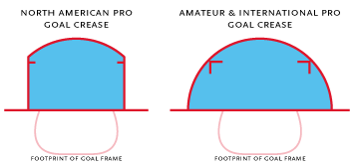
In front of each goal, there is a goal crease, which is surrounded by thin red lines and filled in with light blue. The crease is a special area of the ice designed to allow the goaltender to perform his or her duties without interference. In most leagues, no attacking player may enter the goal crease with a stick, skate, or any body part before the puck. For the purposes of this rule, the crease extends vertically from the painted lines to the top of the goal frame. This rule was eliminated from the National Hockey League and other North American professional leagues beginning in the 1999-2000 season.
In amateur and international hockey, the goal crease is a half circle with radius of 6 ft (1.8 m). In the NHL and North American professional leagues, this goal crease is truncated by straight lines extending from the goal line 1 ft (30.5 cm) outside each goal post.

Goaltender Trapezoid
During the 2004-05 AHL season, an experimental rule was implemented for the first seven weeks of the season. This additional area behind the goal line is officially referred to as the Goaltender Trap Zone, but is more frequently called the trapezoid in reference to its shape. The area consists of a centered, symmetrical trapezoid. The bases of the trapezoid are formed by the goal line and the end boards. The base on the goal line measures 18 feet (5.5 m) and the base on the end boards measures 28 feet (8.5 m). It is prohibited for the goaltender to handle the puck anywhere behind the goal line that is not within the trapezoidal area. If he does so he is assessed a minor penalty for delay of game. The motivation for the introduction of the trapezoid was to promote game flow and prolonged offensive attacks by making it more difficult for the goaltender to possess and clear the puck.
The seven-week experiment proved so successful that the AHL moved to enforce the rule for the rest of the season, and then was approved by the NHL when play resumed for the 2005-06 season following the previous lockout. The ECHL, the only other developmental league in the Professional Hockey Players Association (along with the AHL) also approved the rule for 2005-06.
The zone has been referred to as different names. The Trapezoid is the most common, but former Chicago Wolves broadcaster coined the term "Forbidden Zone" possibly taking a line from the film Strange Brew.

Referee Crease
The referee crease is an area in front of the scorekeepers bench that no player may enter during a stoppage of play. It has no function during play. If a player enters the referee crease during stoppage of play he/she will be ejected.

Zones
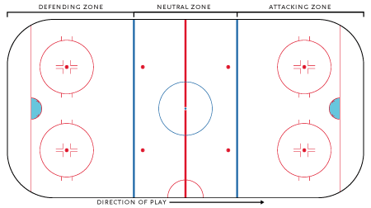
The blue lines divide the rink into three zones. The central zone is called the neutral zone or simply center ice. The generic term for the outer zones is end zones, but they are more commonly referred to by terms relative to each team. The end zone in which a team is trying to score is called the attacking zone or offensive zone; the end zone in which the team's own goal net is located is called the defending zone or defensive zone.
The blue line is considered part of whichever zone the puck is in. Therefore, if the puck is in the neutral zone, the blue line is part of the neutral zone. It must completely cross the blue line to be considered in the end zone. Once the puck is in the end zone, the blue line becomes part of that end zone. The puck must now completely cross the blue line in the other direction to be considered in the neutral zone again.
Top of page

Benches
There are five or seven benches outside a hockey rink: two players benches where the players and coaches of each team sit during the game, two penalty benches where penalized players serve their time, and a scorekeepers bench where most of the off-ice officials sit. Often, there is also a goal judge bench behind each goal where the goal judge sits.

Glass
In many rinks, the height of the boards is extended with glass or plexiglas to prevent pucks from leaving the playing surface and injuring spectators. Often, there is netting above the glass for further protection. Pucks that deflect off the glass and remain inside the rink are still in play, whereas pucks that hit the netting are considered out of play.

Half Boards
In a hockey rink, the half boards are the area along the side boards half-way between the blue line and the goal line, roughly from the hash marks to the top of the faceoff circle.
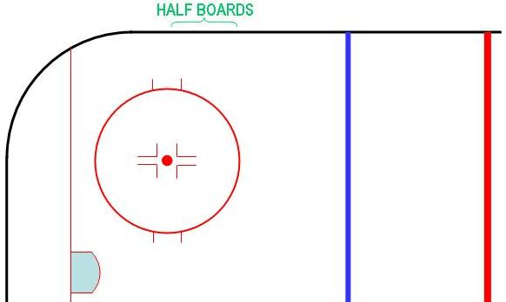
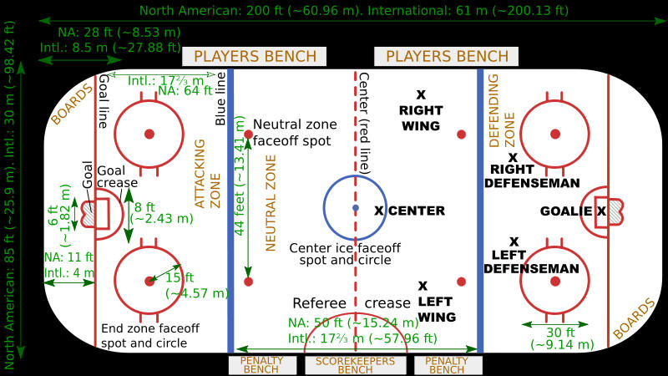
Top of page.

