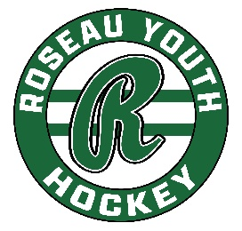
RYH Board Meeting | February 26, 2025
6:30 pm, Legion
In Attendance: Phil, Luke, Matt, Jenni, Keith, Paul B., Zach, Tara Neville, Nick Kvidt

Agenda:
- Call to Order: The meeting was called to order at 6:31 pm.
- Approve Agenda: Zach motions to approve, Paul B seconds. Agenda approved.
- Secretary’s Minutes: Matt moves to approve, Luke seconds. Minutes approved.
- Treasurer’s Report: Matt motions to approve, Zach seconds. Report approved.
- Committee Updates:
  - Coaches/Player Development: No report.
  - Fundraising: $47,500 worth of invoices for board advertising is going out. School reached out to see if they could be involved in Board advertising (Sports Center). We briefly discussed how that could be a partnership moving forward, but we’re not going to pursue further discussion at this time.
  - NR: Nothing to report
  - Paul B makes a motion that the Tournament Director have access to a debit/credit card to register for any/all team tournaments, Zach seconds. After discussions, the motion is tabled, to be discussed next month. *This was in response to a conversation about registering for Tournaments each Spring and finding ways to avoid coaches having to front the registration fee.

- NR Skate/Lace shop inquiry – Parker Jaenicke
  - The group briefly discussed a lease agreement, looking for a small percentage to be donated back to the organization after the year-end. No decisions were made, table logistics of lease at this time. Will discuss again next month.
- Adjourn: Meeting is adjourned at 7:44 pm
  - Next Meeting, March 26, 5:30 at the Legion (work session)
FYI:
- Next season Gamesheet will cost $9/game for usage. Discussions to continue regarding options, i.e. raising tourney fees? Will the District help pick up a portion of the cost? It’s required by MN Hockey. We will need to discuss further at upcoming meetings.
- March 31st Memorial ice out.
- After the meeting, via email, the Board approved a donation of a BHHA camp registration for the Lifecare Gala (prize).

