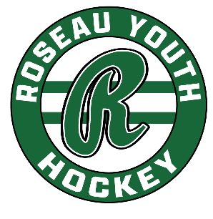
RYH Board Meeting | August 18, 2025
Gene’s, 6:15 pm

In Attendance: Phil, Paul B, Luke, Matt, Keith, Mark Jennings, Tara Neville

Minutes:
- Call to Order: 6:16pm
- Approve Agenda: Luke motions to approve, Paul B seconds, agenda approved
- Secretary’s Minutes: Matt motions to approve, Paul B seconds, minutes approved.
- Treasurer’s Report: Paul B motions to approve, Matt seconds, report approved.
- Standing Committee Updates
  - North Rink:Ads?
  - Player Development/Coaching: Summer Camp brought in $22,000
  - Fundraising: Front door?

- City Agreement: Parties agreed to a 2-year deal, starting Fall 2026. (Option #2) City is installing meters to monitor electric/gas and will use that data to negotiate future contracts.
- REA Grant: Mark Jennings has offered to submit grant on our behalf; those present agreed to do updates with/without grant funding.
  - Paul B motions, Matt seconds to move forward with lighting fixes up to $7500 without grant dollars.
  - Leaving lights on $8500/year, timer on breakers, $1000
  - Mark J.: motion sensors, new LED lights in hall, approx. $1800 materials/$1800 labor (approx. $4000)
- East Side Locker rooms – Do we want to hire someone to clean those locker rooms in the Fall before tournament season? Same in the Spring once tournaments wrap?
  - Volunteer hours – area confirmation kids are looking for ways to volunteer too.
- NR Dumpster: Visit with City once tournament season starts to make arrangements for a shared dumpster with Legion/Memorial.
- Other items:
  - HS players – register w/RYH?
    - $20? $100?
  - Roseau County Ford – Zamboni advertising/wrap
    - $5000/5 years
    - Brant Johnson
  - Raffle – cash only for prizes
    - Approximately 3200 tickets total (less than last year)
    - 6U/Tiny Mites (hockey is free), but sell 1 book of tickets
- Adjourn/Next Meeting

